



Unit Test Plan

FSD012 – Contract Value Request

04/11/2025

Version: 1.0

Table of Contents

1 Technical Details 6

1.1 Requirements 6

1.2 System Changes 6

1.3 Assumptions 6

1.4 Test Method 6

1.5 Verification Technique 6

2 Data Configuration 8

2.1 System Changes for Delivered Configuration 8

2.1.1 Algorithm 8

2.1.2 Algorithm Type 8

2.1.3 Application Service 9

2.1.4 Business Object 10

2.1.5 Data Area 13

2.1.6 Field 14

2.1.7 Message 17

2.1.8 Request Type 17

2.1.9 Script 18

2.1.10 UI Map 19

2.2 System Changes for Client Configuration 20

2.2.1 Bill Factor 20

3 Test Conditions and Results 22

3.1 Go to Admin Menu > R > Request Type > Add. Select the Mass Overgeneration Transfer Request Type. 27

3.2 In the Mass Overgeneration Transfer page, populate all the fields correctly. Click Cancel button. 28

3.3 In the Mass Overgeneration Transfer page, populate all the fields correctly. Click Save button. 29

3.4 In the Request Type page, click Edit button for the active Mass Overgeneration Transfer Request Type. 31

3.5 In the Request Type page, update the existing active Mass Overgeneration Transfer Request Type and click Save button. 31

3.6 In the Request Type page, click Duplicate button for existing active Mass Overgeneration Transfer Request Type. 32

3.7 In the Request Type page, duplicate the existing Mass Overgeneration Transfer Request Type and click Save button. 33

3.8 In the Request Type page, click Delete button for the Mass Overgeneration Transfer Request Type 34

3.9 In the Confirmation Delete pop-up window, click Cancel button. 35

3.10 In the Confirmation Delete pop-up window, click OK button. 36

3.11 In the Request Type page, click Deactivate button for the Mass Overgeneration Transfer Request Type. 37

3.12 Go to Main Menu > Tools > Request > Add. Select the Mass Overgeneration Transfer Request Type. 38

3.13 In the Mass Overgeneration Transfer Request Maintenance page, click Cancel button. 40

3.14 In the Mass Overgeneration Transfer Request Maintenance page, click the CSV File to Upload button. 41

3.15 In the File Upload pop-up window, click the Submit button 42

3.16 In the File Upload pop-up window, click the Choose File button. 43

3.17 In the File Upload pop-up window, click the Choose File button and select a file that is not in CSV format. 44

3.18 In the File Upload pop-up window, click the Choose File button, select a file and click Submit button. 46

3.19 In the Mass Overgeneration Transfer Request Maintenance page, file contents are loaded in the table. Select and submit another CSV file 48

3.20 In the Mass Overgeneration Transfer Maintenance page, file contents are loaded in the table. Click the Delete button. 50

3.21 In the Mass Overgeneration Transfer Maintenance page, file contents are loaded in the table. Click the Add button. 51

3.22 In the Mass Overgeneration Transfer Maintenance page, file contents are loaded in the table without the SA ID and click Save button 52

3.23 In the Mass Overgeneration Transfer Maintenance page, file contents are loaded in the table without Contract Value Bill Factor and click Save button. 53

3.24 In the Mass Overgeneration Transfer Maintenance page, file contents are loaded in the table without the Contract Value Amount and click Save button 54

3.25 In the Mass Overgeneration Transfer Maintenance page, file contents are loaded in the table. Provide invalid Contract Value Amount and click Save button 55

3.26 In the Mass Overgeneration Transfer Maintenance page, file contents are loaded in the table. Click the Save button 56

3.27 In the Request page, click Edit button for the pending Mass Overgeneration Transfer Request. 59

3.28 In the Request page, update the existing Mass Overgeneration Transfer Request and click Save button 60

3.29 In the Request page, click Delete button for the pending Mass Overgeneration Transfer Request 61

3.30 In the Confirmation Delete pop-up window, click Cancel button 62

3.31 In the Confirmation Delete pop-up window, click OK button 63

3.32 In the Request page, click Process button for the pending Mass Overgeneration Transfer Request with all fields correctly populated. 64

3.33 In the Request page, click Process button for the pending Mass Overgeneration Transfer Request with missing SA ID 66

3.34 In the Request page, click Process button for the pending Mass Overgeneration Transfer Request with missing Contract Value Bill Factor 67

3.35 In the Request page, click Process button for the pending Mass Overgeneration Transfer Request with missing Contract Value Amount 69

3.36 In the Request page, click Process button for the pending Mass Overgeneration Transfer Request with invalid SA ID 70

3.37 In the Request page, click Process button for the pending Mass Overgeneration Transfer Request with invalid Contract Value Bill Factor 71

3.38 In the Request page, click Process button for the pending Mass Overgeneration Transfer Request with invalid Contract Value Amount 73

3.39 In the Request page, click Process button for the pending Mass Overgeneration Transfer Request with SA that has existing Contract Value with the same Bill Factor and Start Date. 75

3.40 In the Request page, click Process button for the pending Mass Overgeneration Transfer Request with SA that has existing Contract Value with the same Bill Factor, Start Date and End Date. 77

3.41 In the Mass Overgeneration Request BO – Processed status, update the Transitory State to No and clear the Transition Condition. In the Request page, click Process button for the pending Mass Overgeneration Transfer Request. 79

**Document Revision History**

|  |  |  |  |
| --- | --- | --- | --- |
| Date | Version | Author | Notes |
| 04/04/2025 | 0.1 | John Mari Alcausin | Initial Version. |
| 04/11/2025 | 0.2 | John Mari Alcausin | Updated after 1st pass review |
| 04/11/2025 | 1.0 | John Mari Alcausin | Signed Off. |
| 06/20/2025 | 1.1 | John Mari Alcausin | Bug 162998. Script was updated and added validation if Service Agreement Contract Value has the same Bill Factor and Start Date |

**Related Documents**

|  |  |  |
| --- | --- | --- |
| Date | Version | Document Name |
| 04/11/2025 | 0.5 | IPC_TD_FSD012 - Contract Value Request |
|  |  |  |

# Technical Details

## Requirements

An Algorithm will be created and integrated into an Overgeneration Transfer Request BO, the algorithm will process the and validate the records for the Request. It will then generate an SA Contract Value for the Overgeneration credit from one service to another.

## System Changes

These configurations were created / updated for delivery to the client:

* Algorithm Type: CM-BOSEN-CSC
* Application Service: CM-MOXFRREQTYPBO; CM-MOXFRREQBO
* Business Object: CM-MassOvergenXferReqType; CM-MassOvergenXferReq
* Data Area: CM-MassOvergenXferReqData; CM-MassOvergenXferReqException
* Field: CM_MOXR_CONTRACT_VAL_BF_LBL; CM_MOXR_CONTRACT_VAL_AMT_LBL; CM_MOXR_CREDIT_DATA_LBL; CM_MOXR_EXCEPTION_LIST_LBL; CM_MOXR_LBL; CM_MOXR_MAIN_LBL; CM_MOXR_SA_ID_LBL; CM_MOXR_SEQ_NBR_LBL; CM_MOXR_CREDITS_LIST_LBL
* Message: 90003 / 12601-12606
* Request Type: MASSOGENXFER
* Script: CMCrSACntVal
* UI Map: CM-MassOvergenXferRecordAction; CM-MassOvergenXferMaint

These configurations were created / re-used for client configurations:

* Algorithm: CM-BOSEN-CSC
* Bill Factor: JA-KWHBF; JA-DLRBF

## Assumptions

* The focus is solely on testing the CSV upload process and creation of SA contract values. Any other configurations, such as the related Bill Factor and SQI, will be pre-configured in the environment when applying and testing in client environments.
* This is a manual process, and we don’t have any control regarding IPC’s processing on what will be used and when it will be used.
* Start Date and End Date are used as 1 effective date.

## Test Method

Testing will be performed by going through the UI of the Request then editing records, deleting records, and validating if records are valid and complete to be able to create a SA Contract Value.

## Verification Technique

Testing will be verified if an SA Contract Value will be successfully created for the valid records and for the invalid records, an appropriate message will be shown to determine the cause of why it is invalid.

# Data Configuration

## System Changes for Delivered Configuration

### Algorithm Type

#### CM-BOSEN-CSC

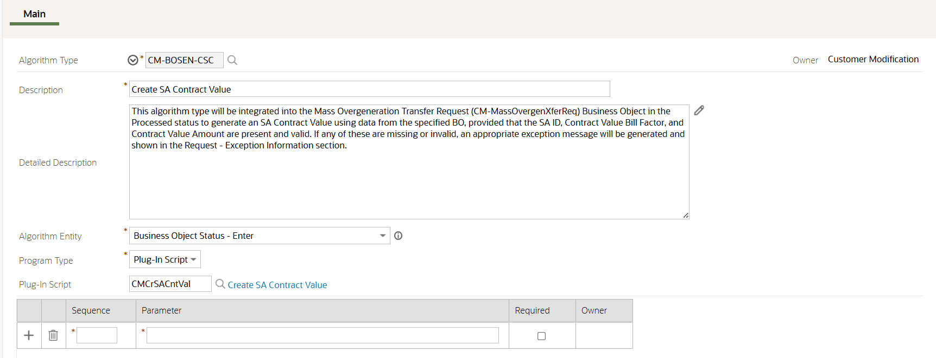

### Application Service

#### CM-MOXFRREQTYPBO

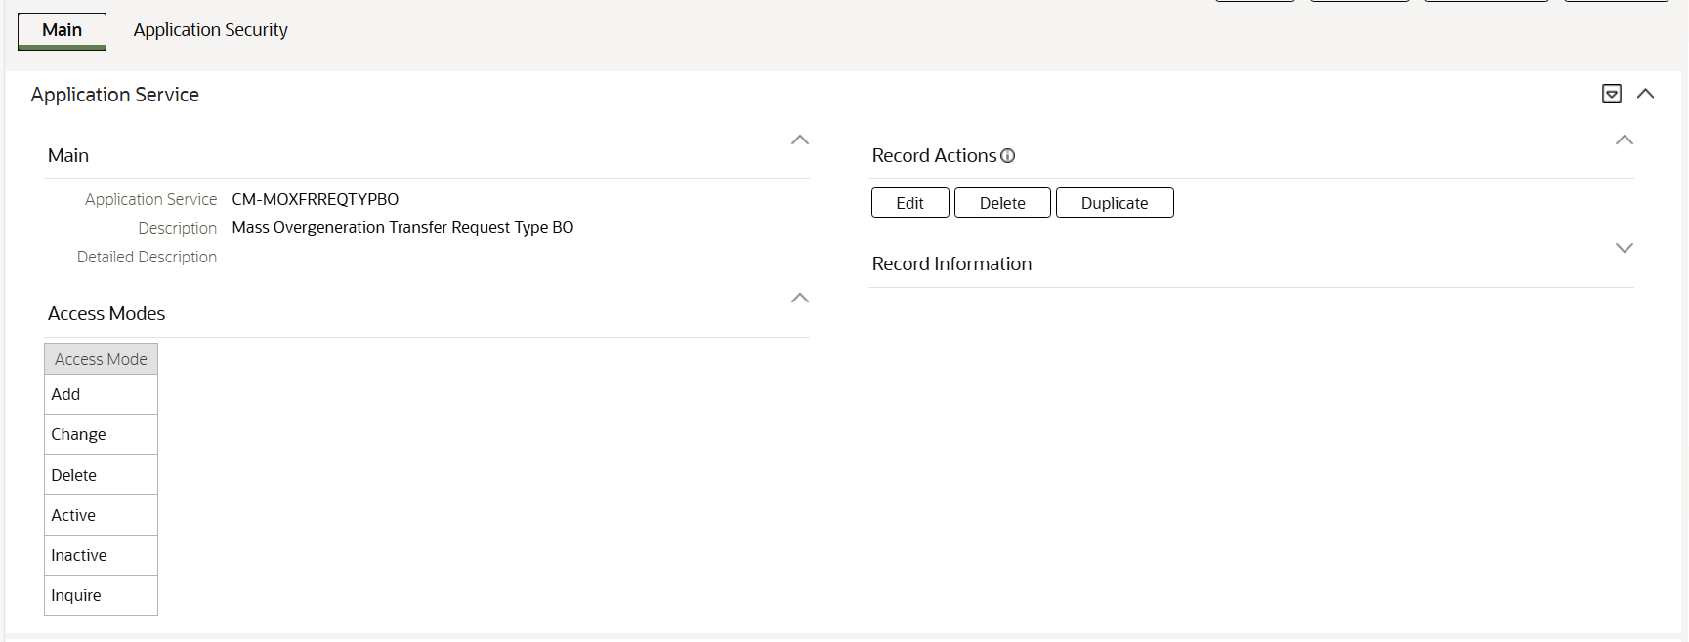

#### CM-MOXFRREQBO

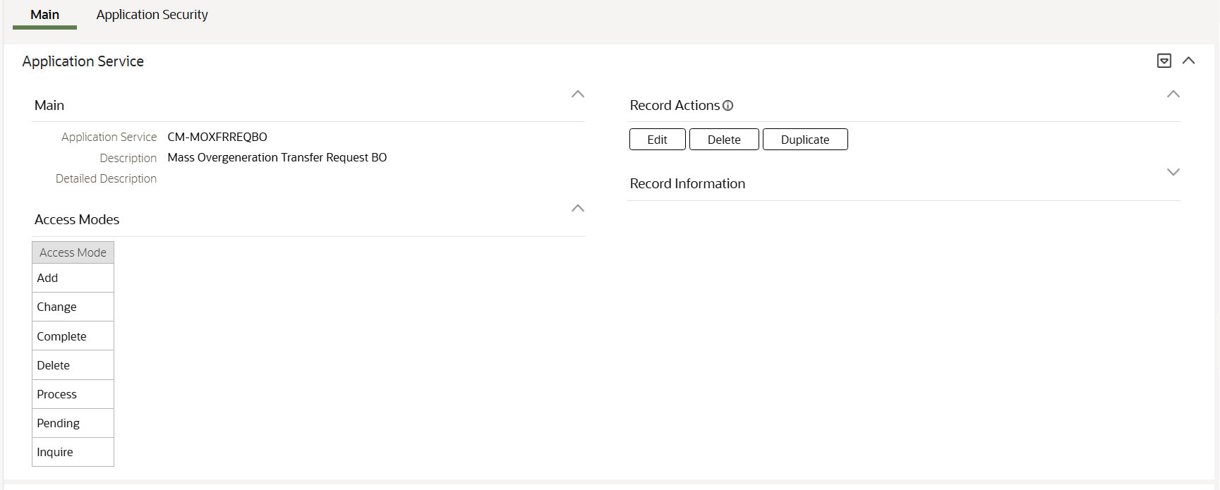

### Business Object

#### CM-MassOvergenXferReqType

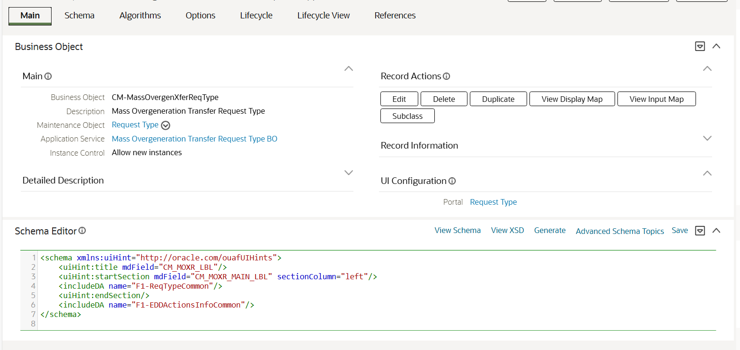

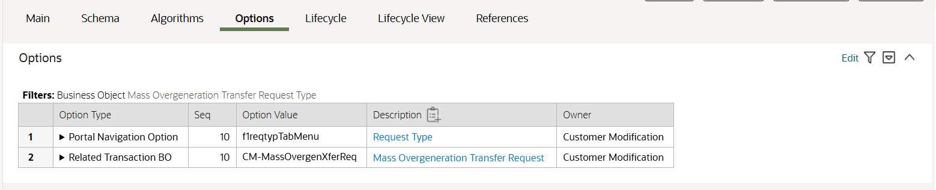

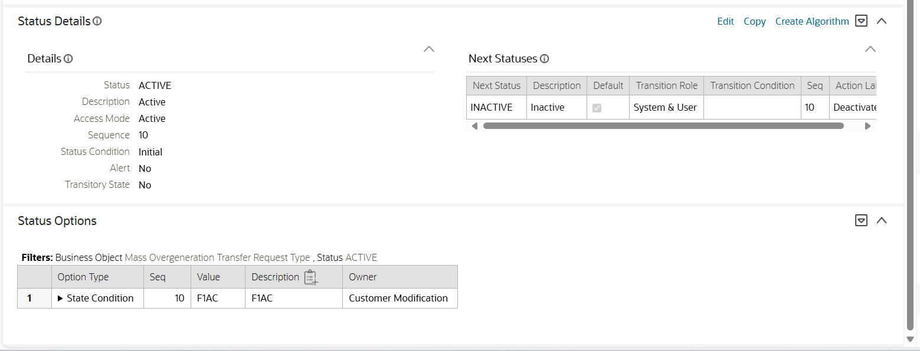

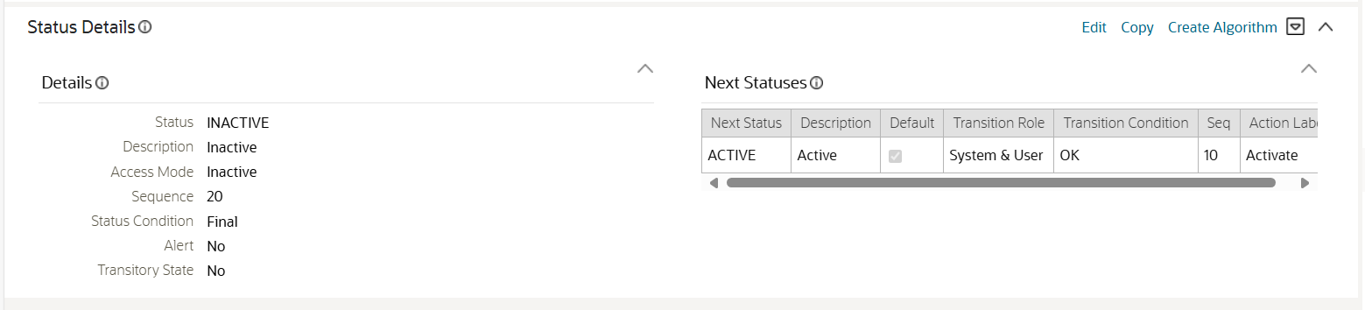

#### CM-MassOvergenXferReq

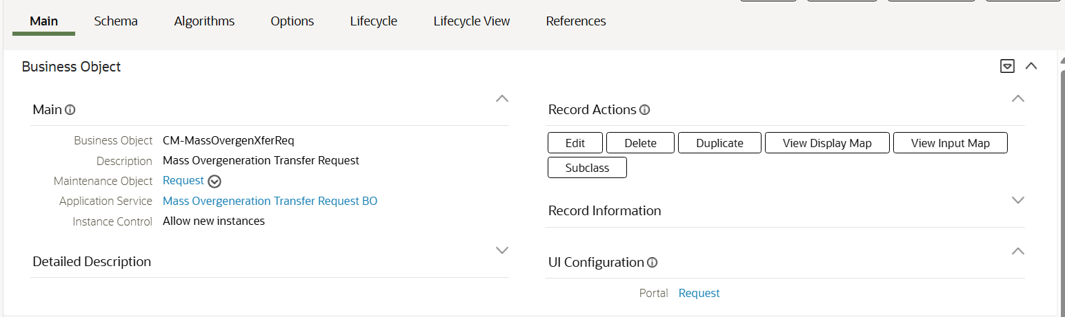

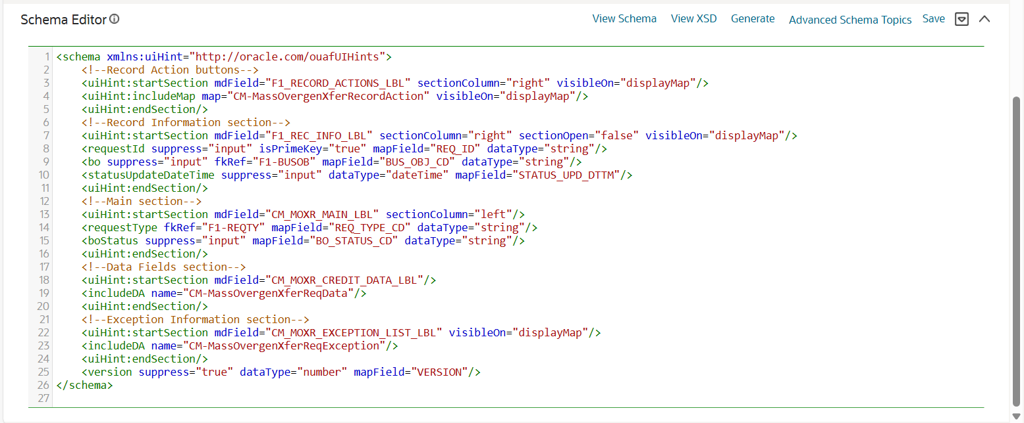

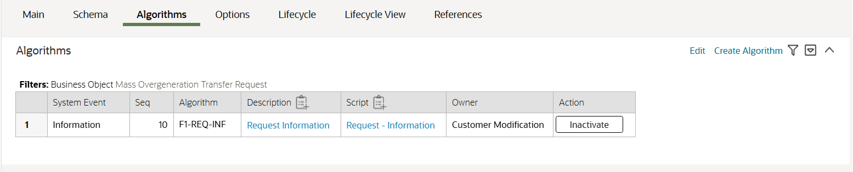

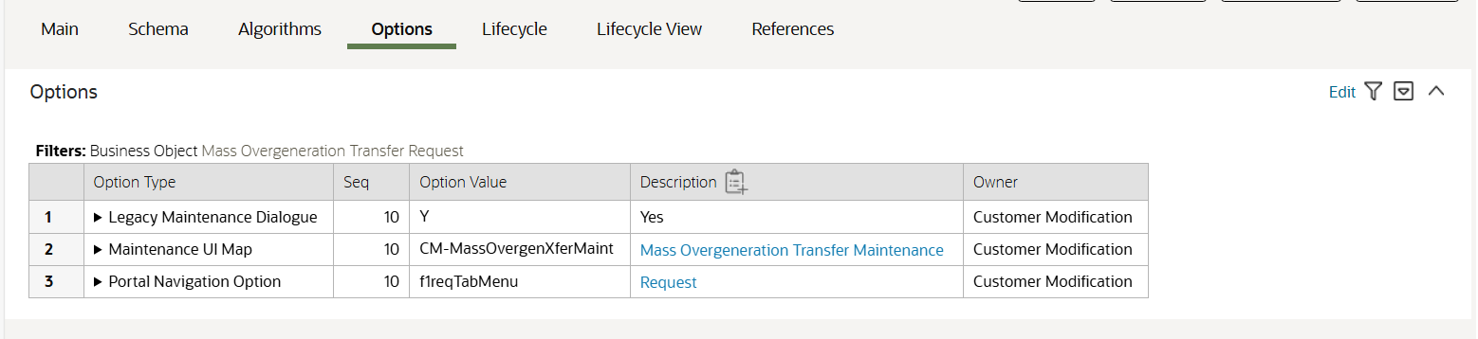

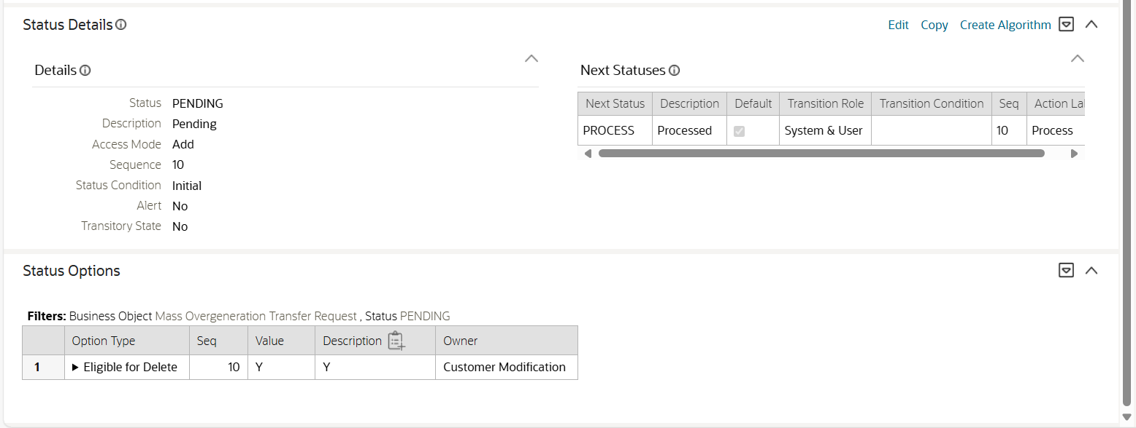

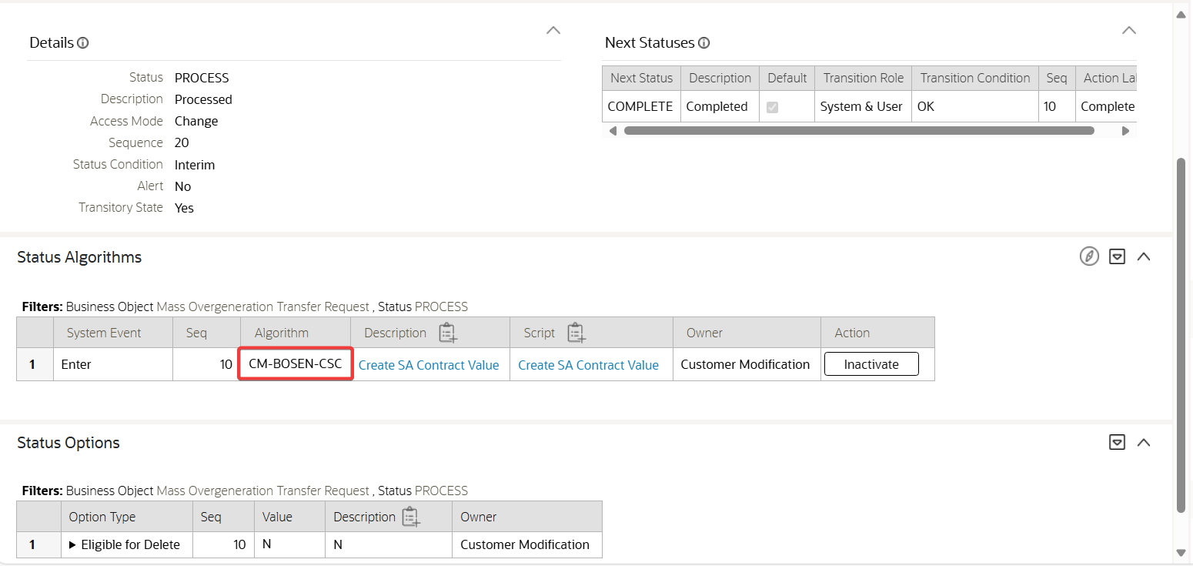

### Data Area

#### CM-MassOvergenXferReqData

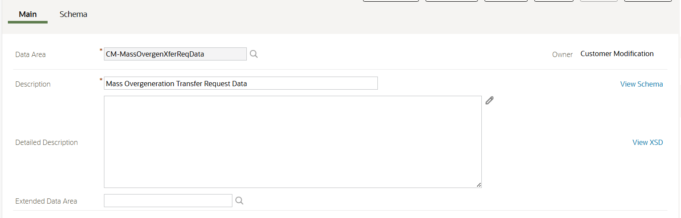

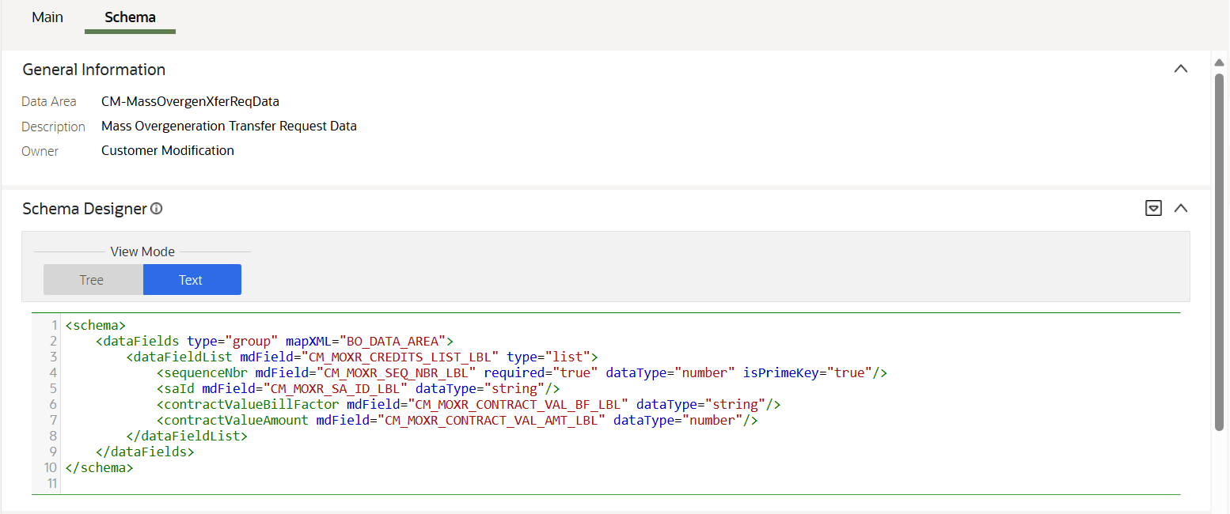

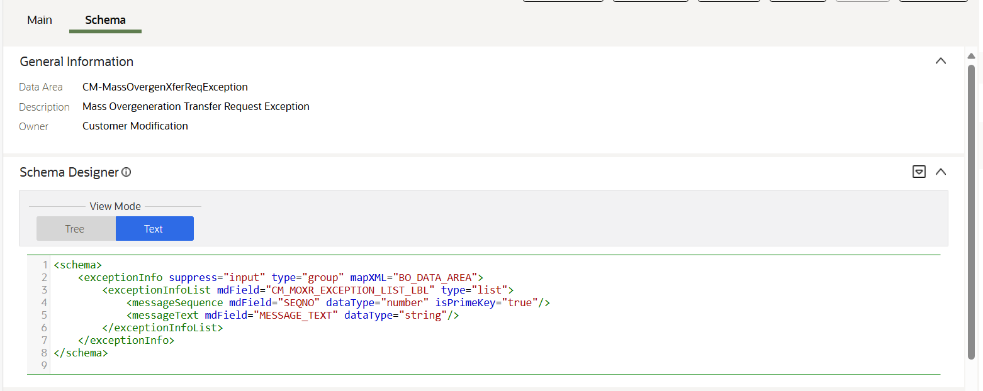

#### CM-MassOvergenXferReqException

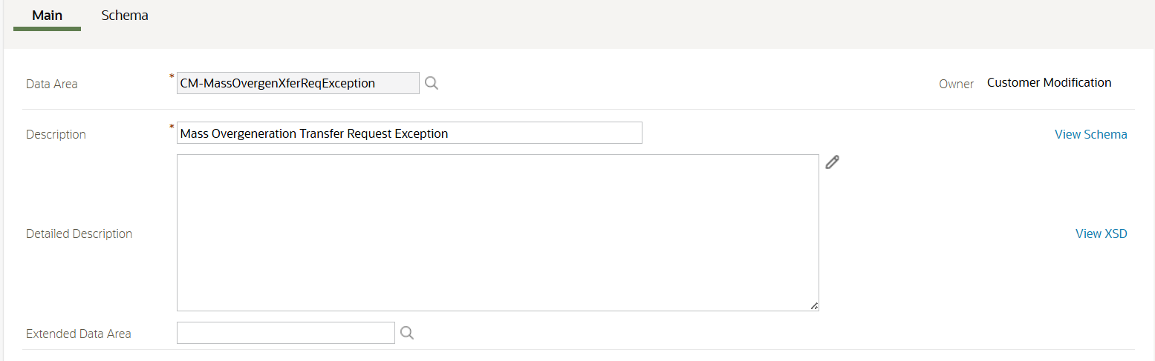

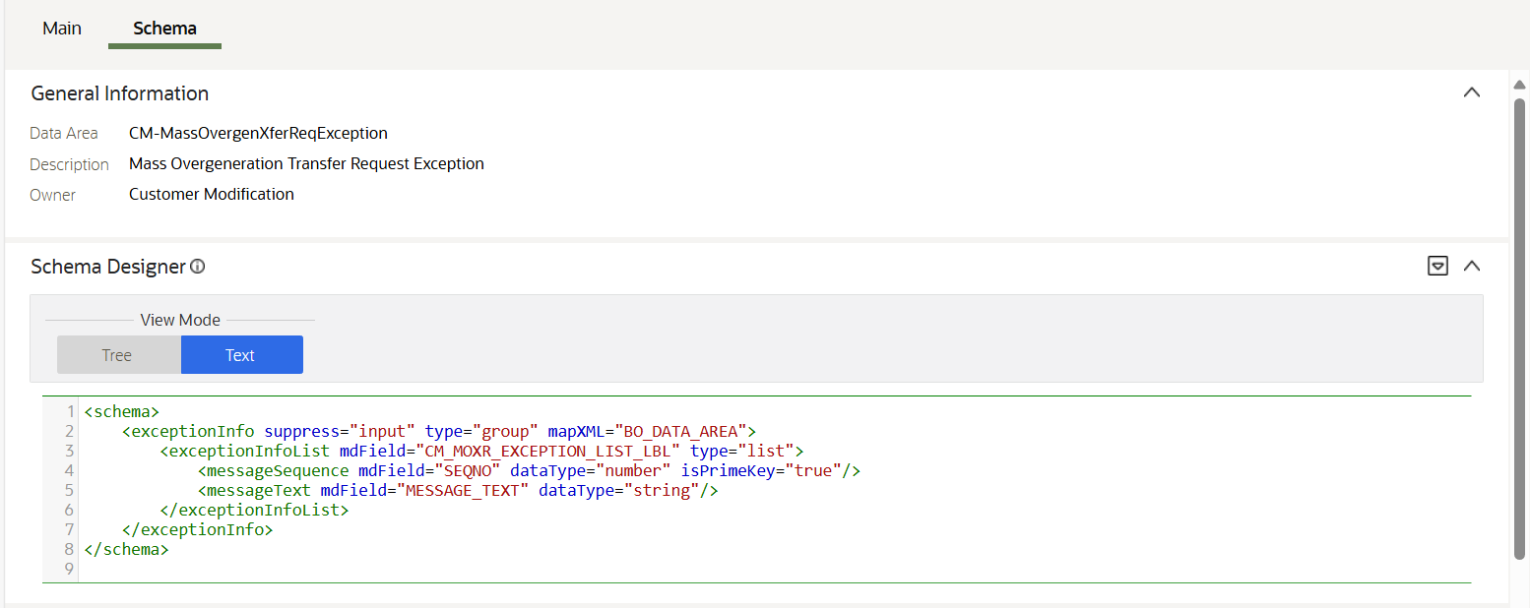

### Field

#### CM_MOXR_CONTRACT_VAL_BF_LBL

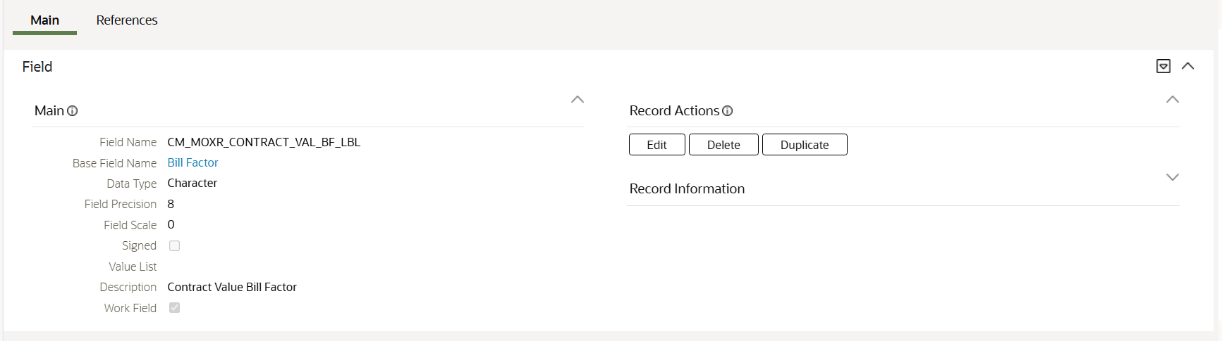

#### CM_MOXR_CONTRACT_VAL_AMT_LBL

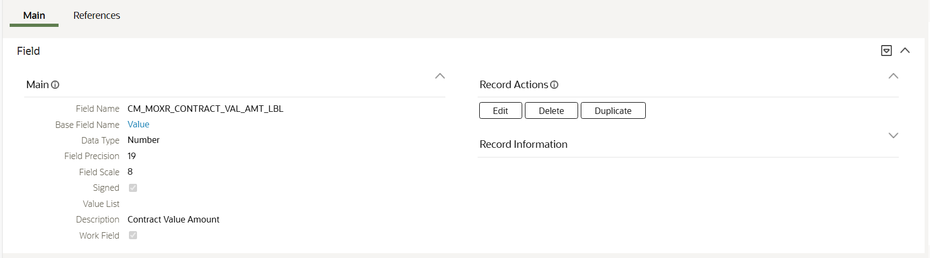

#### CM_MOXR_CREDIT_DATA_LBL

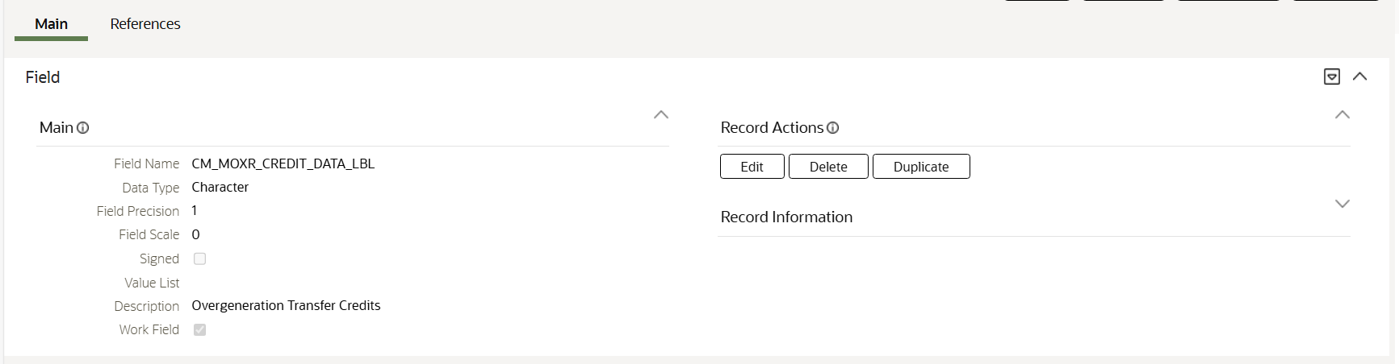

#### CM_MOXR_EXCEPTION_LIST_LBL

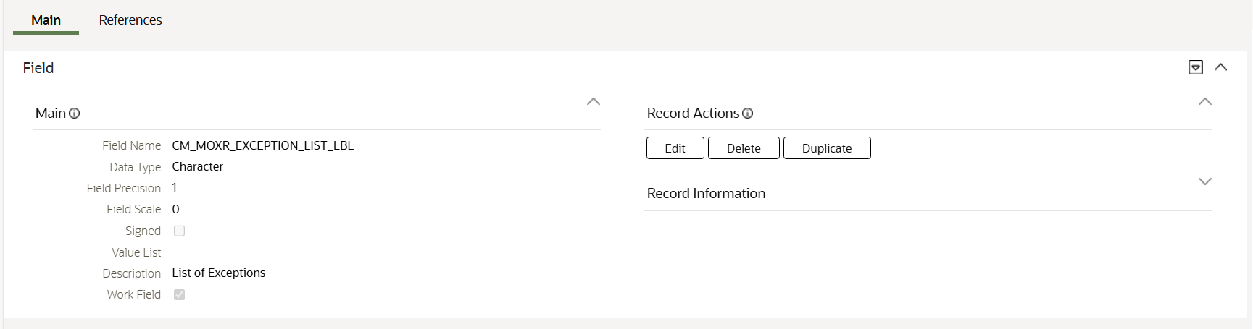

#### CM_MOXR_LBL

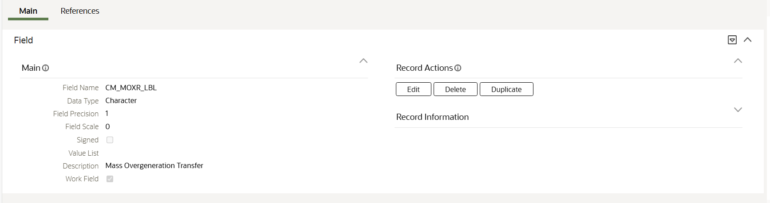

#### CM_MOXR_MAIN_LBL

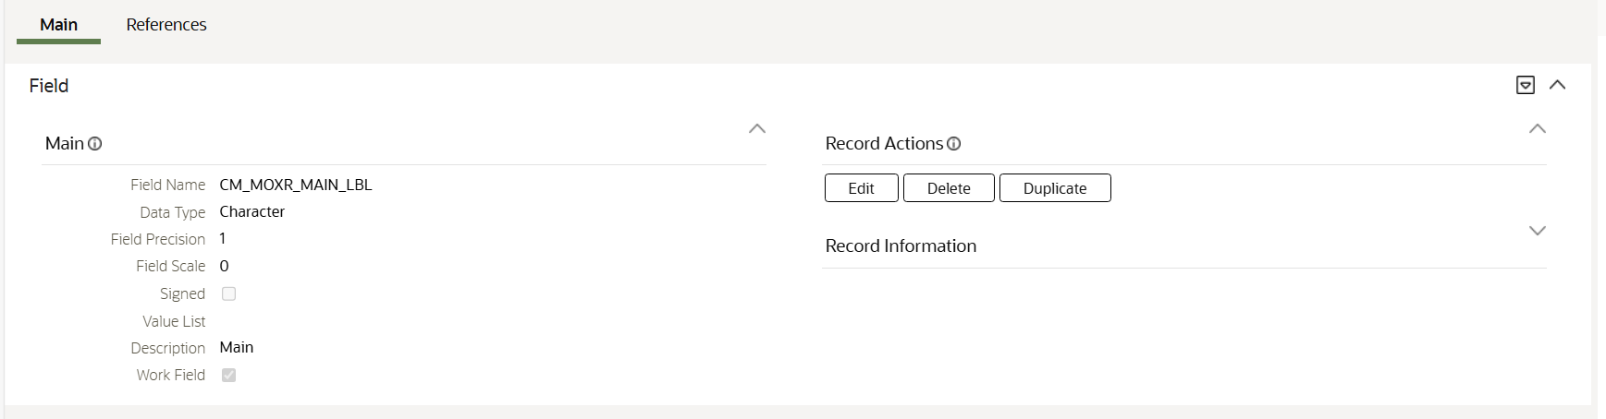

#### CM_MOXR_SA_ID_LBL

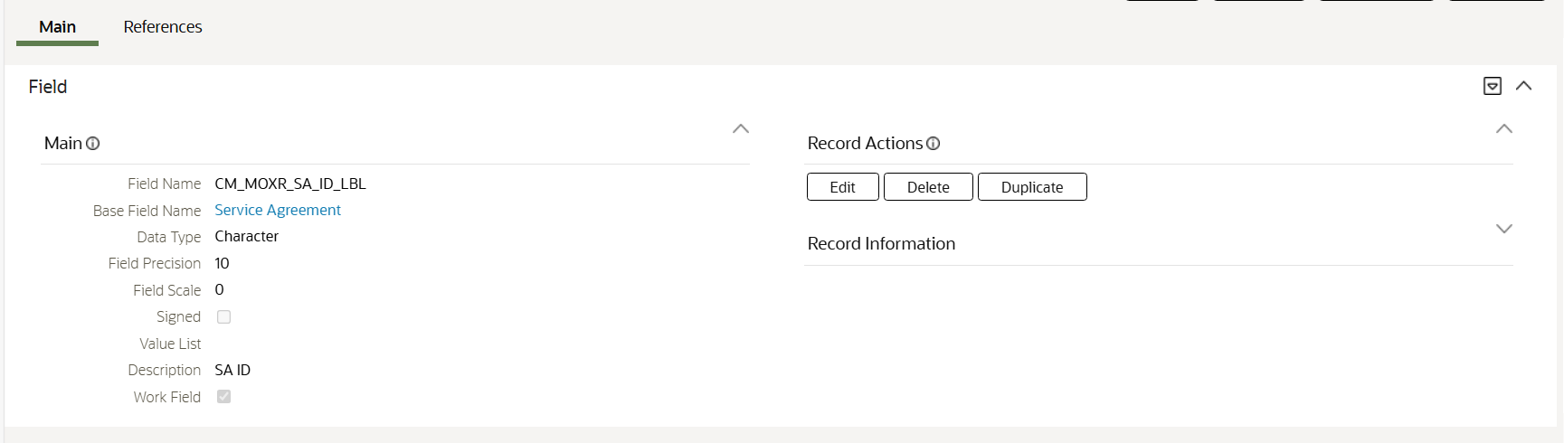

#### CM_MOXR_SEQ_NBR_LBL

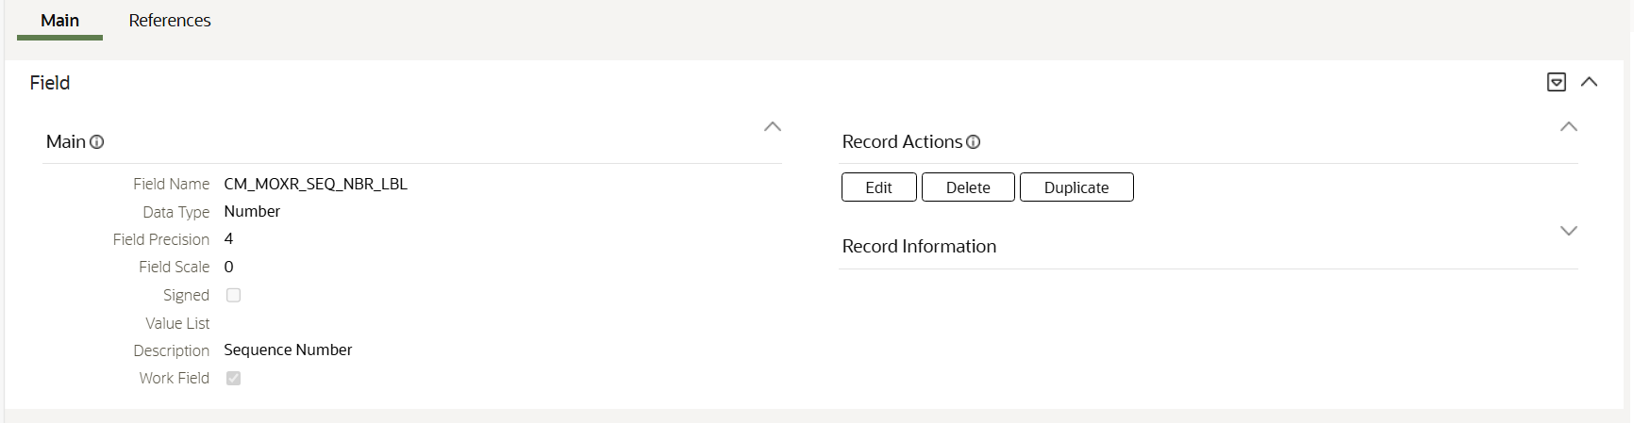

#### CM_MOXR_CREDITS_LIST_LBL

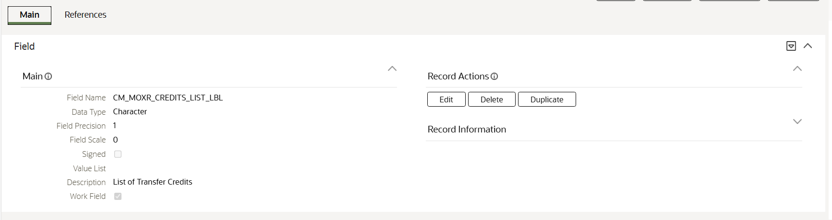

### Message

#### 90003 / 12601-12606

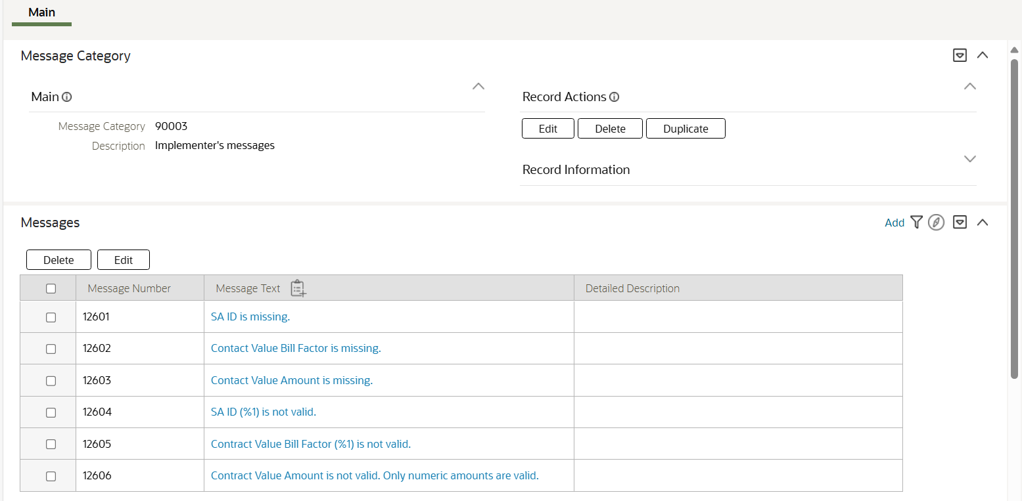

### Request Type

#### MASSOGENXFER

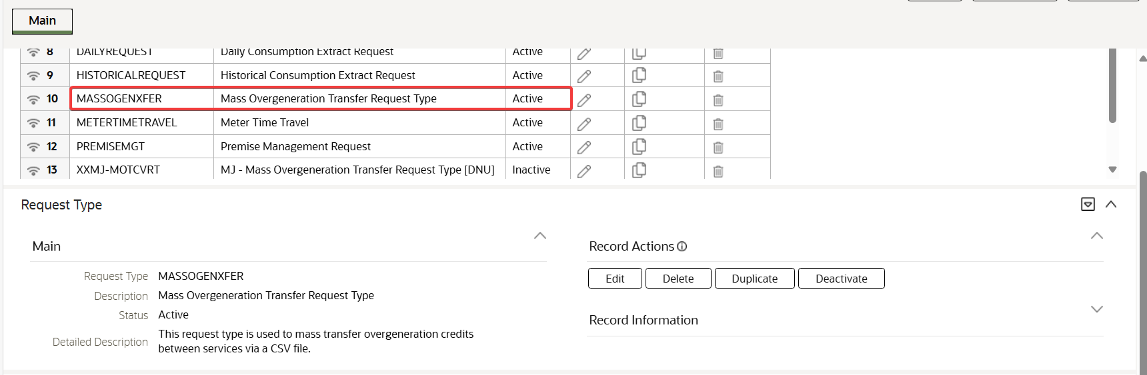

### Script

#### CMCrSACntVal

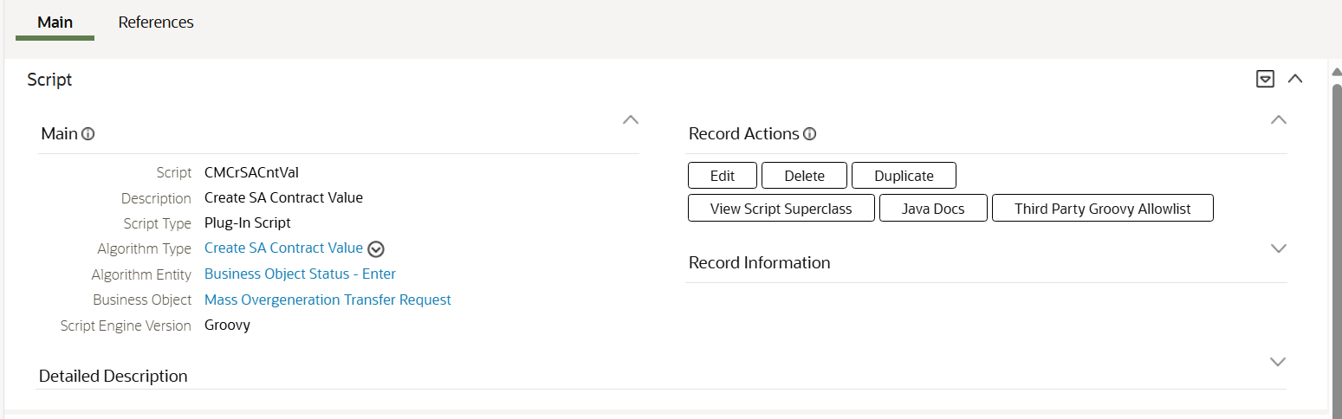

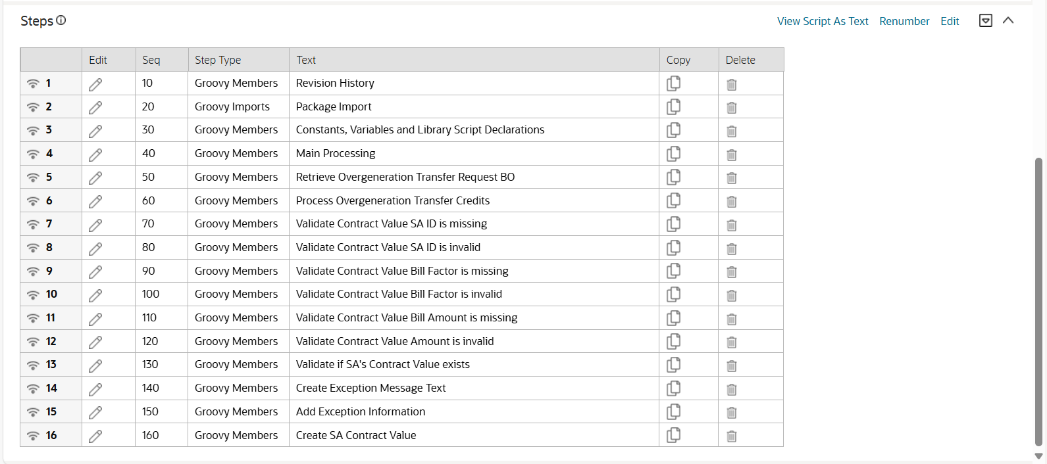



### UI Map

#### CM-MassOvergenXferRecordAction

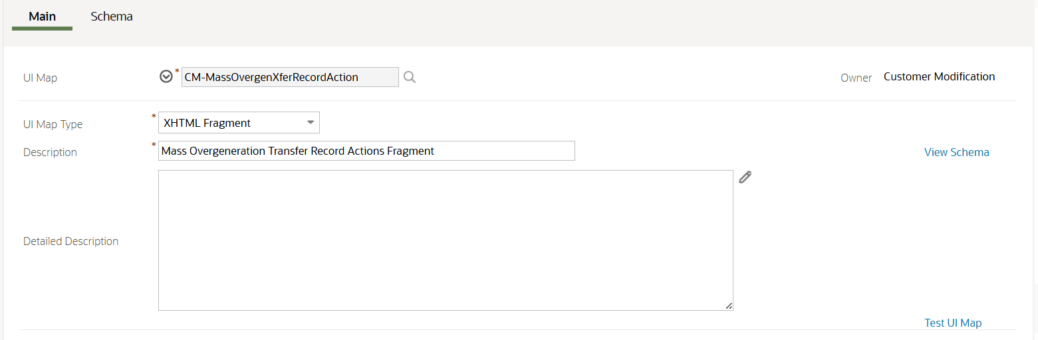

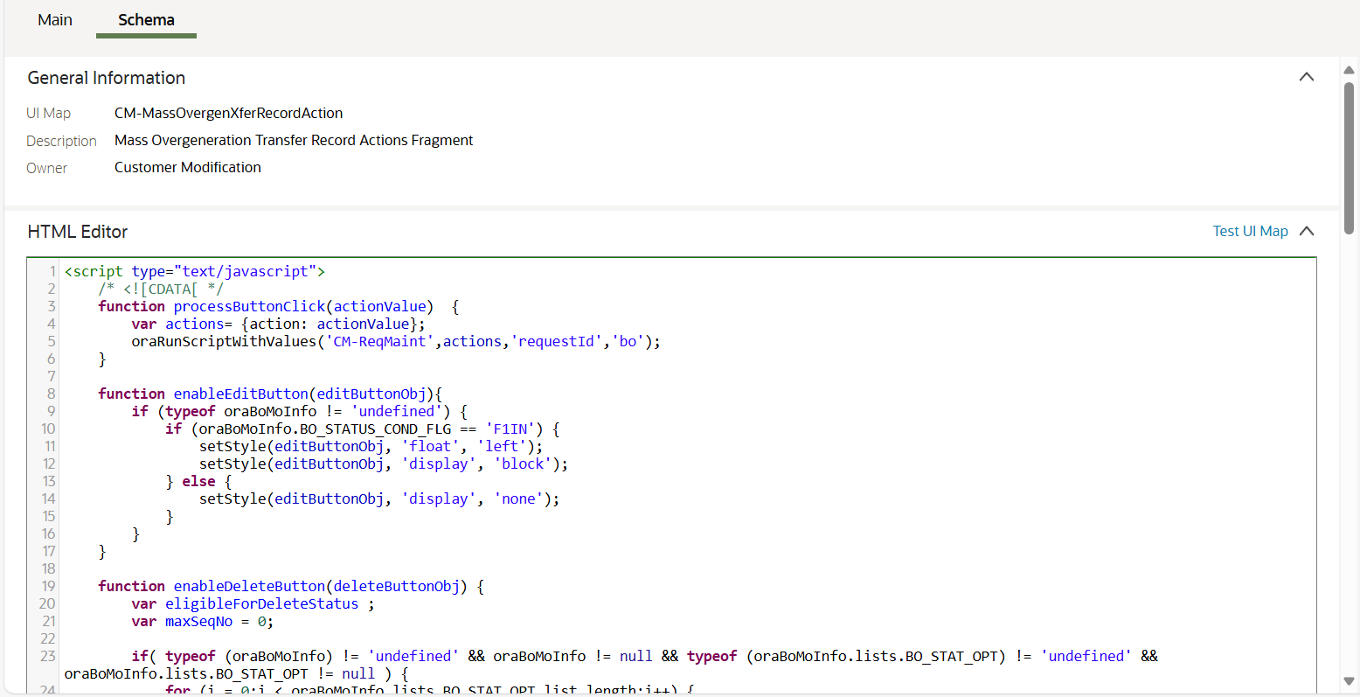



#### CM-MassOvergenXferMaint

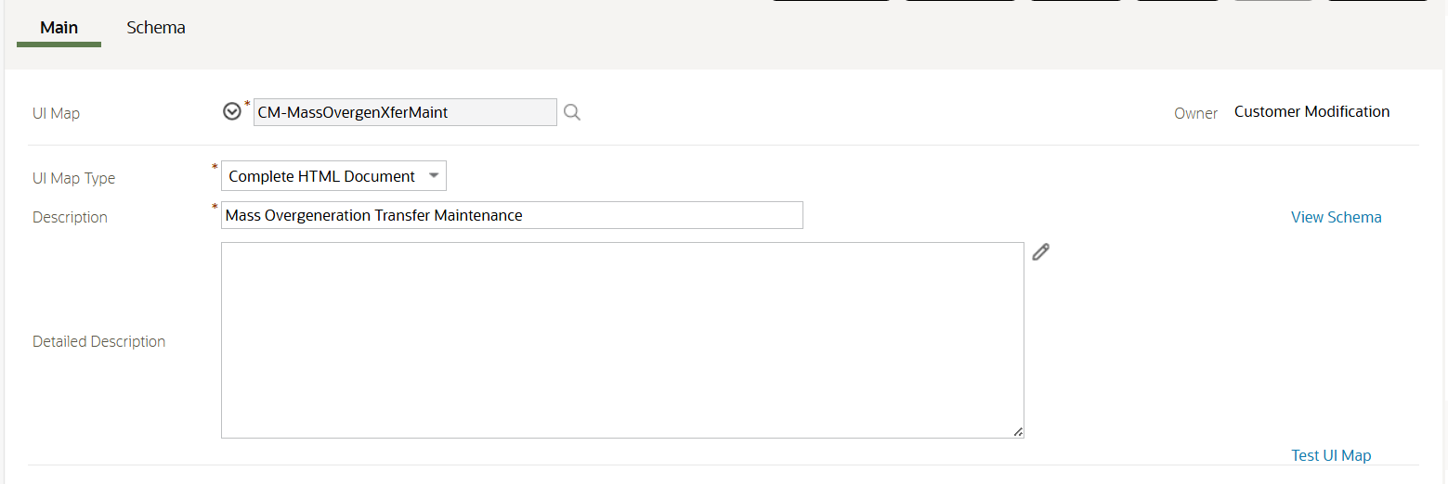

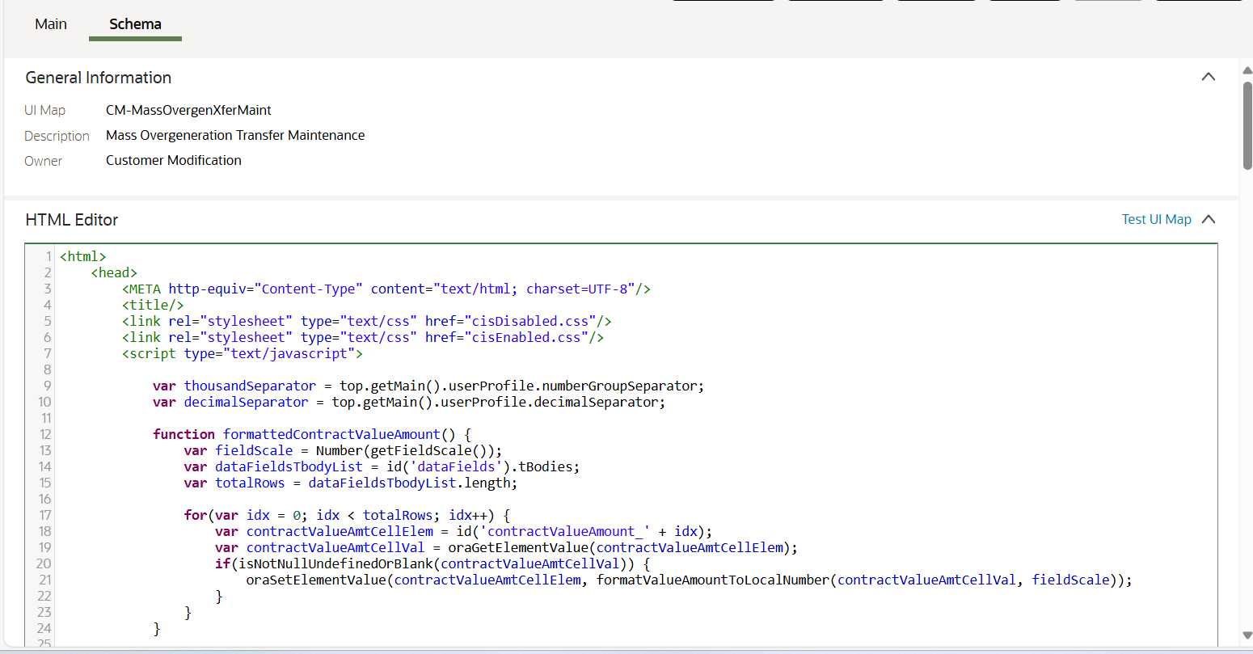



## System Changes for Client Configuration

### Algorithm

#### CM-BOSEN-CSC

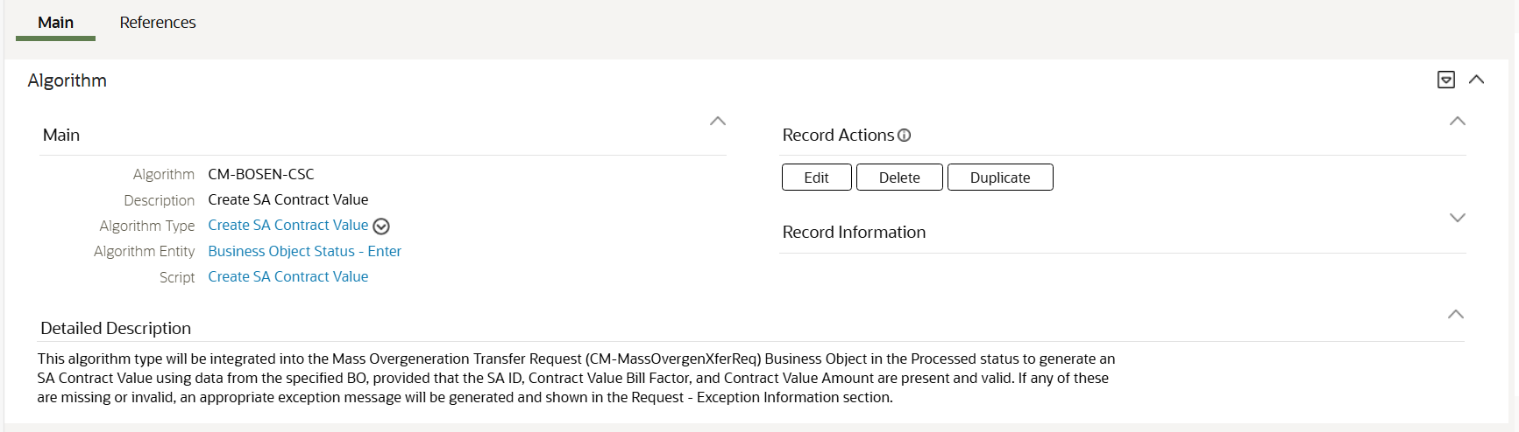

### Bill Factor

#### JA-KWHBF

**Technical Note: This configuration is created for testing purposes only.**

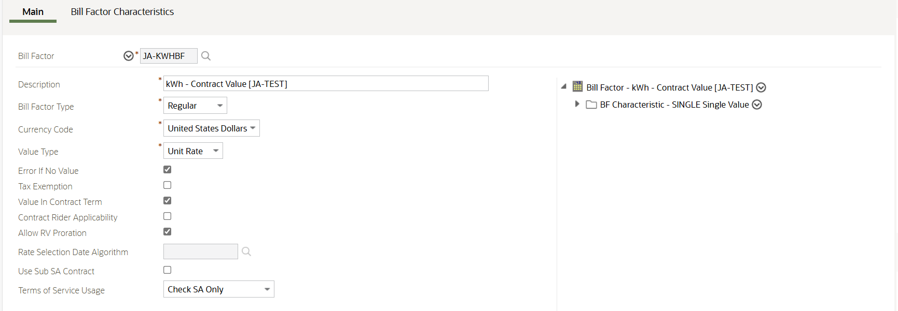

#### JA-DLRBF

**Technical Note: This configuration is created for testing purposes only.**

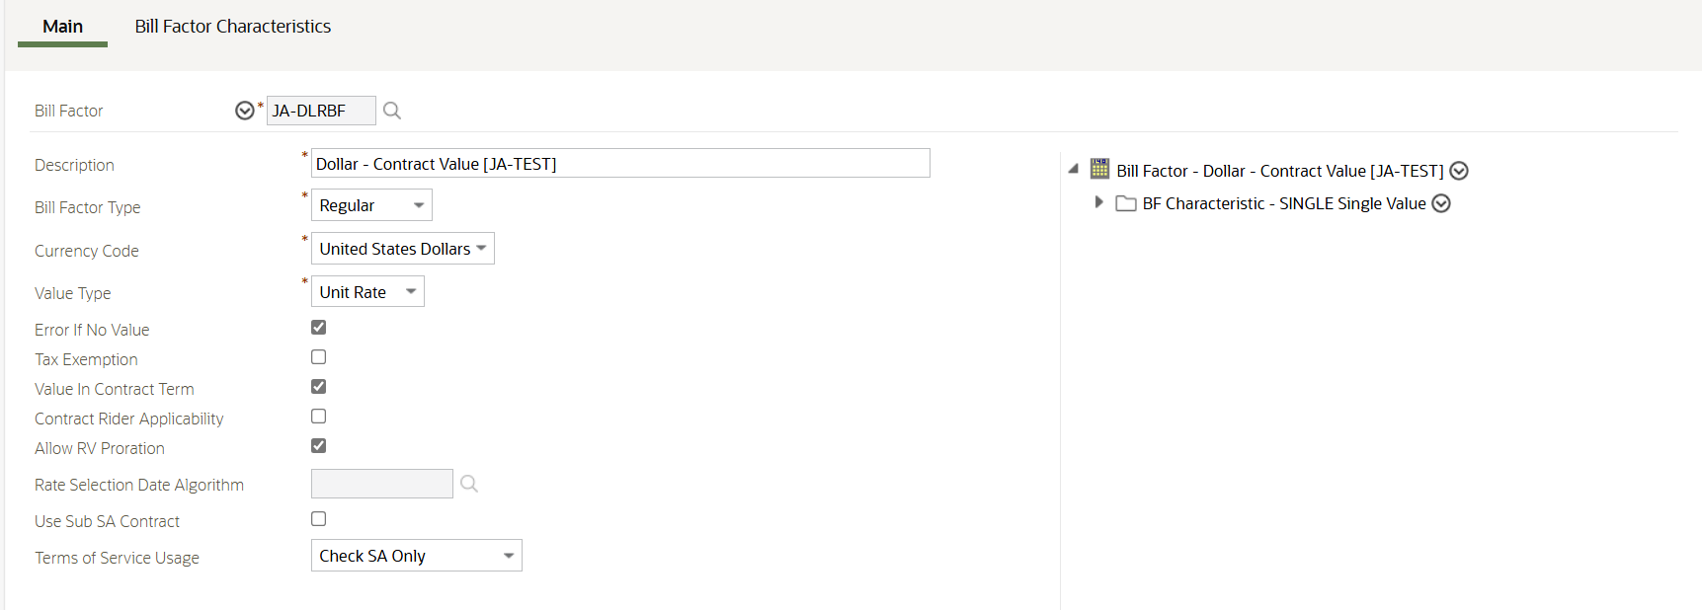

# Test Conditions and Results

|  |  |  |  |
| --- | --- | --- | --- |
| **Seq.** | **Test Scenario** | **Expected Results** | **Passed?** |
| 1 | Go to Admin Menu > R > Request Type > Add. Select the Mass Overgeneration Transfer Request Type. | The Mass Overgeneration Transfer page is shown with the following input details:   * Request Type, Description, and Detailed Description   Save and Cancel buttons | Y |
| 2 | In the Mass Overgeneration Transfer page, populate all the fields correctly. Click Cancel button. | The page is closed. | Y |
| 3 | In the Mass Overgeneration Transfer page, populate all the fields correctly. Click Save button. | The Mass Overgeneration Transfer is created with all the provided details in Active status ang log entry. Navigated to the Request Type page.  UI details:   * Main section (right side)   + Request Type – request type description   + Description   + Status – status description   + Detailed Description * Records Actions section (left side)   + Edit, Delete, Duplicate, and Deactivate buttons * Record Information (left side)   + Business Object   + Owner   Request Type Log zone | Y |
| 4 | In the Request Type page, click Edit button for the active Mass Overgeneration Transfer Request Type. | The Mass Overgeneration Transfer page is shown with the existing contents. | Y |
| 5 | In the Request Type page, update the existing active Mass Overgeneration Transfer Request Type and click Save button. | The Mass Overgeneration Transfer Request Type is updated. The details are loaded in the Request page. | Y |
| 6 | In the Request Type page, click Duplicate button for existing active Mass Overgeneration Transfer Request Type. | The Mass Overgeneration Transfer page is shown with duplicated details, but Request Type is blank. | Y |
| 7 | In the Request Type page, duplicate the existing Mass Overgeneration Transfer Request Type and click Save button. | The Mass Overgeneration Transfer Request Type is duplicated. The details are loaded in the Request page. | Y |
| 8 | In the Request Type page, click Delete button for the Mass Overgeneration Transfer Request Type. | The Confirmation Delete pop-up window is shown. | Y |
| 9 | In the Confirmation Delete pop-up window, click Cancel button. | The pop-up is closed. | Y |
| 10 | In the Confirmation Delete pop-up window, click OK button. | The request type is deleted and navigated to the Request Type Query page. | Y |
| 11 | In the Request Type page, click Deactivate button for the Mass Overgeneration Transfer Request Type. | The request type is successfully transitioned to Inactive status. | Y |
| 12 | Go to Main Menu > Tools > Request > Add.  Select the Mass Overgeneration Transfer Request Type. | The Mass Overgeneration Transfer Maintenance page is shown with the following sections:   * Main section   + Request Type – description of the selected request type   + Status – description of request type’s status * Overgeneration Transfer Credits   + An empty input table with Add button, Delete button, Sequence, SA ID, Contract Value Bill Factor and Contract Value Amount   + A CSV File To Upload button   Save and Cancel buttons | Y |
| 13 | In the Mass Overgeneration Transfer Request Maintenance page, click Cancel button. | The Mass Overgeneration Transfer Maintenance page is closed. | Y |
| 14 | In the Mass Overgeneration Transfer Request Maintenance page, click the CSV File to Upload button. | The File Upload pop-up window is shown. | Y |
| 15 | In the File Upload pop-up window, click the Submit button | An appropriate error message is shown to specify a file. | Y |
| 16 | In the File Upload pop-up window, click the Choose File button. | The Windows Explorer window is shown to select a file. | Y |
| 17 | In the File Upload pop-up window, click the Choose File button and select a file that is not in CSV format. | An appropriate error message is shown stating that the file has invalid file type. | Y |
| 18 | In the File Upload pop-up window, click the Choose File button, select a file and click Submit button. | The File Upload popup page is closed.  The contents of the file is loaded on Overgeneration Transfer Credits table. | Y |
| 19 | In the Mass Overgeneration Transfer Request Maintenance page, file contents are loaded in the table. Select and submit another CSV file. | The File Upload popup page is closed.  The previous contents are cleared, and the contents of the current file is loaded on Overgeneration Transfer Credits table. | Y |
| 20 | In the Mass Overgeneration Transfer Maintenance page, file contents are loaded in the table. Click the Delete button. | The row is deleted in the table. | Y |
| 21 | In the Mass Overgeneration Transfer Maintenance page, file contents are loaded in the table. Click the Add button. | The row is added in the table. | Y |
| 22 | In the Mass Overgeneration Transfer Maintenance page, file contents are loaded in the table without the SA ID and click Save button. | The Mass Overgeneration Transfer Maintenance page is closed and navigated to the Request page with Pending request. | Y |
| 23 | In the Mass Overgeneration Transfer Maintenance page, file contents are loaded in the table without Contract Value Bill Factor and click Save button. | The Mass Overgeneration Transfer Maintenance page is closed and navigated to the Request page with Pending request. | Y |
| 24 | In the Mass Overgeneration Transfer Maintenance page, file contents are loaded in the table without the Contract Value Amount and click Save button. | The Mass Overgeneration Transfer Maintenance page is closed and navigated to the Request page with Pending request. | Y |
| 25 | In the Mass Overgeneration Transfer Maintenance page, file contents are loaded in the table. Provide invalid Contract Value Amount and click Save button. | An appropriate error message is raised stating invalid Contract Value Amount. | Y |
| 26 | In the Mass Overgeneration Transfer Maintenance page, file contents are loaded in the table. Click the Save button. | The Mass Overgeneration Transfer Maintenance page is closed and navigated to the Request page with the following sections:   * Main section (left side)   + Request Type – description of the selected request type   + Status – description of the request’s status * Record Actions section (right side)   + Edit, Delete, Process buttons * Record Information section (collapse by default in the right side)   + Request ID   + Business Object   + Status Date/Time * Overgeneration Transfer Credits section (full section)   + List of Transfer Credits table     - Sequence Number, SA ID, Contract Value Bill Factor and Contract Value Amount * Exception Information section   + List of Exceptions table     - Sequence and Message Text * Request Log zone   Request created is in Pending status. | Y |
| 27 | In the Request page, click Edit button for the pending Mass Overgeneration Transfer Request. | The Mass Overgeneration Transfer Maintenance page is shown with the existing contents. | Y |
| 28 | In the Request page, update the existing Mass Overgeneration Transfer Request and click Save button. | The Mass Overgeneration Transfer request is updated. | Y |
| 29 | In the Request page, click Delete button for the pending Mass Overgeneration Transfer Request. | The Confirmation Delete pop-up window is shown. | Y |
| 30 | In the Confirmation Delete pop-up window, click Cancel button. | The pop-up is closed. | Y |
| 31 | In the Confirmation Delete pop-up window, click OK button. | The request is deleted and navigated to the Request Query page. | Y |
| 32 | In the Request page, click Process button for the pending Mass Overgeneration Transfer Request with all fields correctly populated. | Request processed successfully and transitioned to Completed status.  Overgeneration SA has the credits successfully transferred to the specified SAs. Contract values reflect the system date as date of transfer and transfer amount accurately. | Y |
| 33 | In the Request page, click Process button for the pending Mass Overgeneration Transfer Request with missing SA ID. | Request processed successfully but with error message indicating SA ID is missing under Exception Information section.  Request is in Completed status. | Y |
| 34 | In the Request page, click Process button for the pending Mass Overgeneration Transfer Request with missing Contract Value Bill Factor. | Request processed successfully but with error message indicating Contract Value Bill Factor is missing under Exception Information section.  Request is in Completed status. | Y |
| 35 | In the Request page, click Process button for the pending Mass Overgeneration Transfer Request with missing Contract Value Amount. | Request processed successfully but with error message indicating Contract Value Amount is missing under Exception Information section.  Request is in Completed status. | Y |
| 36 | In the Request page, click Process button for the pending Mass Overgeneration Transfer Request with invalid SA ID. | Request processed successfully but with error message indicating SA ID is invalid under Exception Information section.  Request is in Completed status. | Y |
| 37 | In the Request page, click Process button for the pending Mass Overgeneration Transfer Request with invalid Contract Value Bill Factor. | Request processed successfully but with error message indicating Contract Value Bill Factor is not valid under Exception Information section.  Request is in Completed status. | Y |
| 38 | In the Request page, click Process button for the pending Mass Overgeneration Transfer Request with invalid Contract Value Amount. | Request processed successfully but with error message indicating Contract Value Amount is invalid number under Exception Information section.  Request is in Completed status. | Y |
| 39 | In the Request page, click Process button for the pending Mass Overgeneration Transfer Request with SA that has existing Contract Value with the same Bill Factor and Start Date. | Request processed successfully but with error message indicating duplicate Contract Value under Exception Information section.  Request is in Completed status. | Y |
| 40 | In the Request page, click Process button for the pending Mass Overgeneration Transfer Request with SA that has existing Contract Value with the same Bill Factor, Start Date and End Date. | Request processed successfully but with error message indicating duplicate Contract Value under Exception Information section.  Request is in Completed status. | Y |
| 41 | In the Mass Overgeneration Request BO – Processed status, update the Transitory State to No and clear the Transition Condition. In the Request page, click Process button for the pending Mass Overgeneration Transfer Request. Verify that the Complete button is available only within the Record Actions section. | Request processed successfully and transitioned to Processed status.    In the Record Actions section, only the Complete button is available. | Y |

## Go to Admin Menu > R > Request Type > Add. Select the Mass Overgeneration Transfer Request Type.

Test Condition:

* Go to Admin Menu > R > Request Type > Add. Select the Mass Overgeneration Transfer Request Type.

Expected Results:

* The Mass Overgeneration Transfer page is shown with the following input details:
  + Request Type, Description, and Detailed Description
  + Save and Cancel

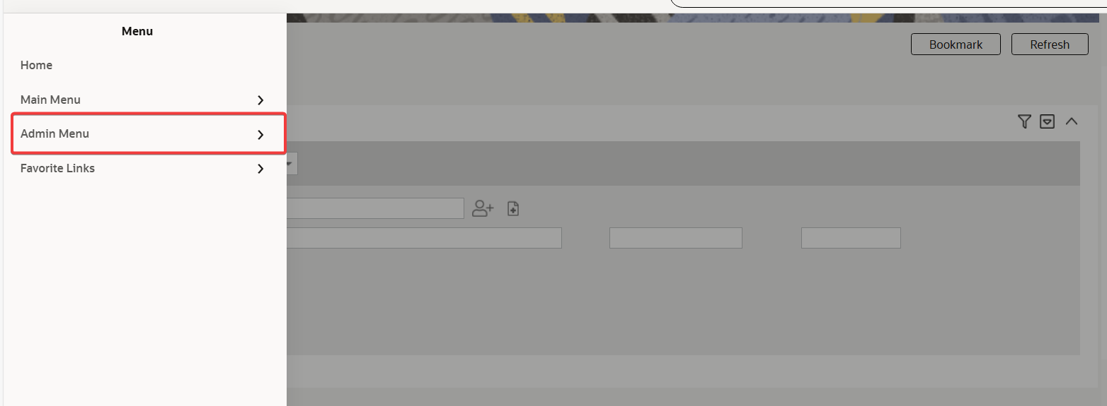

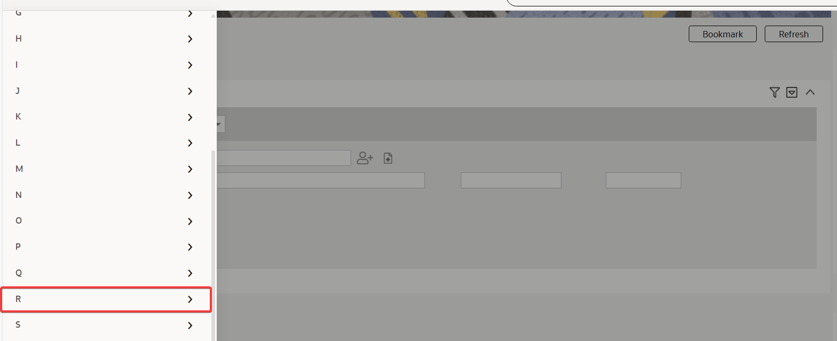

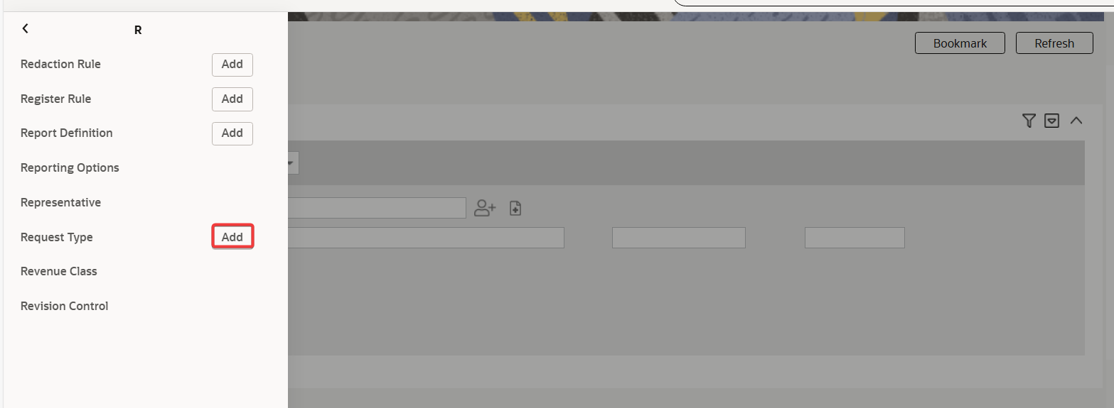

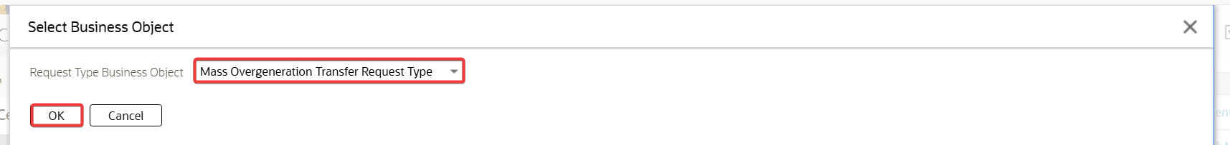

Go to Admin Menu > R > Request Type > Add. Select the Mass Overgeneration Transfer Request Type.

Test Results:

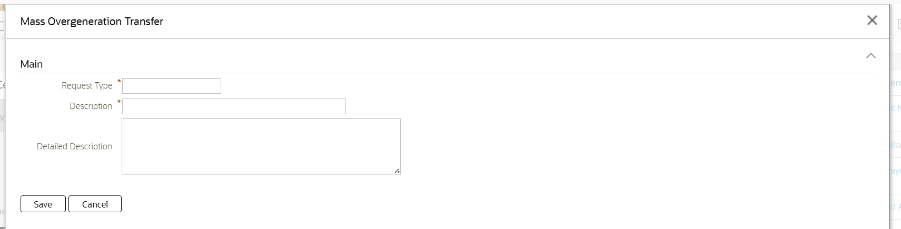

The Mass Overgeneration Transfer page is shown with the following input details:

* Request Type, Description, and Detailed Description
* Save and Cancel

## In the Mass Overgeneration Transfer page, populate all the fields correctly. Click Cancel button.

Test Condition:

* In the Mass Overgeneration Transfer page, populate all the fields correctly. Click Cancel button.

Expected Results:

* The page is closed.

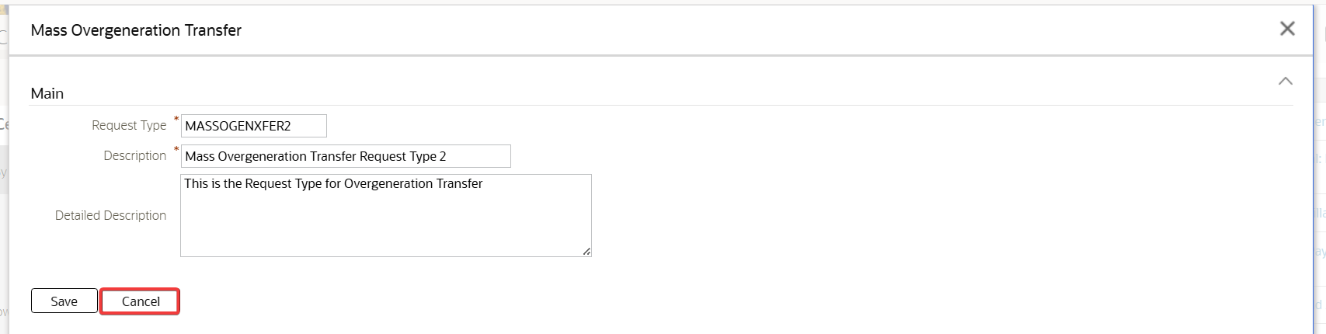

In the Mass Overgeneration Transfer page, populate all the fields correctly. Click Cancel button.

Test Results:

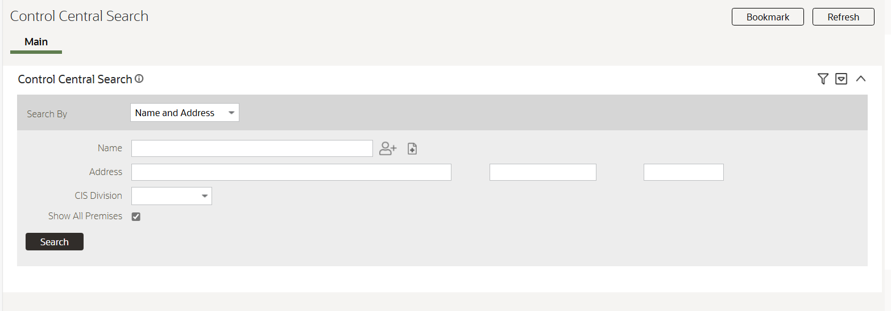

The page is closed.

## In the Mass Overgeneration Transfer page, populate all the fields correctly. Click Save button.

Test Condition:

* In the Mass Overgeneration Transfer page, populate all the fields correctly. Click Save button.

Expected Results:

* The Mass Overgeneration Transfer is created with all the provided details in Active status ang log entry. Navigated to the Request Type page.
* UI details:
  + Main section (right side)
    - Request Type – request type description
    - Description
    - Status – status description
    - Detailed Description
  + Records Actions section (left side)
    - Edit, Delete, Duplicate, and Deactivate buttons
  + Record Information (left side)
    - Business Object
    - Owner
  + Request Type Log zone

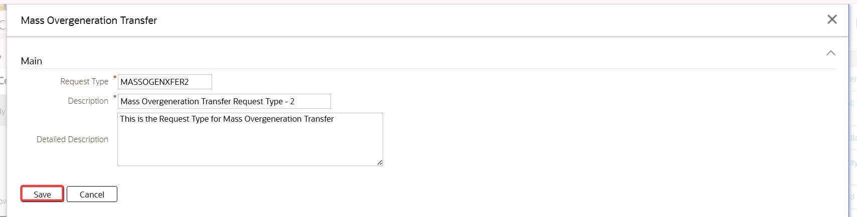

In the Mass Overgeneration Transfer page, populate all the fields correctly. Click Save button.

Test Results:

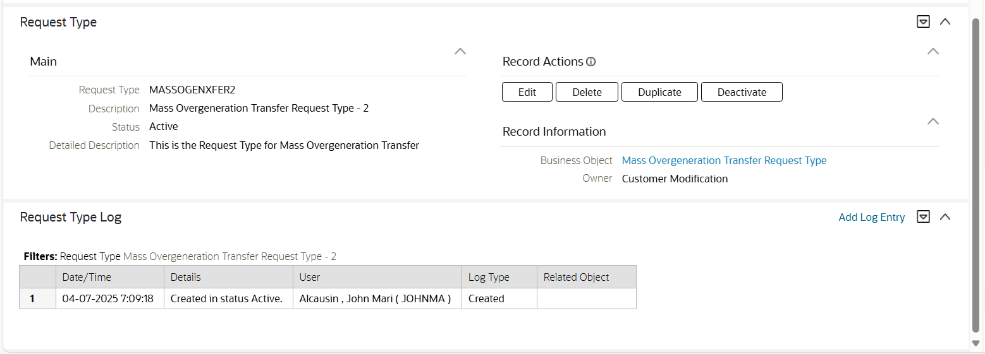

The Mass Overgeneration Transfer is created with all the provided details in Active status ang log entry. Navigated to the Request Type page.

UI details:

* Main section (right side)
  + Request Type – request type description
  + Description
  + Status – status description
  + Detailed Description
* Records Actions section (left side)
  + Edit, Delete, Duplicate, and Deactivate buttons
* Record Information (left side)
  + Business Object
  + Owner
* Request Type Log zone

## In the Request Type page, click Edit button for the active Mass Overgeneration Transfer Request Type.

Test Condition:

* In the Request Type page, click Edit button for the active Mass Overgeneration Transfer Request Type.

Expected Results:

* The Mass Overgeneration Transfer page is shown with the existing contents.

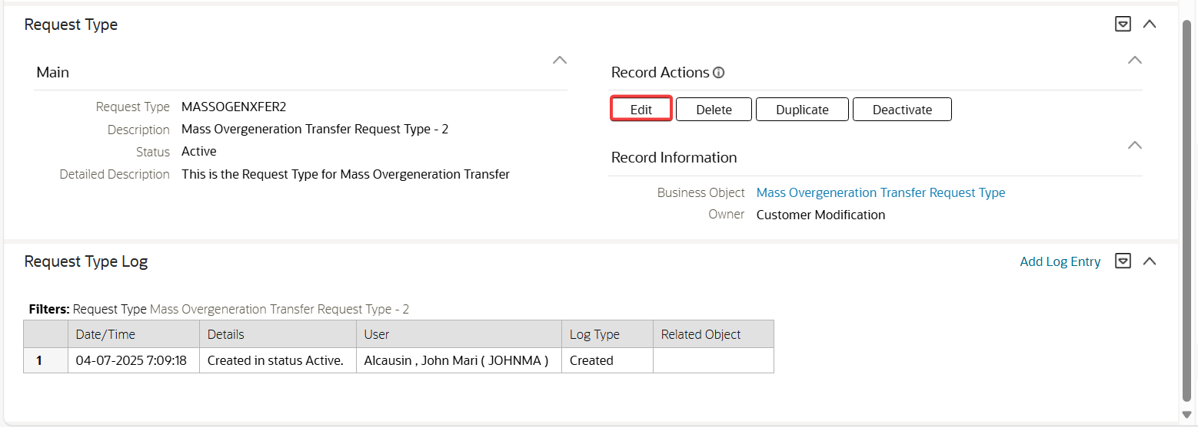

In the Request Type page, click Edit button for the active Mass Overgeneration Transfer Request Type.

Test Results:

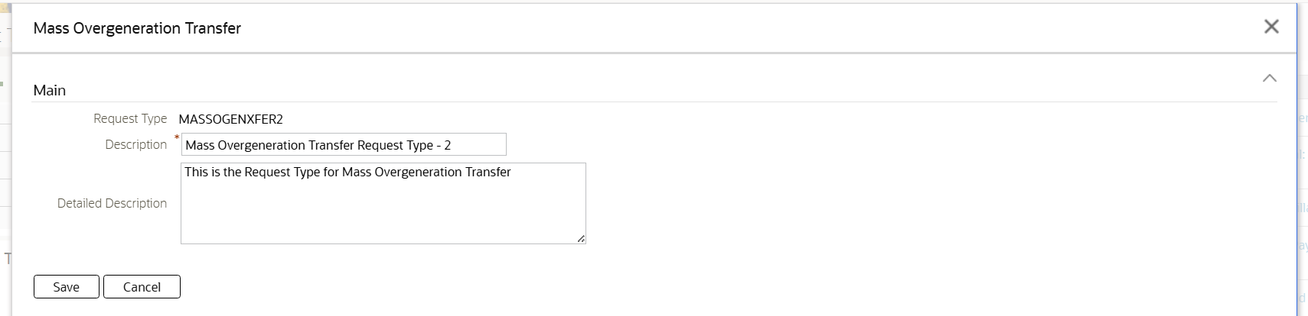

The Mass Overgeneration Transfer page is shown with the existing contents.

## In the Request Type page, update the existing active Mass Overgeneration Transfer Request Type and click Save button.

Test Condition:

* In the Request Type page, update the existing active Mass Overgeneration Transfer Request Type and click Save button.

Expected Results:

* The Mass Overgeneration Transfer Request Type is updated. The details are loaded in the Request page.



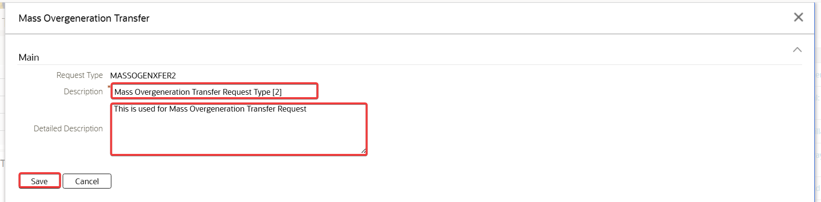

In the Request Type page, update the existing active Mass Overgeneration Transfer Request Type and click Save button.

Test Results:

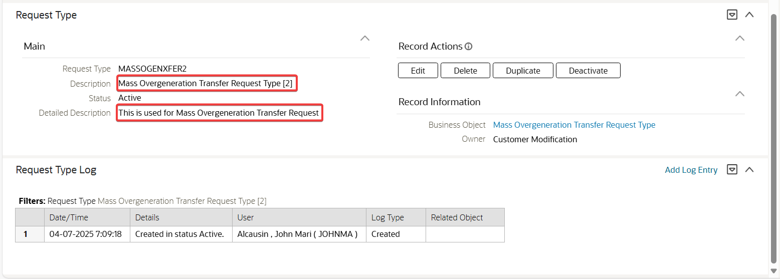

The Mass Overgeneration Transfer Request Type is updated. The details are loaded in the Request page.

## In the Request Type page, click Duplicate button for existing active Mass Overgeneration Transfer Request Type.

Test Condition:

* In the Request Type page, click Duplicate button for existing active Mass Overgeneration Transfer Request Type.

Expected Results:

* The Mass Overgeneration Transfer page is shown with duplicated details, but Request Type is blank.

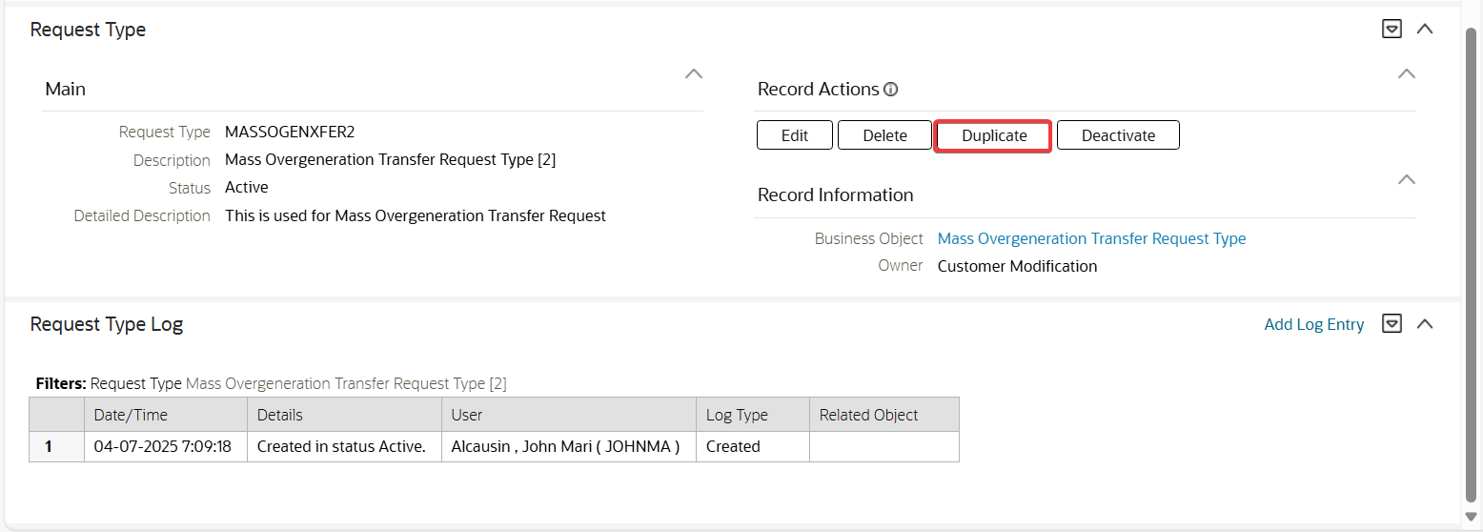

In the Request Type page, click Duplicate button for existing active Mass Overgeneration Transfer Request Type.

Test Results:

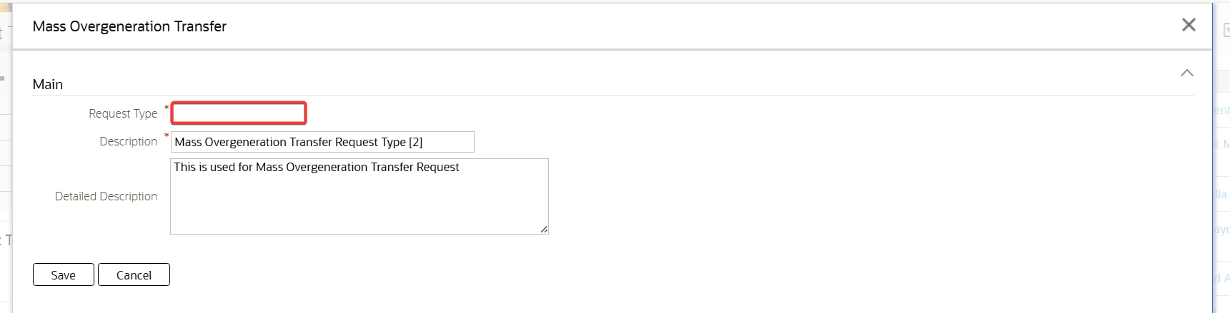

The Mass Overgeneration Transfer page is shown with duplicated details, but Request Type is blank.

## In the Request Type page, duplicate the existing Mass Overgeneration Transfer Request Type and click Save button.

Test Condition:

* In the Request Type page, duplicate the existing Mass Overgeneration Transfer Request Type and click Save button.

Expected Results:

* The Mass Overgeneration Transfer Request Type is duplicated. The details are loaded in the Request page.



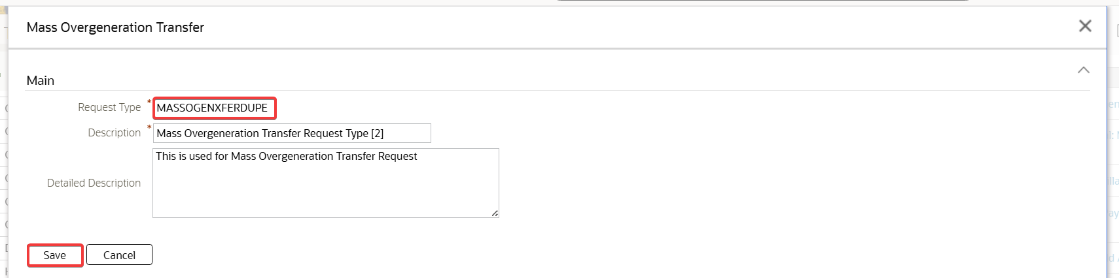

In the Request Type page, duplicate the existing Mass Overgeneration Transfer Request Type and click Save button.

Test Results:

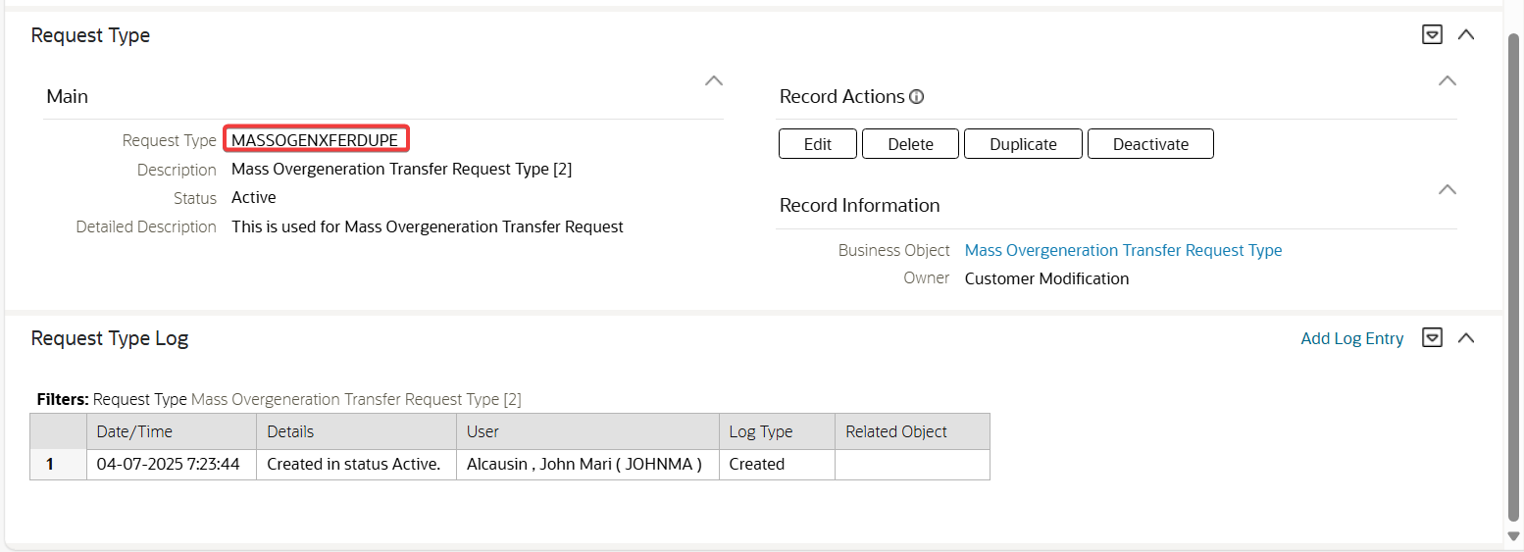

The Mass Overgeneration Transfer Request Type is duplicated. The details are loaded in the Request page.

## In the Request Type page, click Delete button for the Mass Overgeneration Transfer Request Type

Test Condition:

* In the Request Type page, click Delete button for the Mass Overgeneration Transfer Request Type

Expected Results:

* The Confirmation Delete pop-up window is shown.

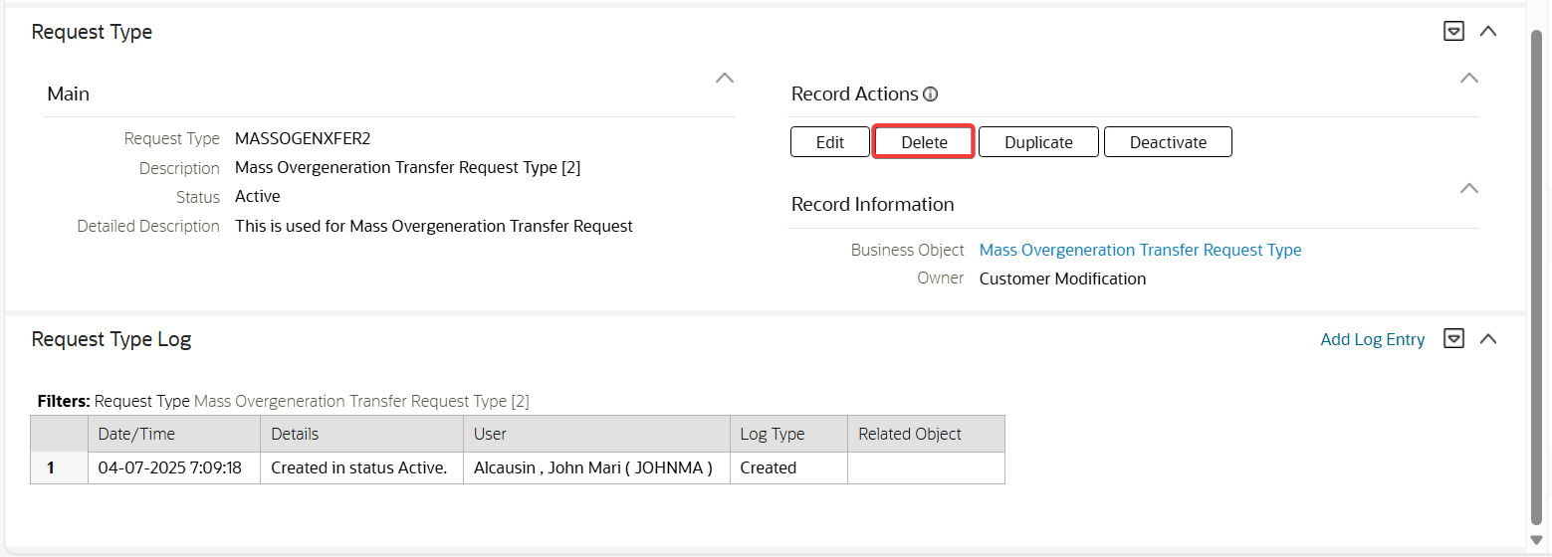

In the Request Type page, click Delete button for the Mass Overgeneration Transfer Request Type

Test Results:

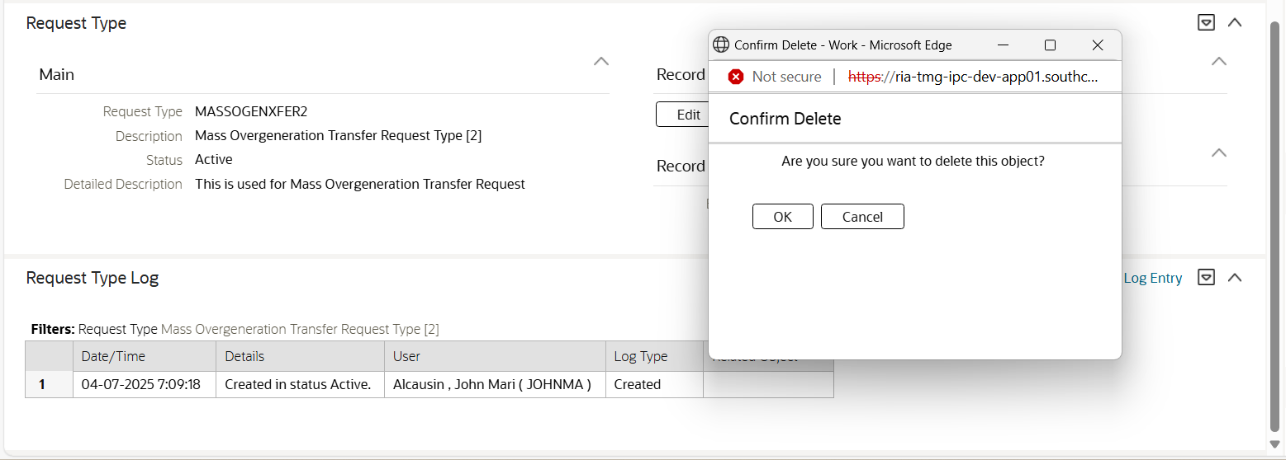

The Confirmation Delete pop-up window is shown.

## In the Confirmation Delete pop-up window, click Cancel button.

Test Condition:

* In the Confirmation Delete pop-up window, click Cancel button.

Expected Results:

* The pop-up is closed.

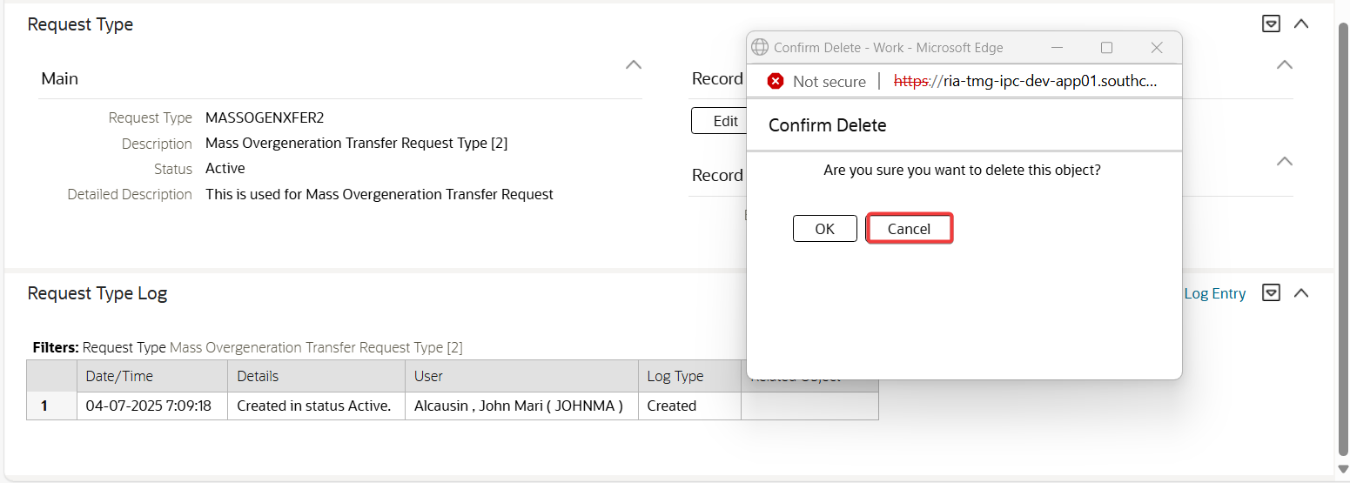

In the Confirmation Delete pop-up window, click Cancel button.

Test Results:

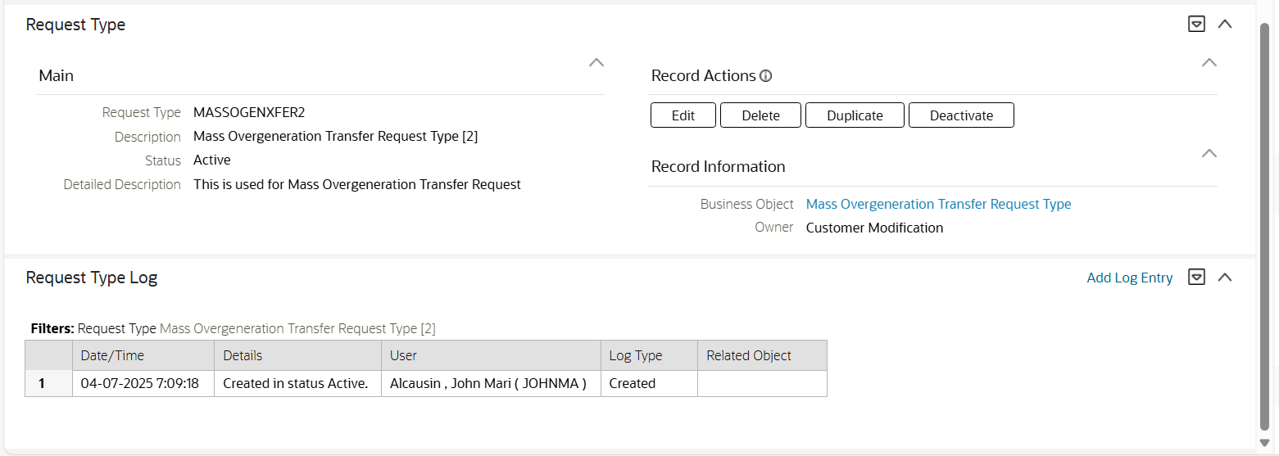

The pop-up is closed.

## In the Confirmation Delete pop-up window, click OK button.

Test Condition:

* In the Confirmation Delete pop-up window, click OK button.

Expected Results:

* The request type is deleted and navigated to the Request Type Query page.

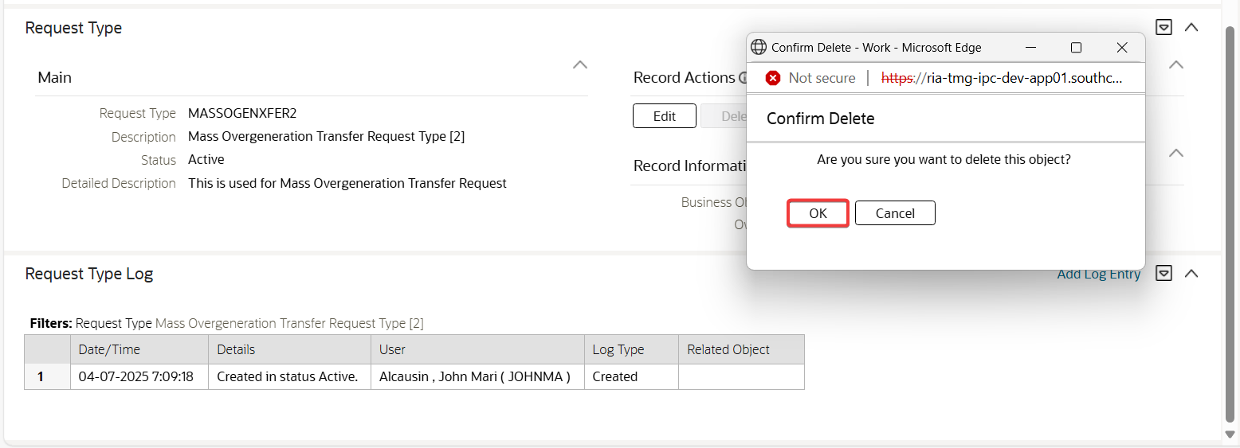

In the Confirmation Delete pop-up window, click OK button.

Test Results:

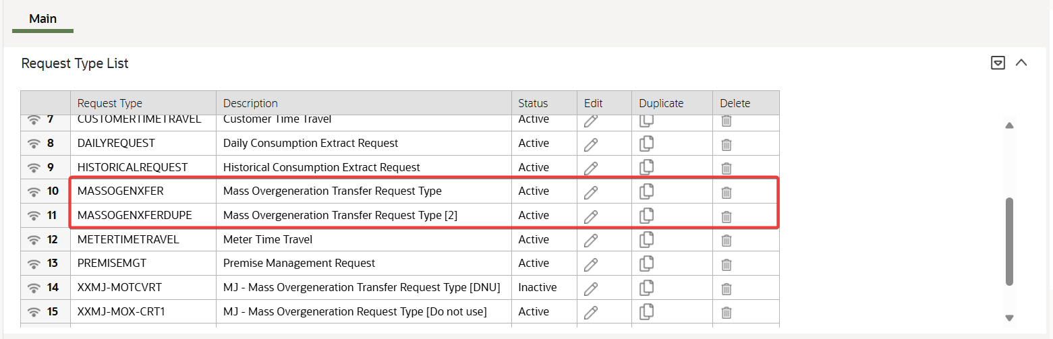

The request type is deleted and navigated to the Request Type Query page.

## In the Request Type page, click Deactivate button for the Mass Overgeneration Transfer Request Type.

Test Condition:

* In the Request Type page, click Deactivate button for the Mass Overgeneration Transfer Request Type.

Expected Results:

* The request type is successfully transitioned to Inactive status.

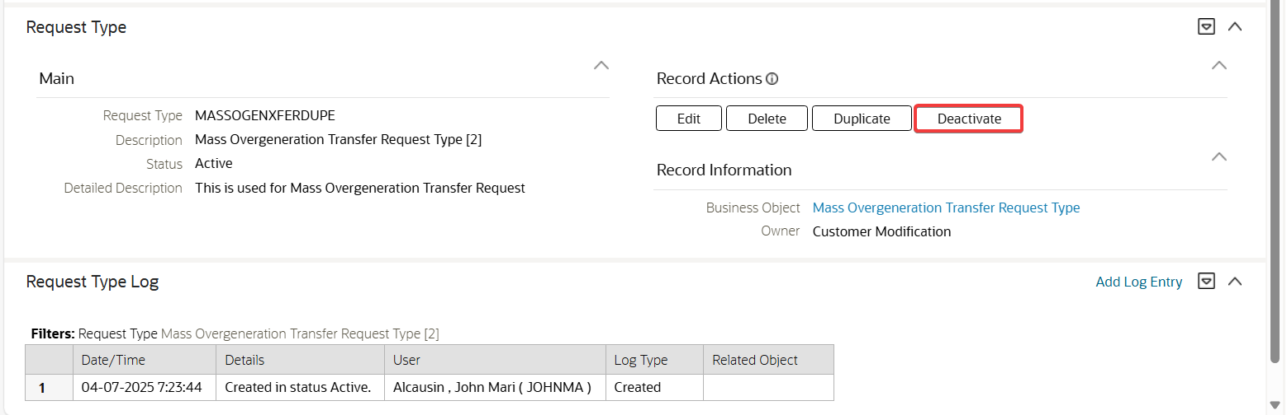

In the Request Type page, click Deactivate button for the Mass Overgeneration Transfer Request Type.

Test Results:

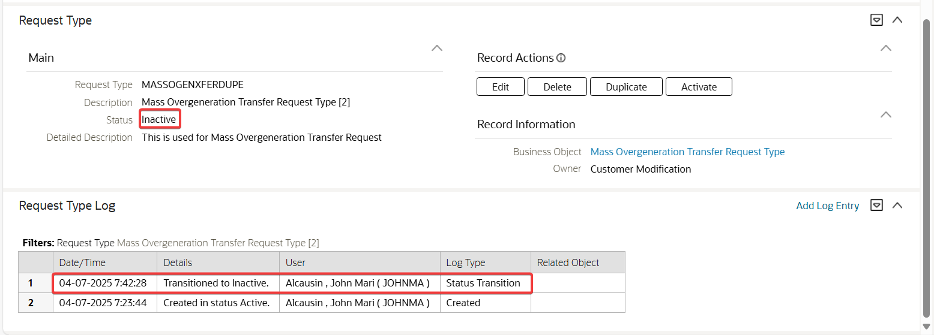

The request type is successfully transitioned to Inactive status.

## Go to Main Menu > Tools > Request > Add. Select the Mass Overgeneration Transfer Request Type.

Test Condition:

* Go to Main Menu > Tools > Request > Add.
* Select the Mass Overgeneration Transfer Request Type.

Expected Results:

* The Mass Overgeneration Transfer Maintenance page is shown with the following sections:
  + Main section
    - Request Type – description of the selected request type
    - Status – description of request type’s status
  + Overgeneration Transfer Credits
    - An empty input table with Add button, Delete button, Sequence, SA ID, Contract Value Bill Factor and Contract Value Amount
    - A CSV File To Upload button
  + Save and Cancel buttons

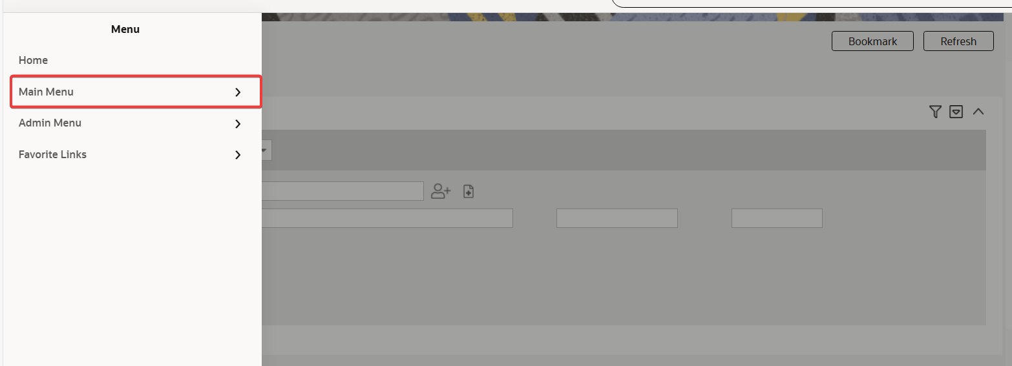

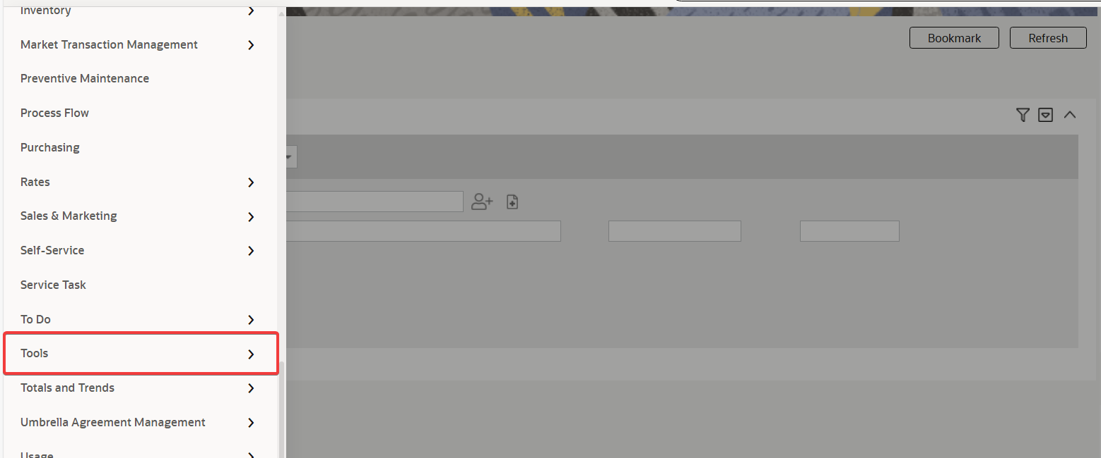

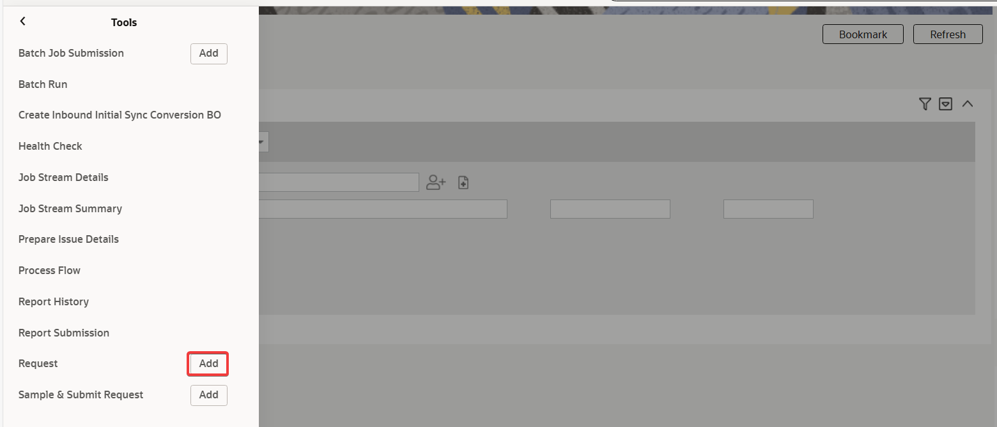

Go to Main Menu > Tools > Request > Add.

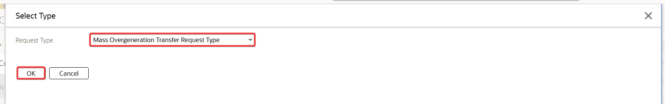

Select the Mass Overgeneration Transfer Request Type.

Test Results:

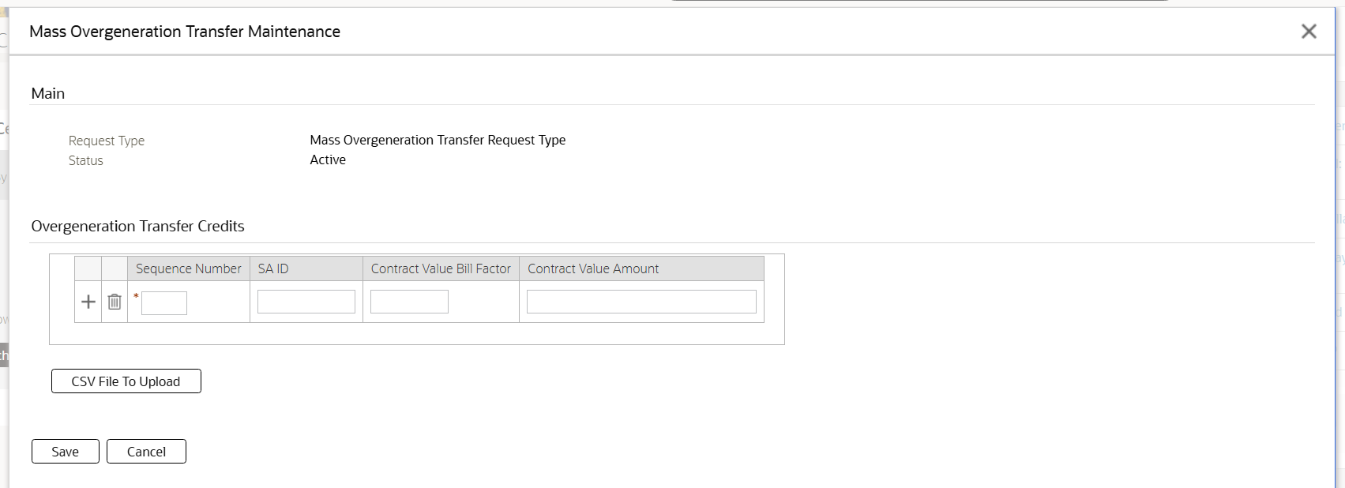

The Mass Overgeneration Transfer Maintenance page is shown with the following sections:

* Main section
  + Request Type – description of the selected request type
  + Status – description of request type’s status
  + Overgeneration Transfer Credits
  + An empty input table with Add button, Delete button, Sequence, SA ID, Contract Value Bill Factor and Contract Value Amount
  + A CSV File To Upload button
* Save and Cancel buttons

## In the Mass Overgeneration Transfer Request Maintenance page, click Cancel button.

Test Condition:

* In the Mass Overgeneration Transfer Request Maintenance page, click Cancel button.

Expected Results:

* The Mass Overgeneration Transfer Maintenance page is closed.

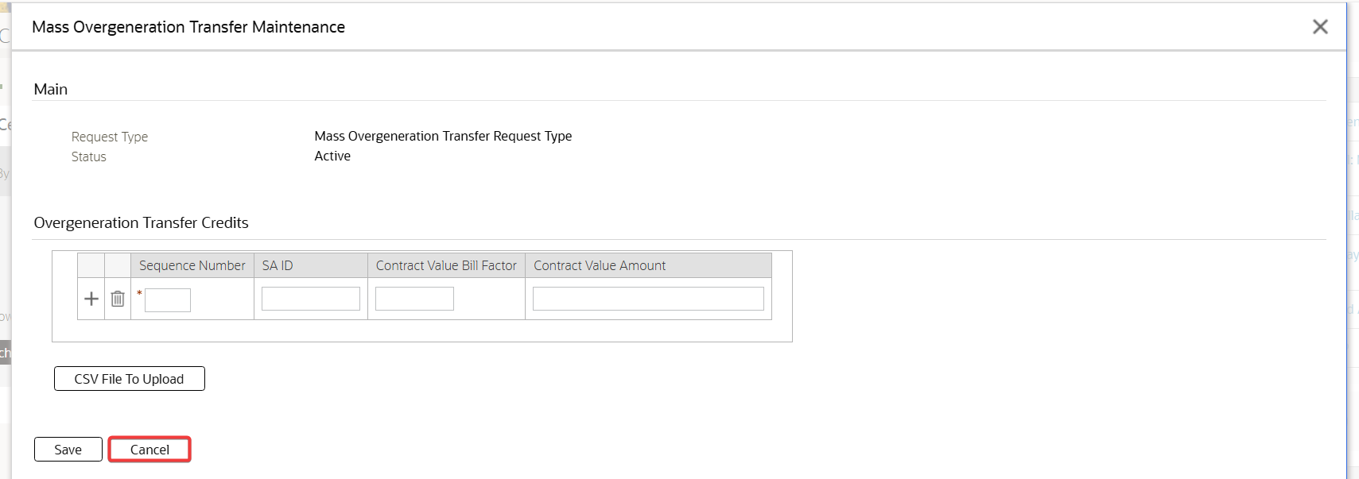

In the Mass Overgeneration Transfer Request Maintenance page, click Cancel button.

Test Results:

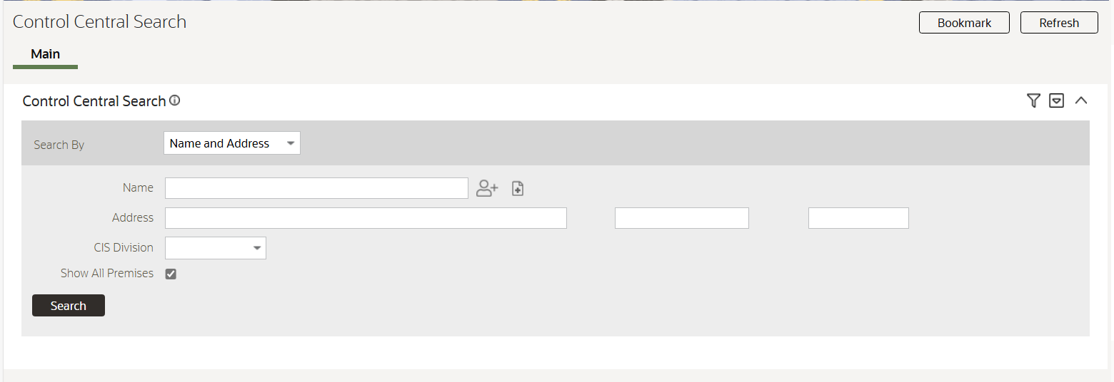

The Mass Overgeneration Transfer Maintenance page is closed.

## In the Mass Overgeneration Transfer Request Maintenance page, click the CSV File to Upload button.

Test Condition:

* In the Mass Overgeneration Transfer Request Maintenance page, click the CSV File to Upload button.

Expected Results:

* The File Upload pop-up window is shown.

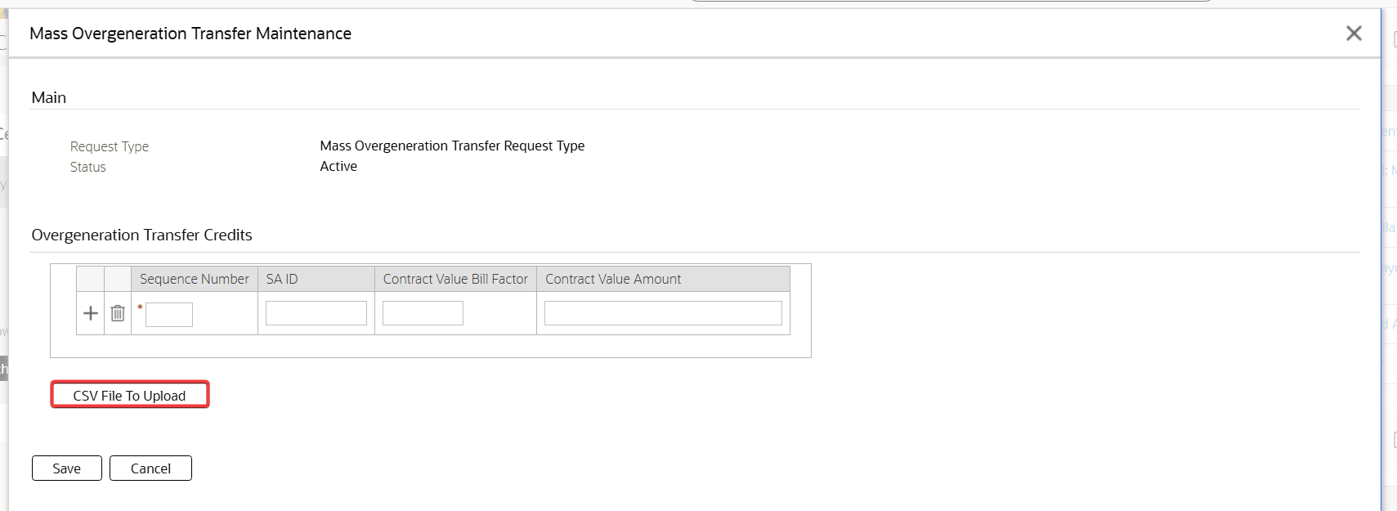

In the Mass Overgeneration Transfer Request Maintenance page, click the CSV File to Upload button.

Test Results:

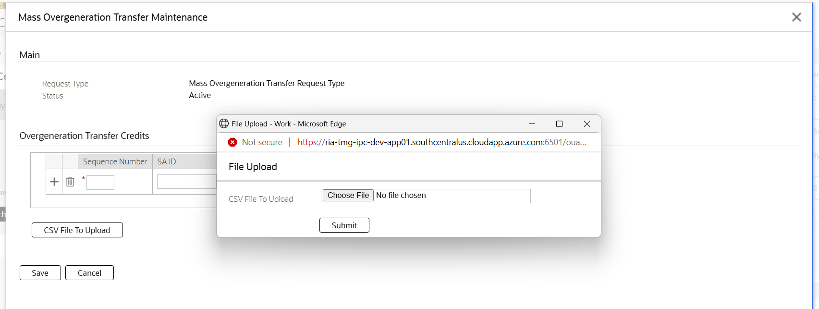

The File Upload pop-up window is shown.

## In the File Upload pop-up window, click the Submit button

Test Condition:

* In the File Upload pop-up window, click the Submit button

Expected Results:

* An appropriate error message is shown to specify a file.

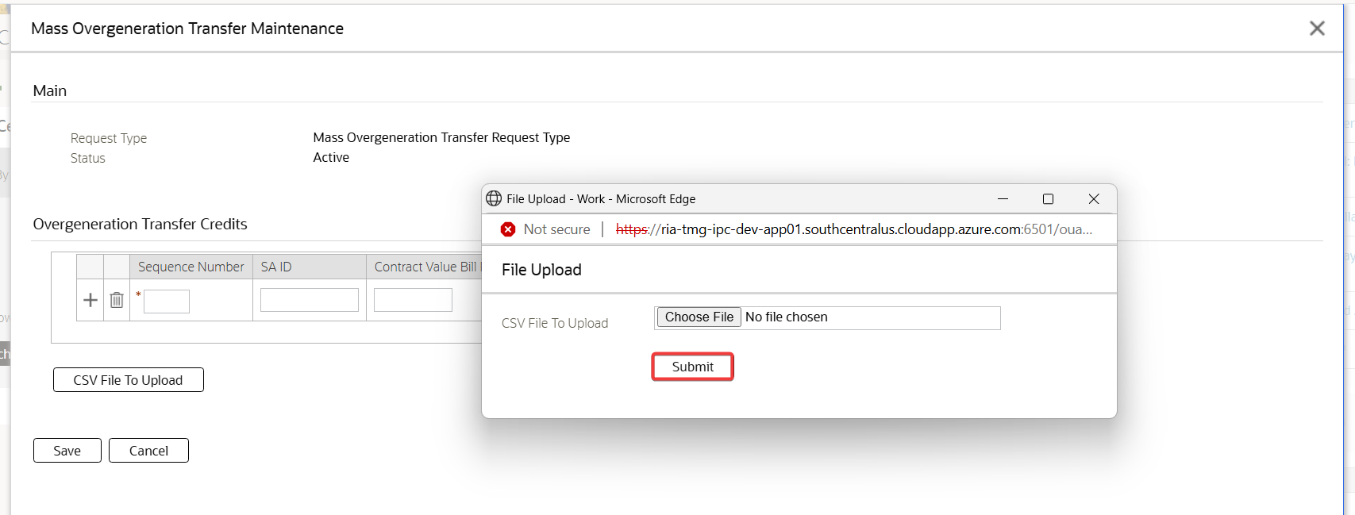

In the File Upload pop-up window, click the Submit button

Test Results:

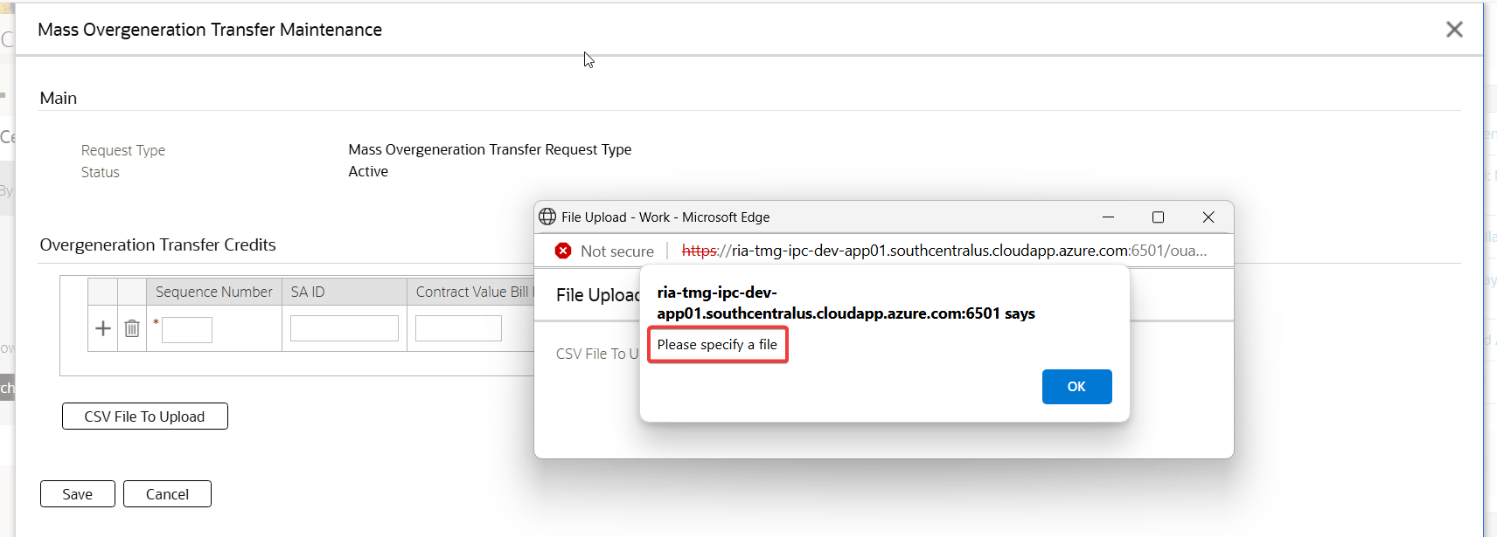

An appropriate error message is shown to specify a file

## In the File Upload pop-up window, click the Choose File button.

Test Condition:

* In the File Upload pop-up window, click the Choose File button.

Expected Results:

* The Windows Explorer window is shown to select a file.

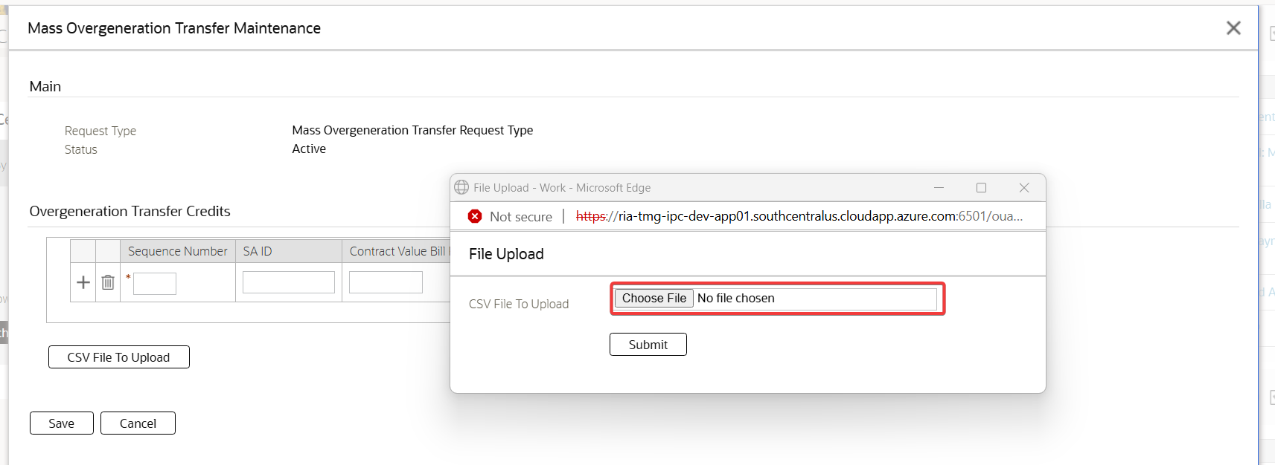

In the File Upload pop-up window, click the Choose File button.

Test Results:

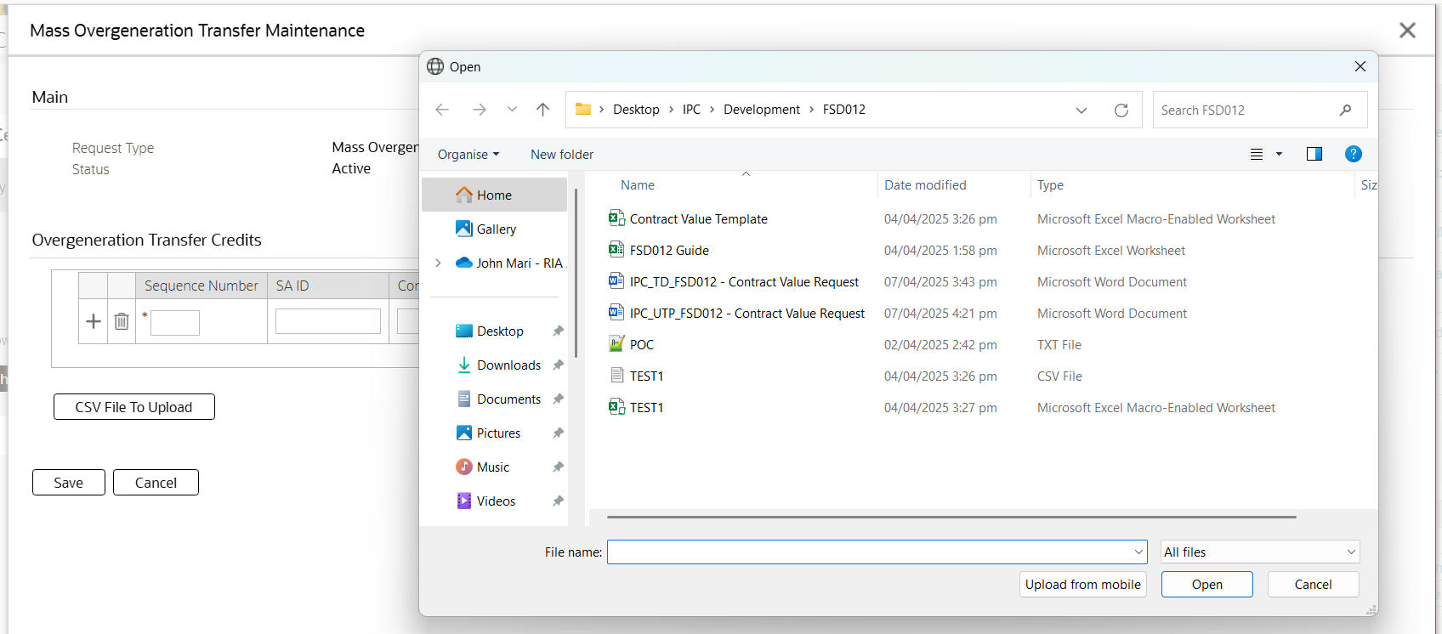

The Windows Explorer window is shown to select a file.

## In the File Upload pop-up window, click the Choose File button and select a file that is not in CSV format.

Test Condition:

* In the File Upload pop-up window, click the Choose File button and select a file that is not in CSV format.

Expected Results:

* An appropriate error message is shown stating that the file has invalid file type.

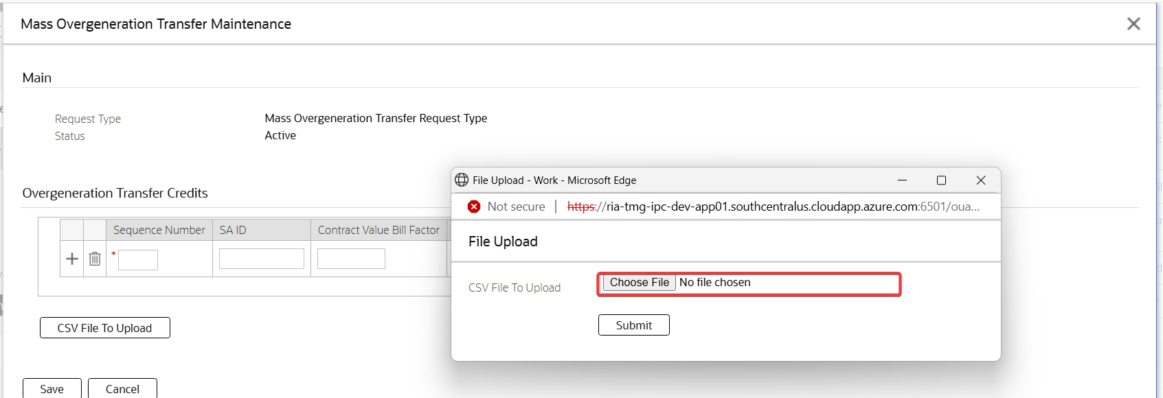

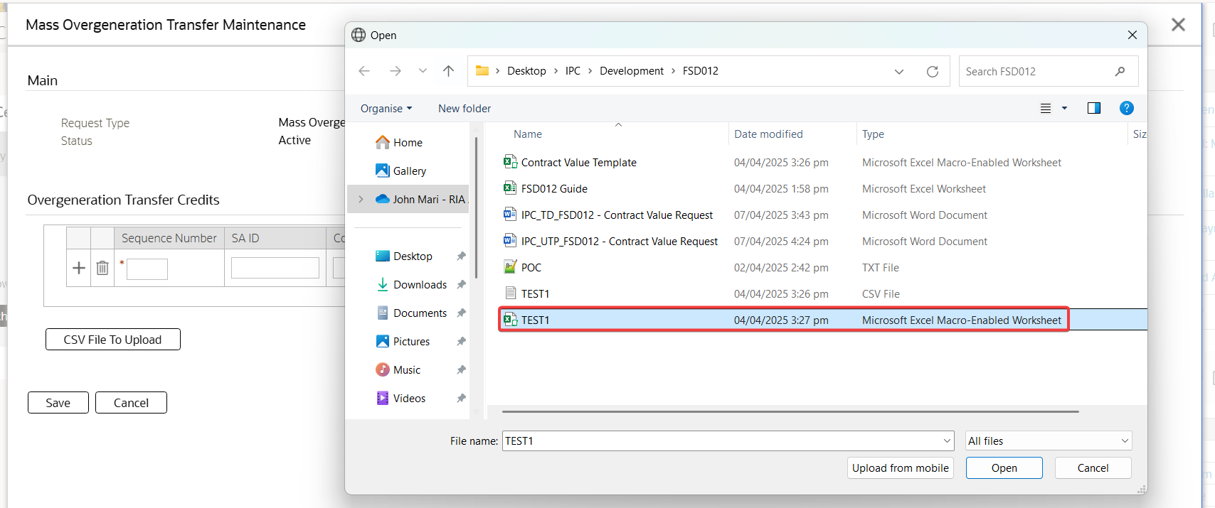

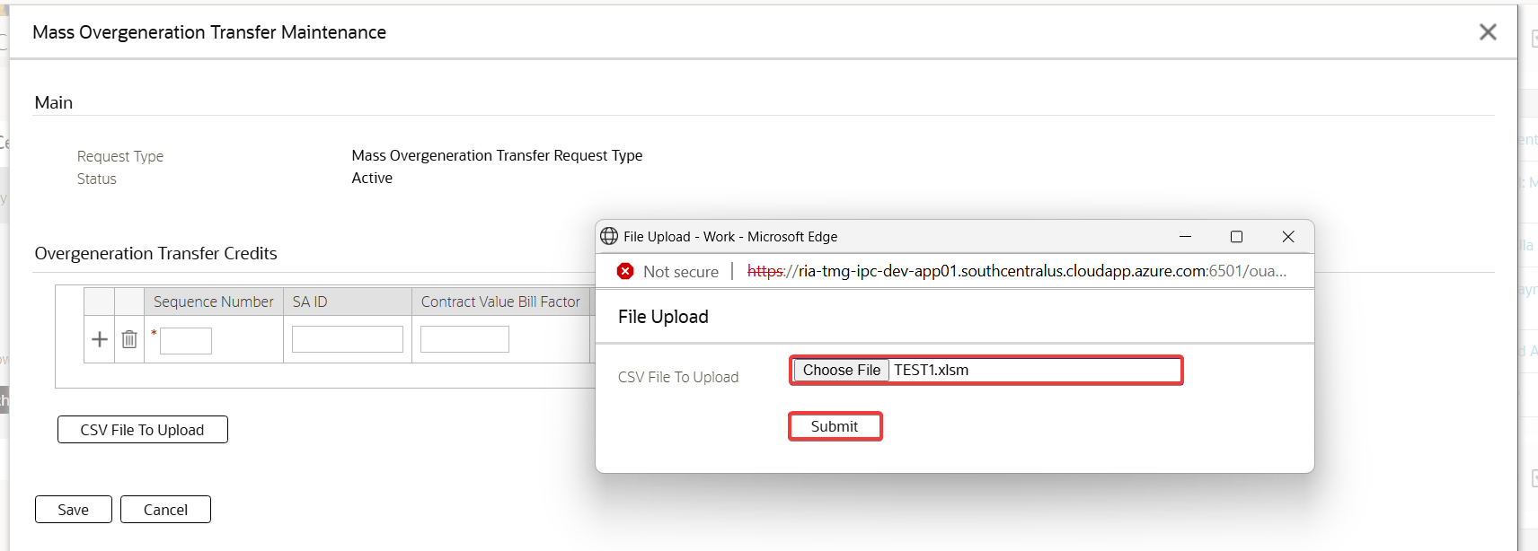

In the File Upload pop-up window, click the Choose File button and select a file that is not in CSV format.



Test Results:

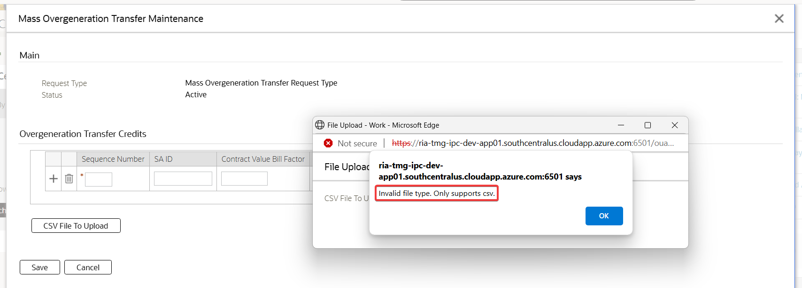

An appropriate error message is shown stating that the file has invalid file type.

## In the File Upload pop-up window, click the Choose File button, select a file and click Submit button.

Test Condition:

* In the File Upload pop-up window, click the Choose File button, select a file and click Submit button

Expected Results:

* The File Upload popup page is closed
* The contents of the file are loaded on Overgeneration Transfer Credits table.

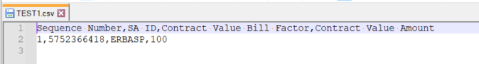



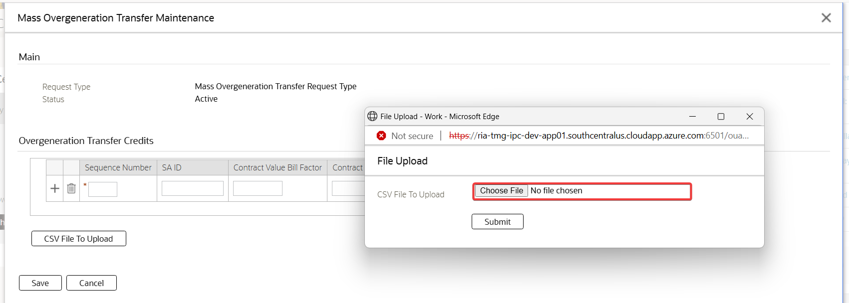

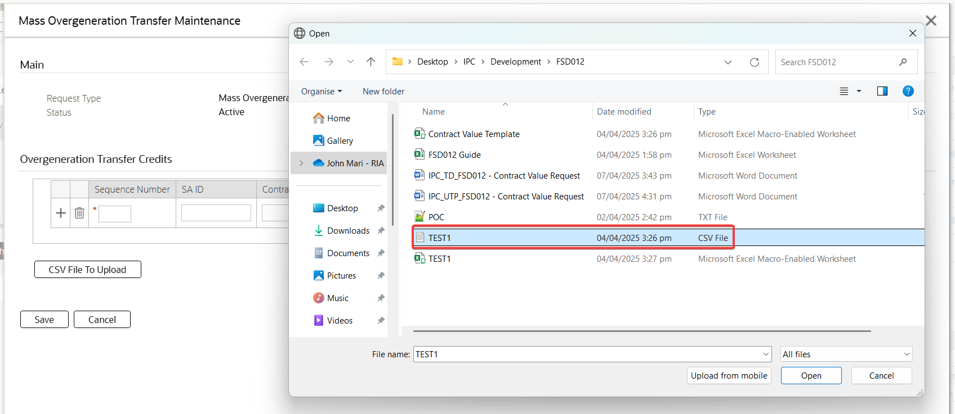

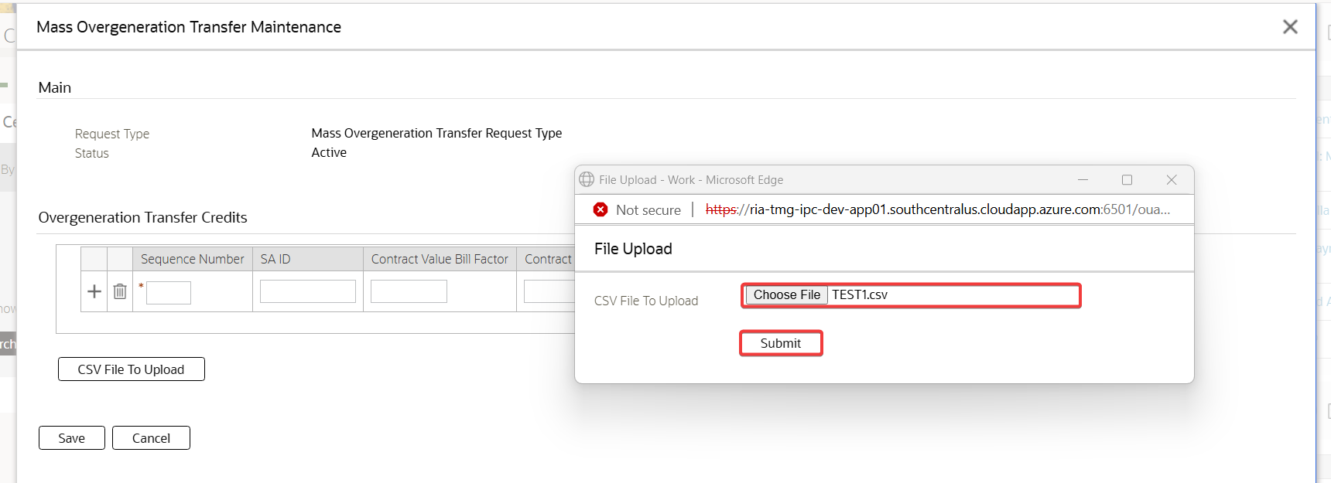

In the File Upload pop-up window, click the Choose File button, select a file and click Submit button

Test Results:

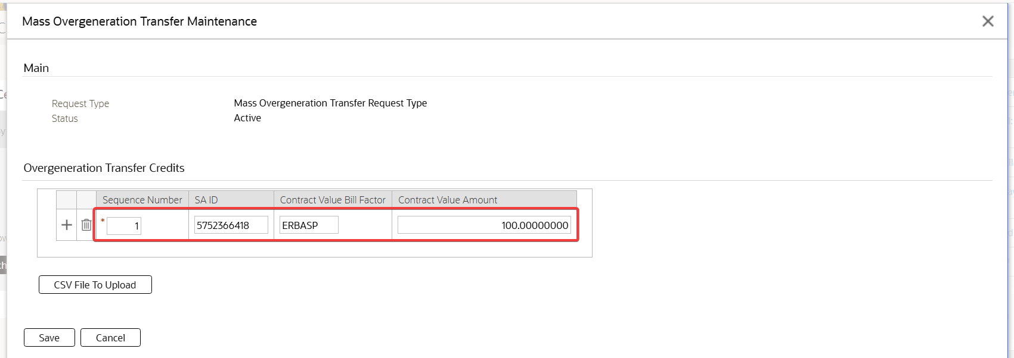

The File Upload popup page is closed. The contents of the file are loaded on Overgeneration Transfer Credits table.

## In the Mass Overgeneration Transfer Request Maintenance page, file contents are loaded in the table. Select and submit another CSV file

Test Condition:

* In the Mass Overgeneration Transfer Request Maintenance page, file contents are loaded in the table. Select and submit another CSV file

Expected Results:

* The File Upload popup page is closed
* The previous contents are cleared, and the contents of the current file is loaded on Overgeneration Transfer Credits table.

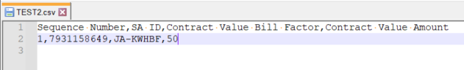



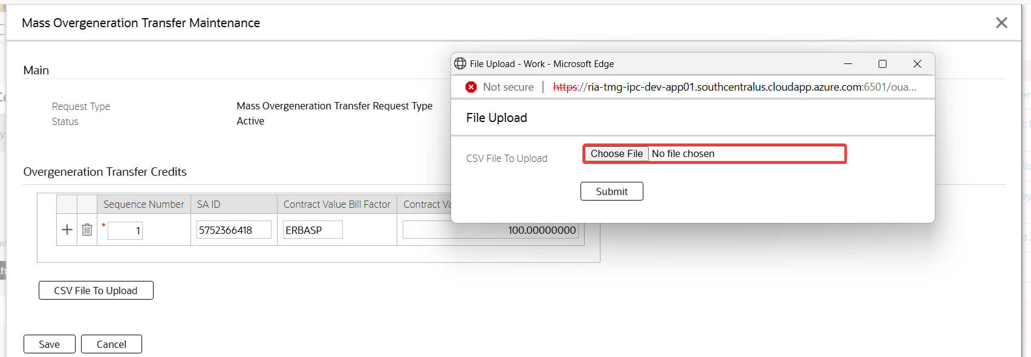

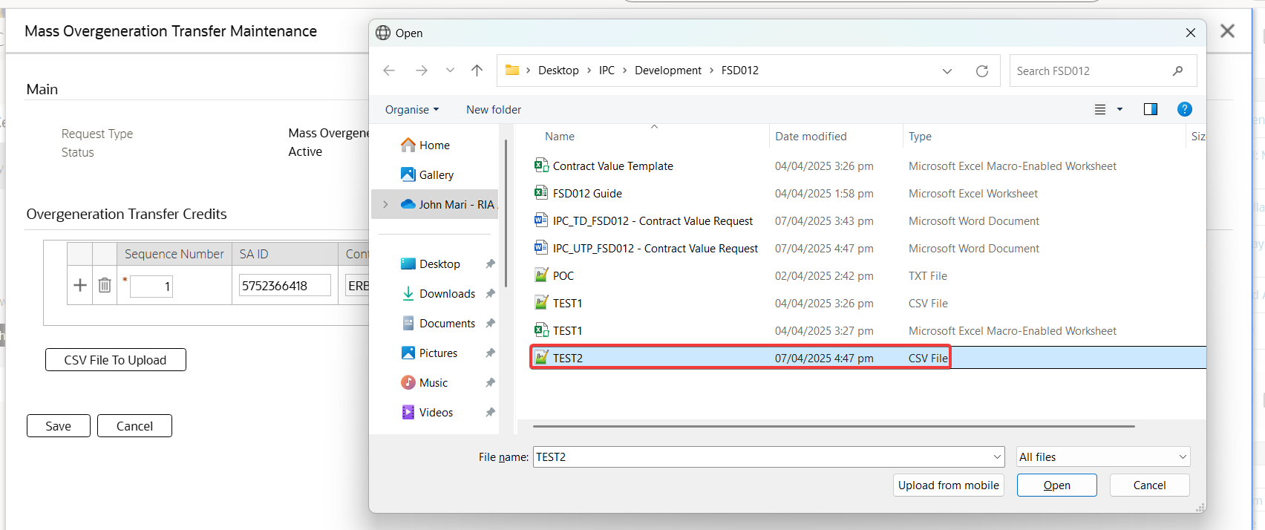

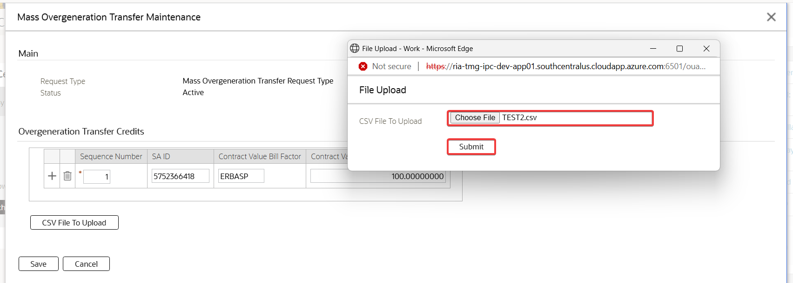

In the Mass Overgeneration Transfer Request Maintenance page, file contents are loaded in the table. Select and submit another CSV file

Test Results:

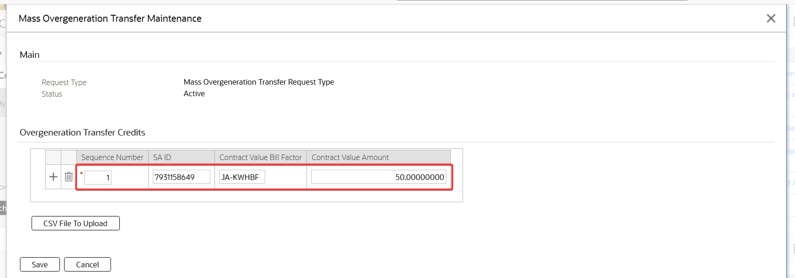

The File Upload popup page is closed. The previous contents are cleared, and the contents of the current file is loaded on Overgeneration Transfer Credits table.

## In the Mass Overgeneration Transfer Maintenance page, file contents are loaded in the table. Click the Delete button.

Test Condition:

* In the Mass Overgeneration Transfer Maintenance page, file contents are loaded in the table. Click the Delete button.

Expected Results:

* The row is deleted in the table.

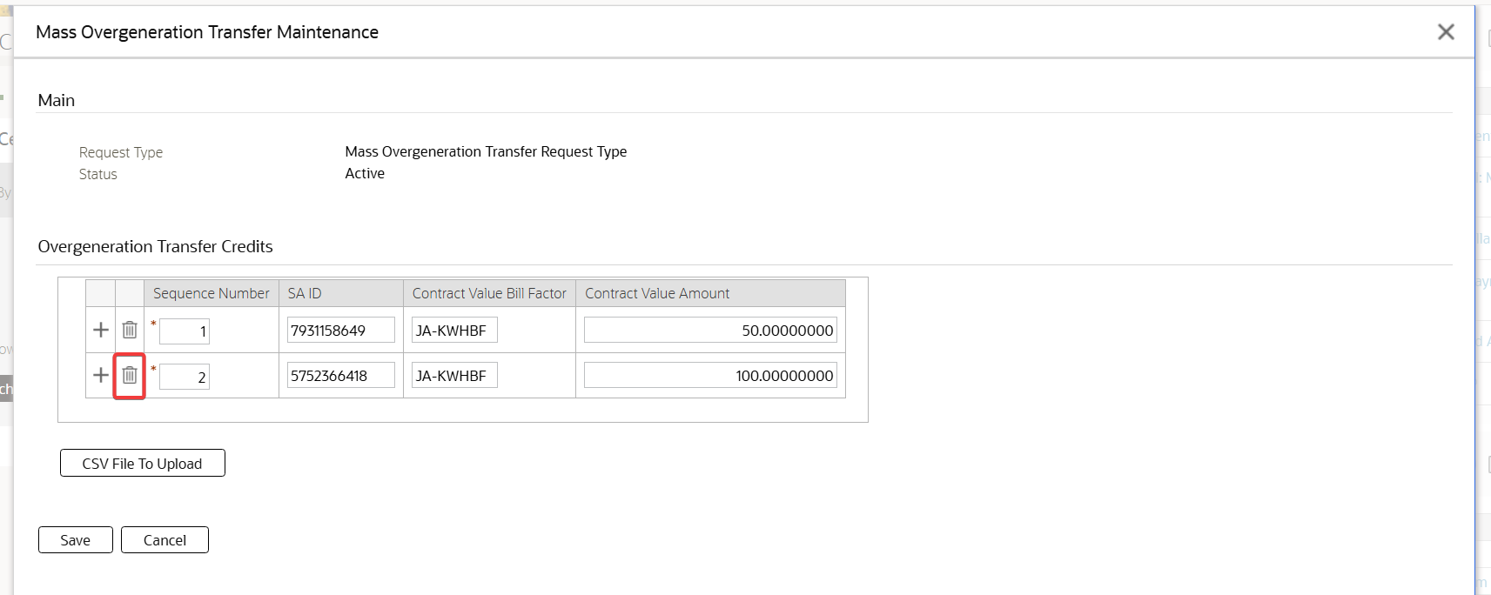

In the Mass Overgeneration Transfer Maintenance page, file contents are loaded in the table. Click the Delete button.

Test Results:

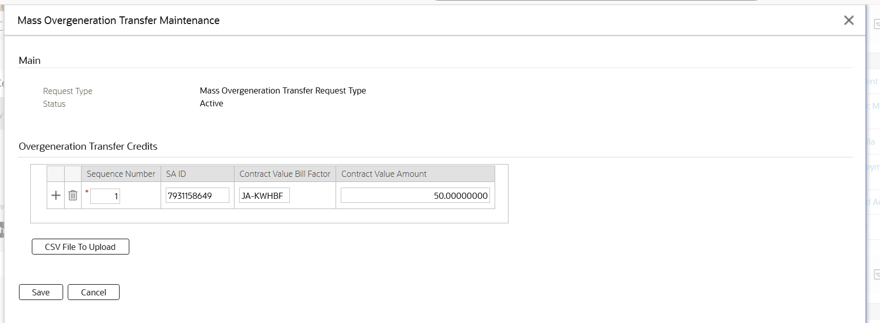

The row is deleted in the table.

## In the Mass Overgeneration Transfer Maintenance page, file contents are loaded in the table. Click the Add button.

Test Condition:

* In the Mass Overgeneration Transfer Maintenance page, file contents are loaded in the table. Click the Add button.

Expected Results:

* The row is added in the table.

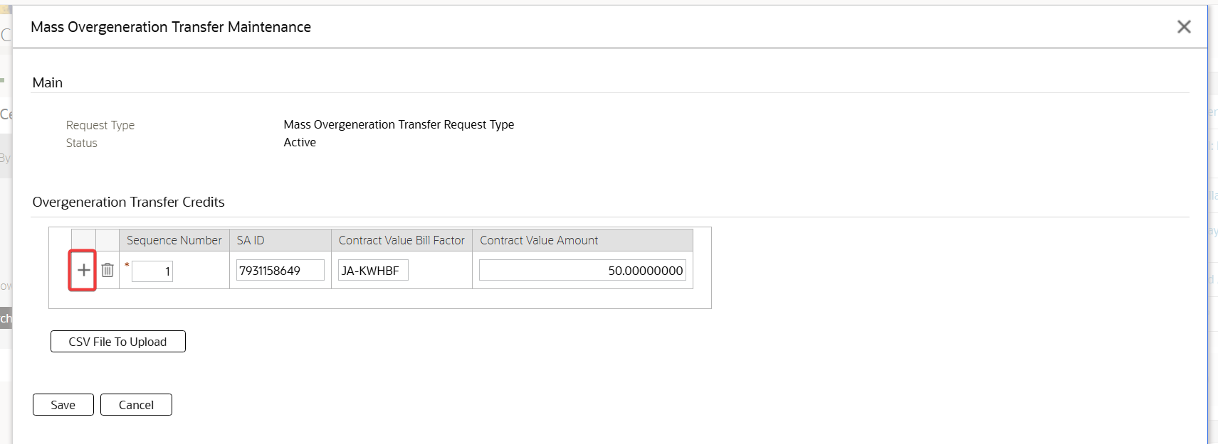

In the Mass Overgeneration Transfer Maintenance page, file contents are loaded in the table. Click the Add button.

Test Results:

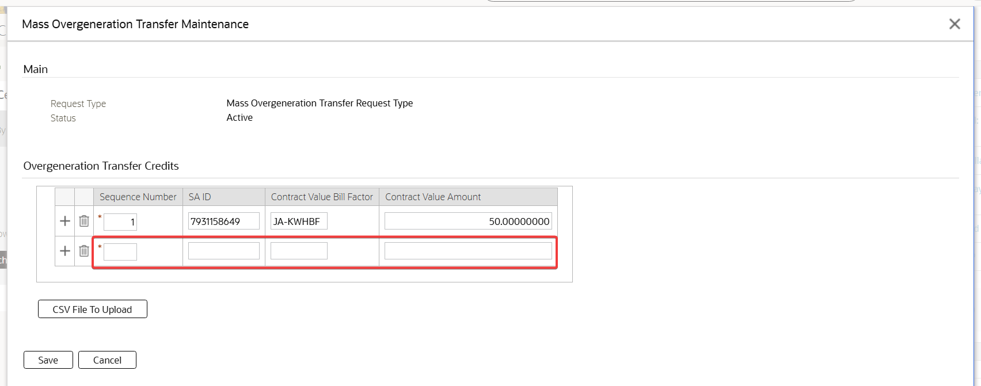

The row is added in the table.

## In the Mass Overgeneration Transfer Maintenance page, file contents are loaded in the table without the SA ID and click Save button

Test Condition:

* In the Mass Overgeneration Transfer Maintenance page, file contents are loaded in the table without the SA ID and click Save button.

Expected Results:

* The Mass Overgeneration Transfer Maintenance page is closed and navigated to the Request page with Pending request

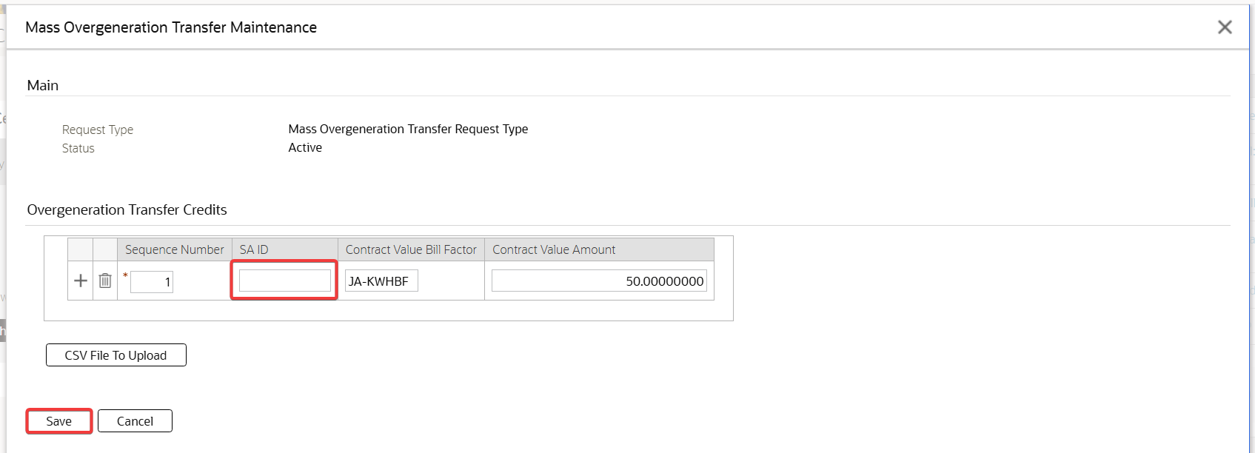

In the Mass Overgeneration Transfer Maintenance page, file contents are loaded in the table without the SA ID and click Save button

Test Results:

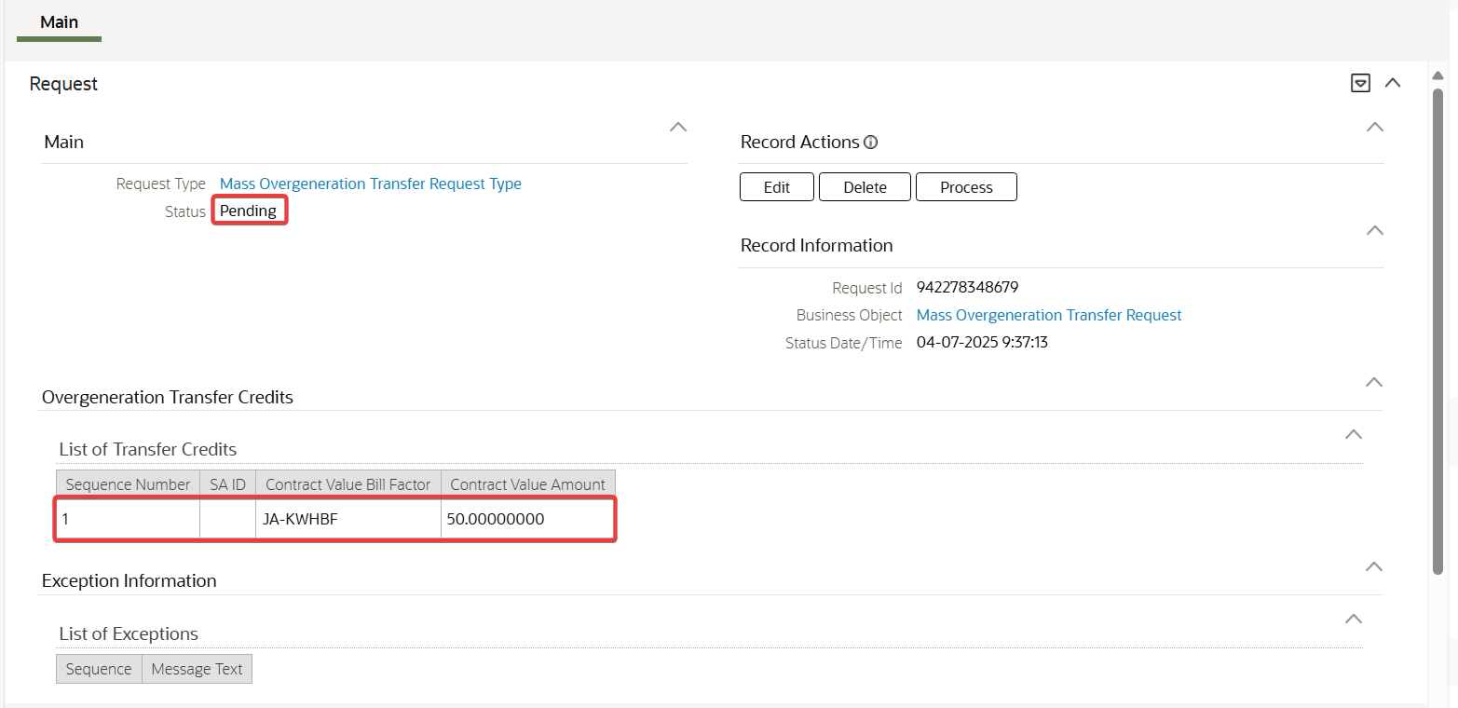

The Mass Overgeneration Transfer Maintenance page is closed and navigated to the Request page with Pending request.

## In the Mass Overgeneration Transfer Maintenance page, file contents are loaded in the table without Contract Value Bill Factor and click Save button.

Test Condition:

* In the Mass Overgeneration Transfer Maintenance page, file contents are loaded in the table without Contract Value Bill Factor and click Save button.

Expected Results:

* The Mass Overgeneration Transfer Maintenance page is closed and navigated to the Request page with Pending request

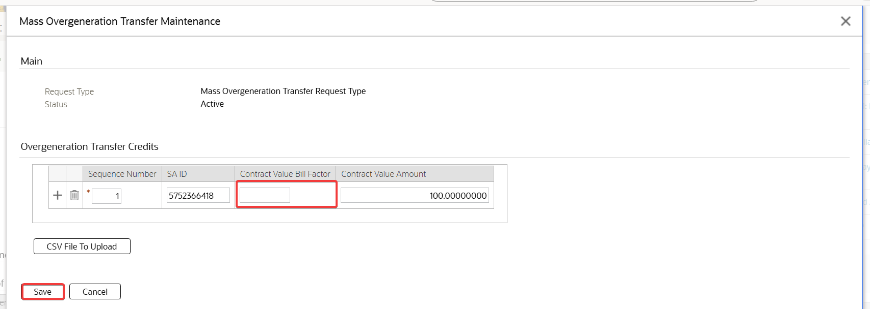

In the Mass Overgeneration Transfer Maintenance page, file contents are loaded in the table without Contract Value Bill Factor and click Save button.

Test Results:



The Mass Overgeneration Transfer Maintenance page is closed and navigated to the Request page with Pending request

## In the Mass Overgeneration Transfer Maintenance page, file contents are loaded in the table without the Contract Value Amount and click Save button

Test Condition:

* In the Mass Overgeneration Transfer Maintenance page, file contents are loaded in the table without the Contract Value Amount and click Save button

Expected Results:

* The Mass Overgeneration Transfer Maintenance page is closed and navigated to the Request page with Pending request

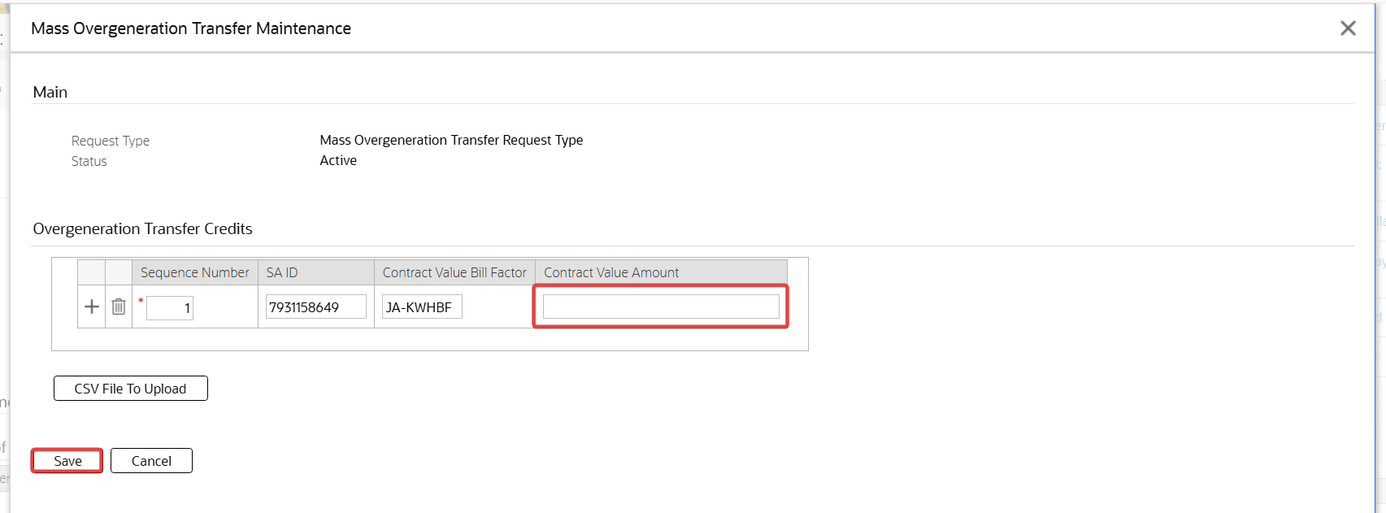

In the Mass Overgeneration Transfer Maintenance page, file contents are loaded in the table without the Contract Value Amount and click Save button

Test Results:

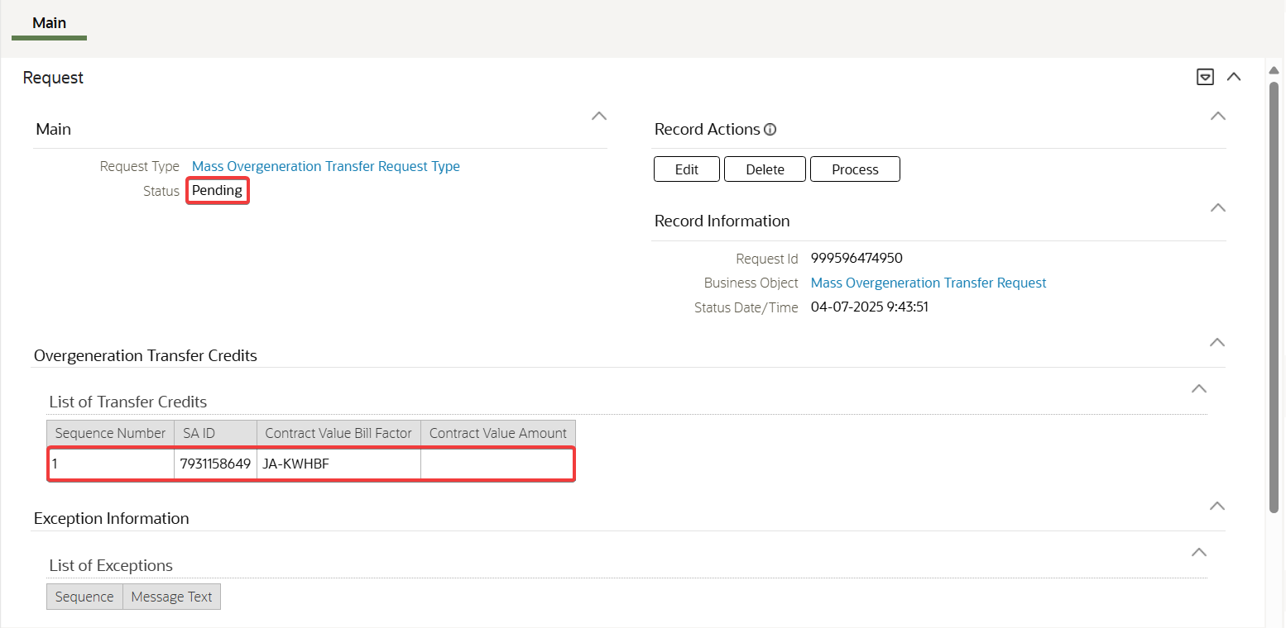

The Mass Overgeneration Transfer Maintenance page is closed and navigated to the Request page with Pending request

## In the Mass Overgeneration Transfer Maintenance page, file contents are loaded in the table. Provide invalid Contract Value Amount and click Save button

Test Condition:

* In the Mass Overgeneration Transfer Maintenance page, file contents are loaded in the table. Provide invalid Contract Value Amount and click Save button

Expected Results:

* An appropriate error message is raised stating invalid Contract Value Amount

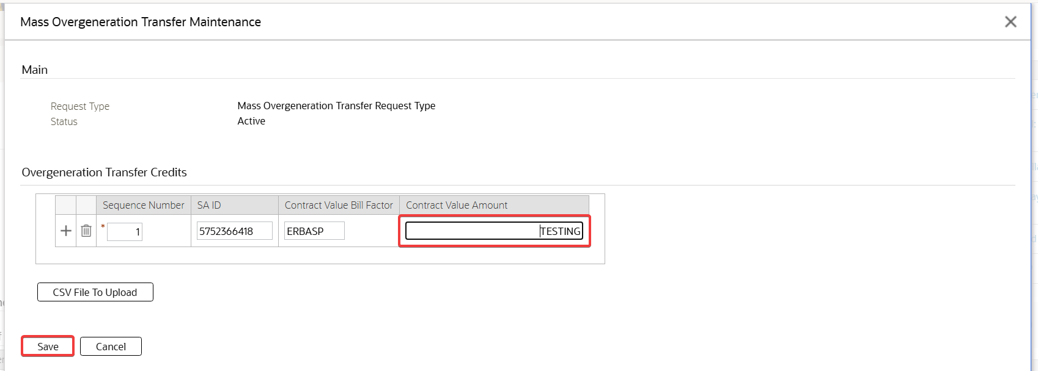

In the Mass Overgeneration Transfer Maintenance page, file contents are loaded in the table. Provide invalid Contract Value Amount and click Save button

Test Results:

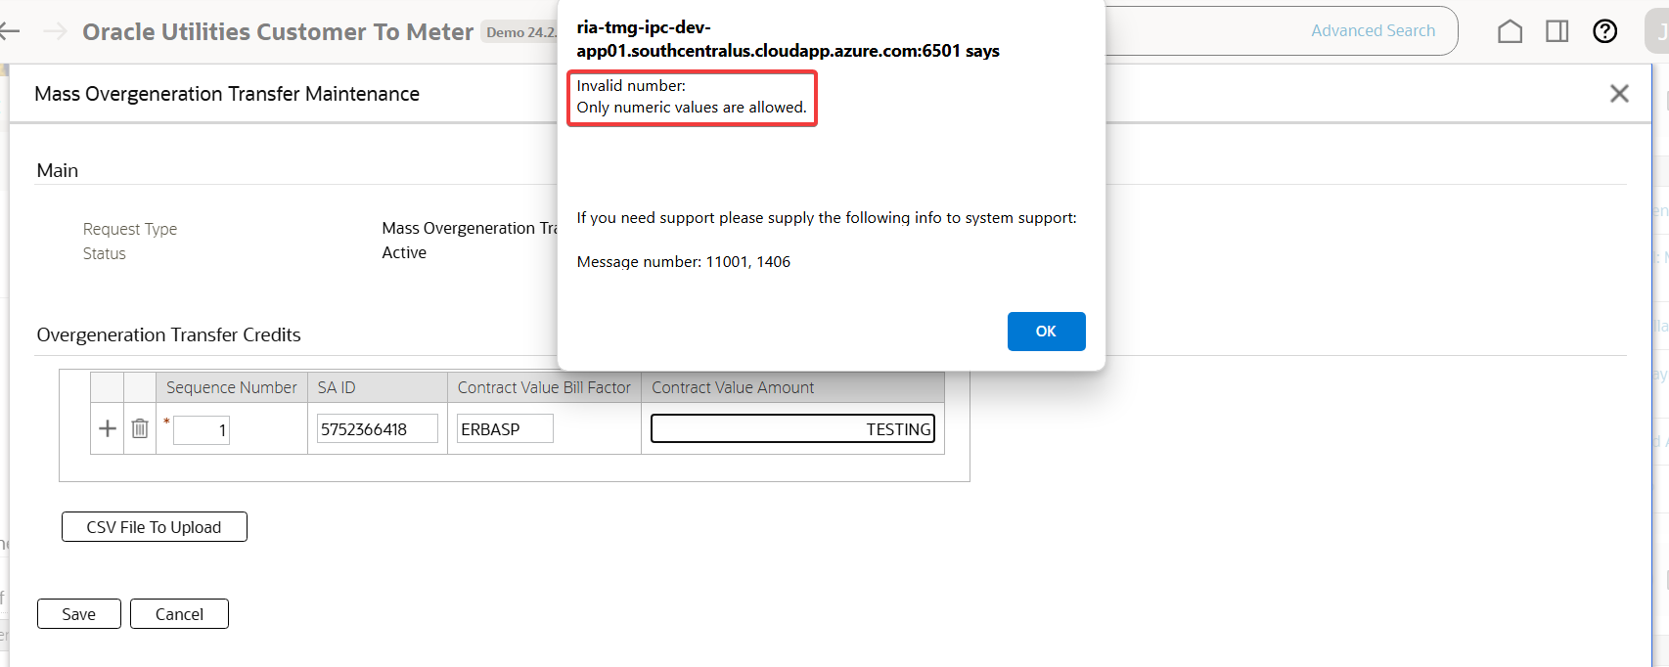

An appropriate error message is raised stating invalid Contract Value Amount

## In the Mass Overgeneration Transfer Maintenance page, file contents are loaded in the table. Click the Save button

Test Condition:

* In the Mass Overgeneration Transfer Maintenance page, file contents are loaded in the table. Click the Save button

Expected Results:

* The Mass Overgeneration Transfer Maintenance page is closed and navigated to the Request page with the following sections:
  + Main section (left side}
    - Request Type – description of the selected request type
    - Status – description of the request’s status
  + Record Actions section (right side)
    - Edit, Delete, Process buttons
  + Record Information section (collapse by default in the right side)
    - Request ID
    - Business Object
    - Status Date/Time
* Overgeneration Transfer Credits section (full section)
  + - List of Transfer Credits table
      * Sequence Number, SA ID, Contract Value Bill Factor and Contract Value Amount
  + Exception Information section
    - List of Exceptions table
      * Sequence and Message Text
  + Request Log zone
* Request created is in Pending status.

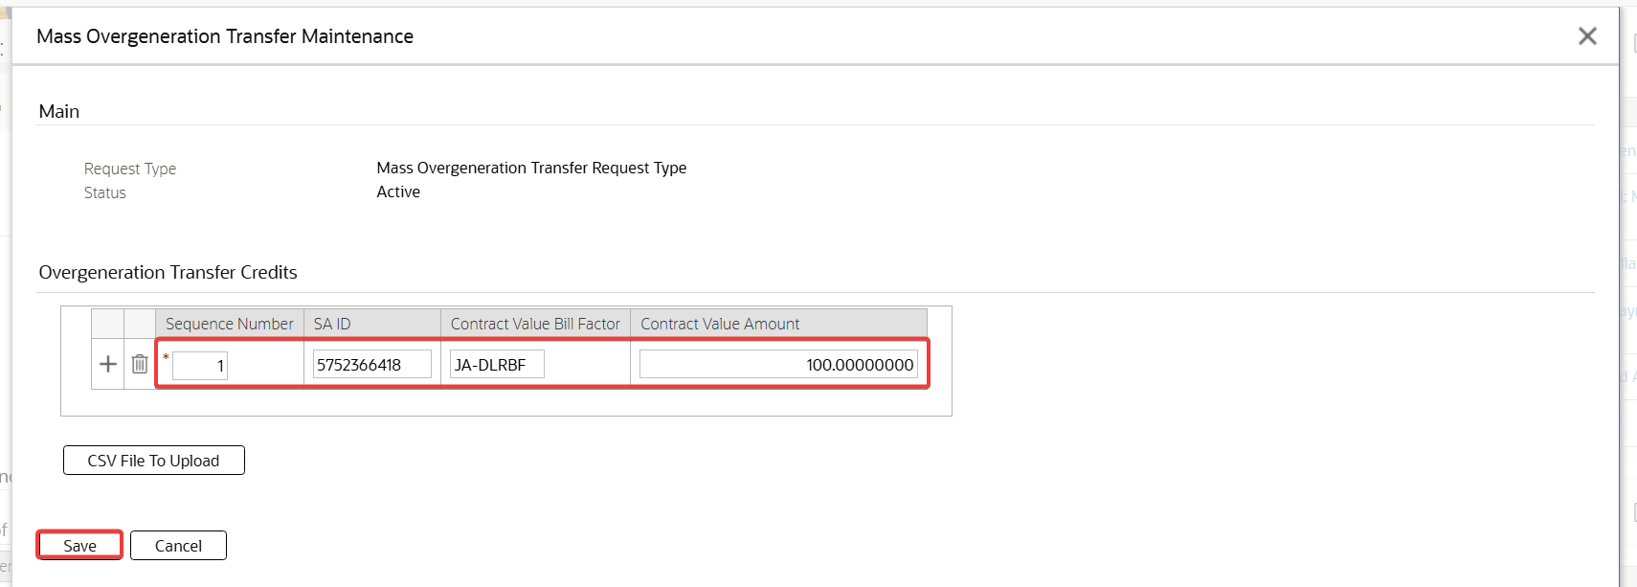

In the Mass Overgeneration Transfer Maintenance page, file contents are loaded in the table. Click the Save button

Test Results:

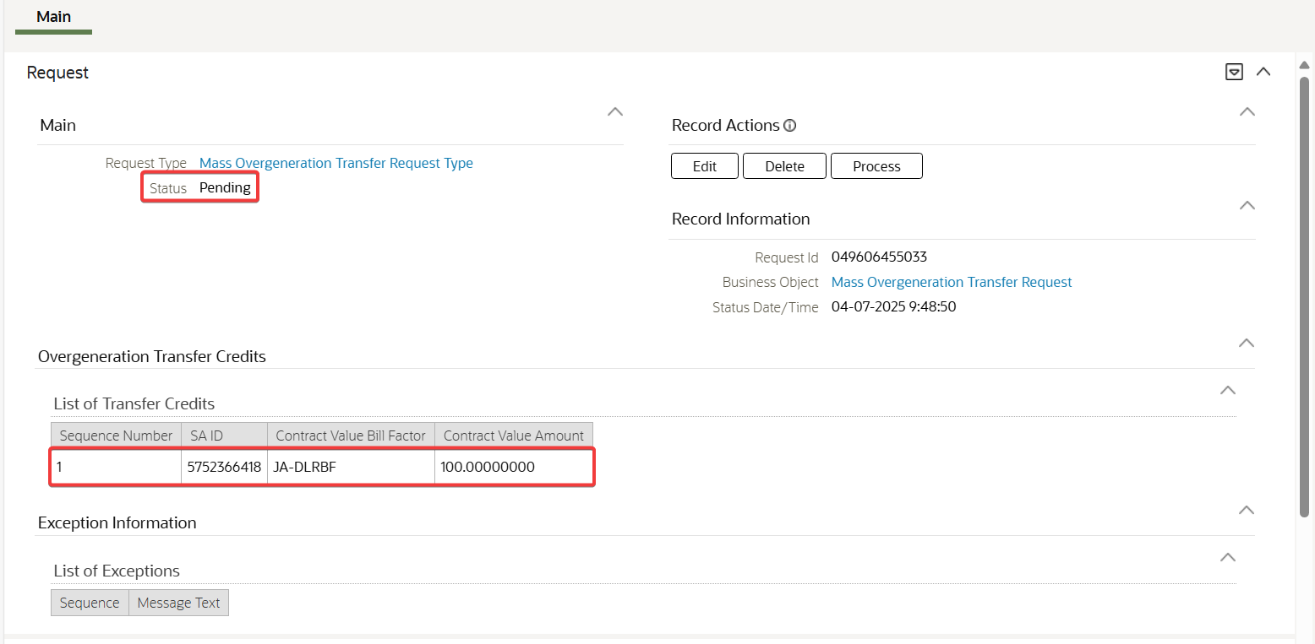

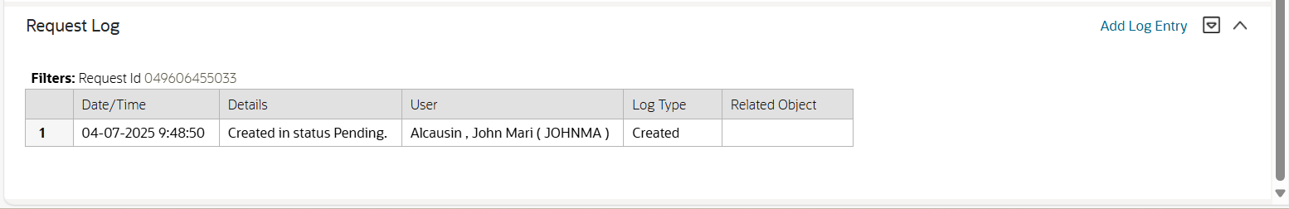

The Mass Overgeneration Transfer Maintenance page is closed and navigated to the Request page with the following sections:

* Main section (left side)
  + Request Type – description of the selected request type
  + Status – description of the request’s status
* Record Actions section (right side)
  + Edit, Delete, Process buttons
* Record Information section (collapse by default in the right side)
  + Request ID
  + Business Object
  + Status Date/Time
* Overgeneration Transfer Credits section (full section)
  + List of Transfer Credits table
    - Sequence Number, SA ID, Contract Value Bill Factor and Contract Value Amount
* Exception Information section
  + List of Exceptions table
    - Sequence and Message Text
* Request Log zone

Request created is in Pending status.

## In the Request page, click Edit button for the pending Mass Overgeneration Transfer Request.

Test Condition:

* In the Request page, click Edit button for the pending Mass Overgeneration Transfer Request.

Expected Results:

* The Mass Overgeneration Transfer Maintenance page is shown with the existing contents

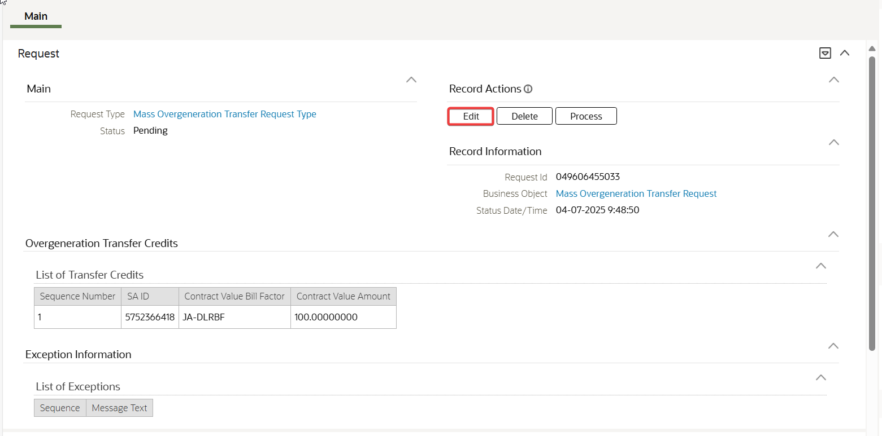

In the Request page, click Edit button for the pending Mass Overgeneration Transfer Request.

Test Results:

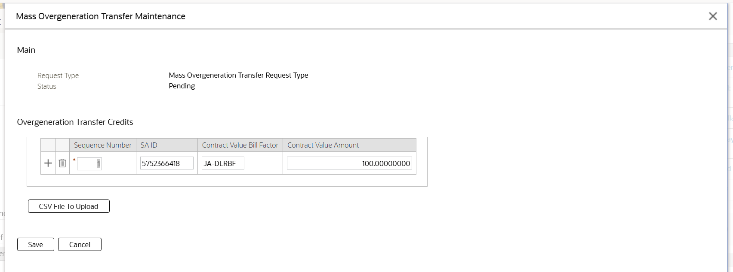

The Mass Overgeneration Transfer Maintenance page is shown with the existing contents

## In the Request page, update the existing Mass Overgeneration Transfer Request and click Save button

Test Condition:

* In the Request page, update the existing Mass Overgeneration Transfer Request and click Save button

Expected Results:

* The Mass Overgeneration Transfer request is updated.



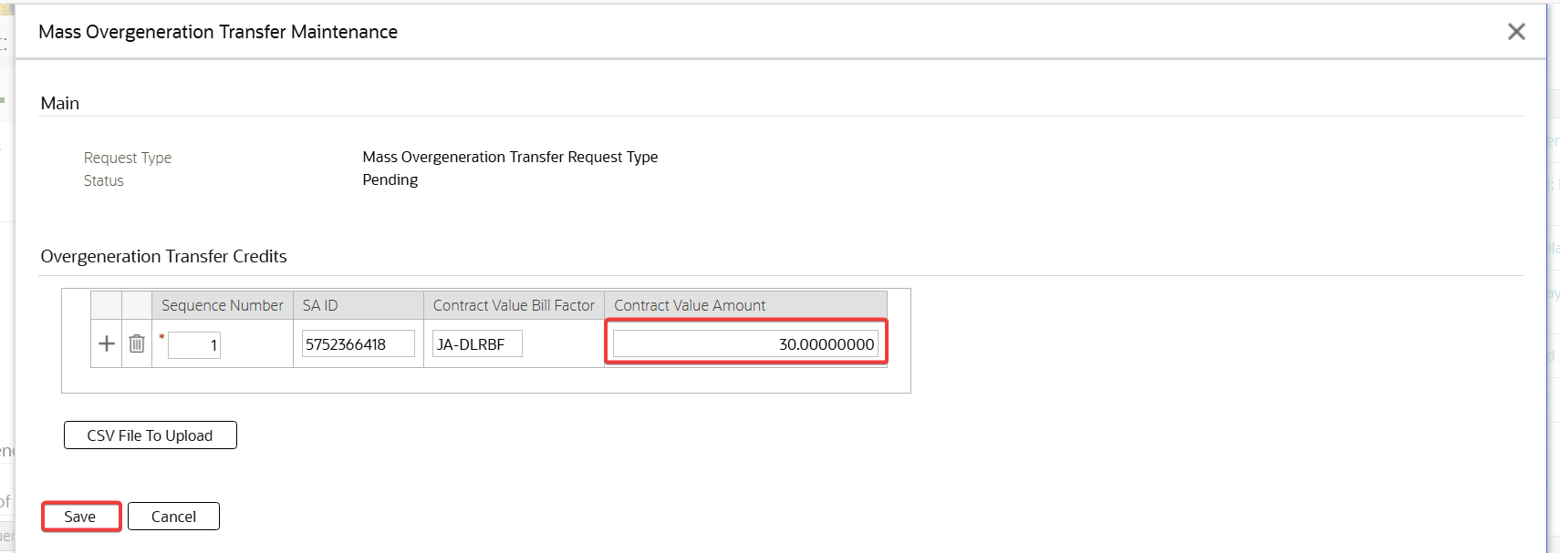

In the Request page, update the existing Mass Overgeneration Transfer Request and click Save button

Test Results:

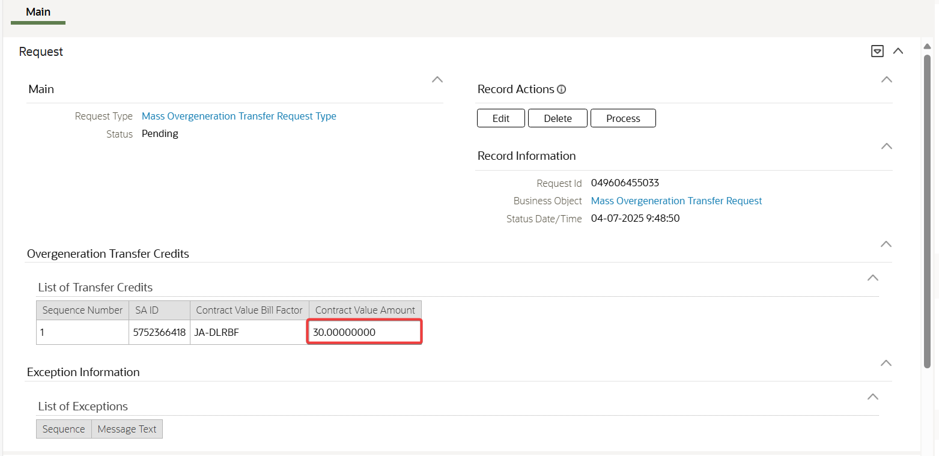

The Mass Overgeneration Transfer request is updated.

## In the Request page, click Delete button for the pending Mass Overgeneration Transfer Request

Test Condition:

* In the Request page, click Delete button for the pending Mass Overgeneration Transfer Request

Expected Results:

* The Confirmation Delete pop-up window is shown

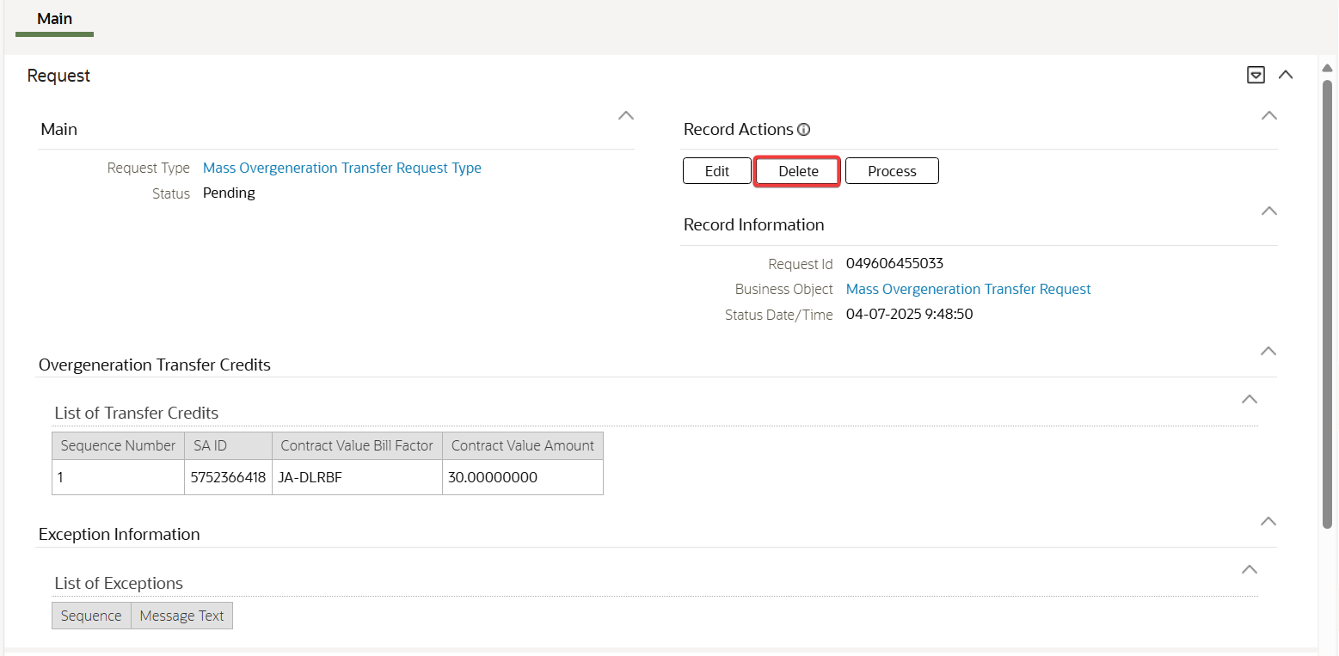

In the Request page, click Delete button for the pending Mass Overgeneration Transfer Request

Test Results:

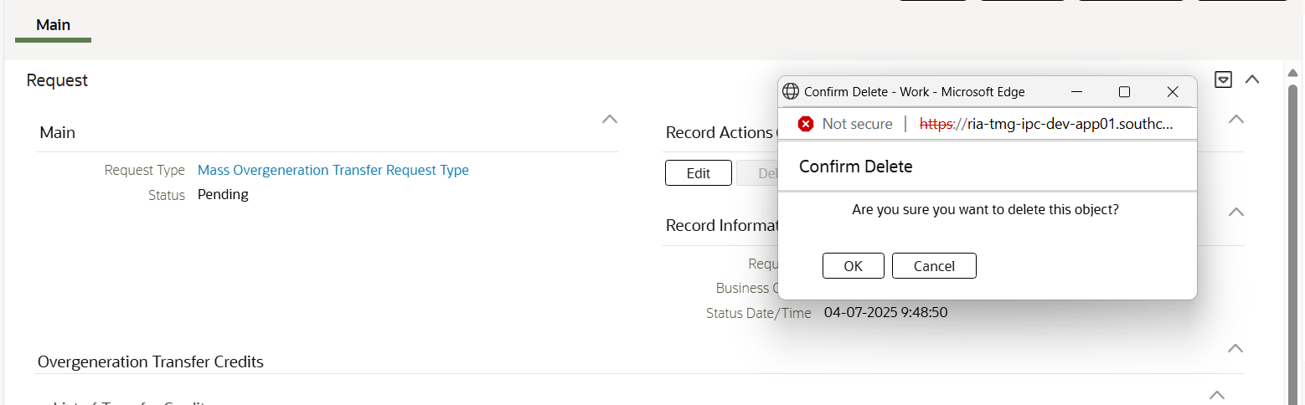

The Confirmation Delete pop-up window is shown

## In the Confirmation Delete pop-up window, click Cancel button

Test Condition:

* In the Confirmation Delete pop-up window, click Cancel button

Expected Results:

* The pop-up is closed

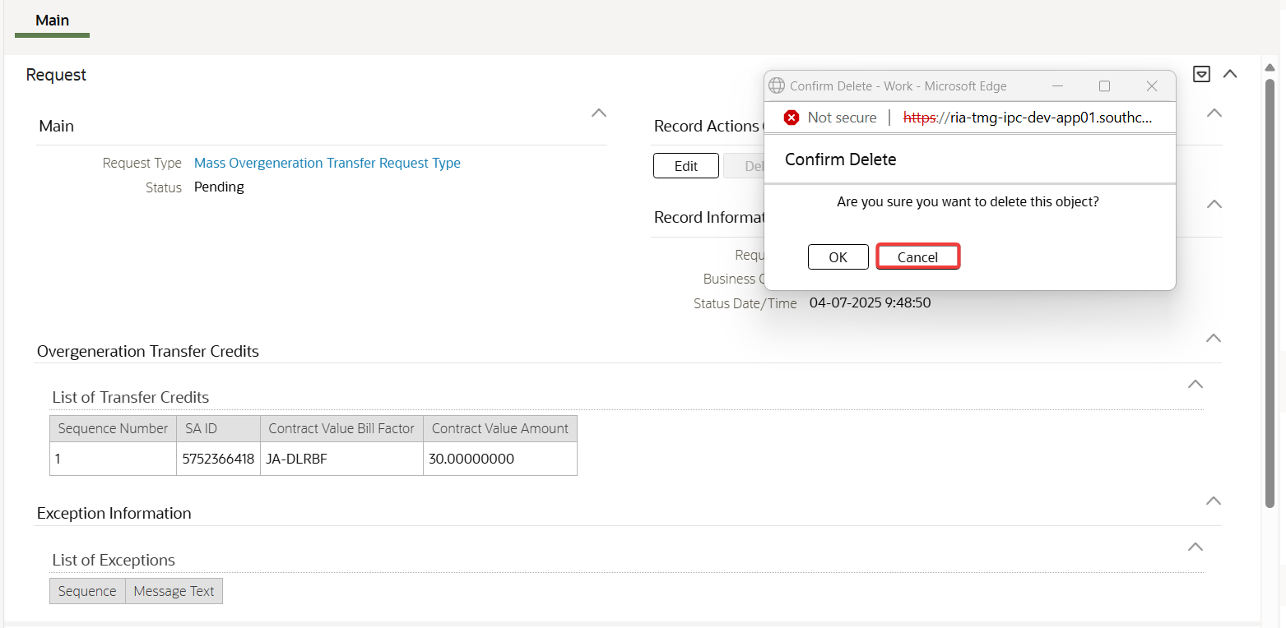

In the Confirmation Delete pop-up window, click Cancel button

Test Results:

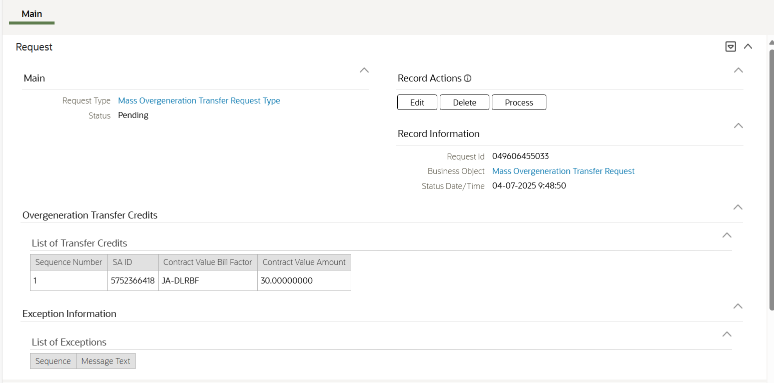

The pop-up is closed

## In the Confirmation Delete pop-up window, click OK button

Test Condition:

* In the Confirmation Delete pop-up window, click OK button

Expected Results:

* The request is deleted and navigated to the Request Query page

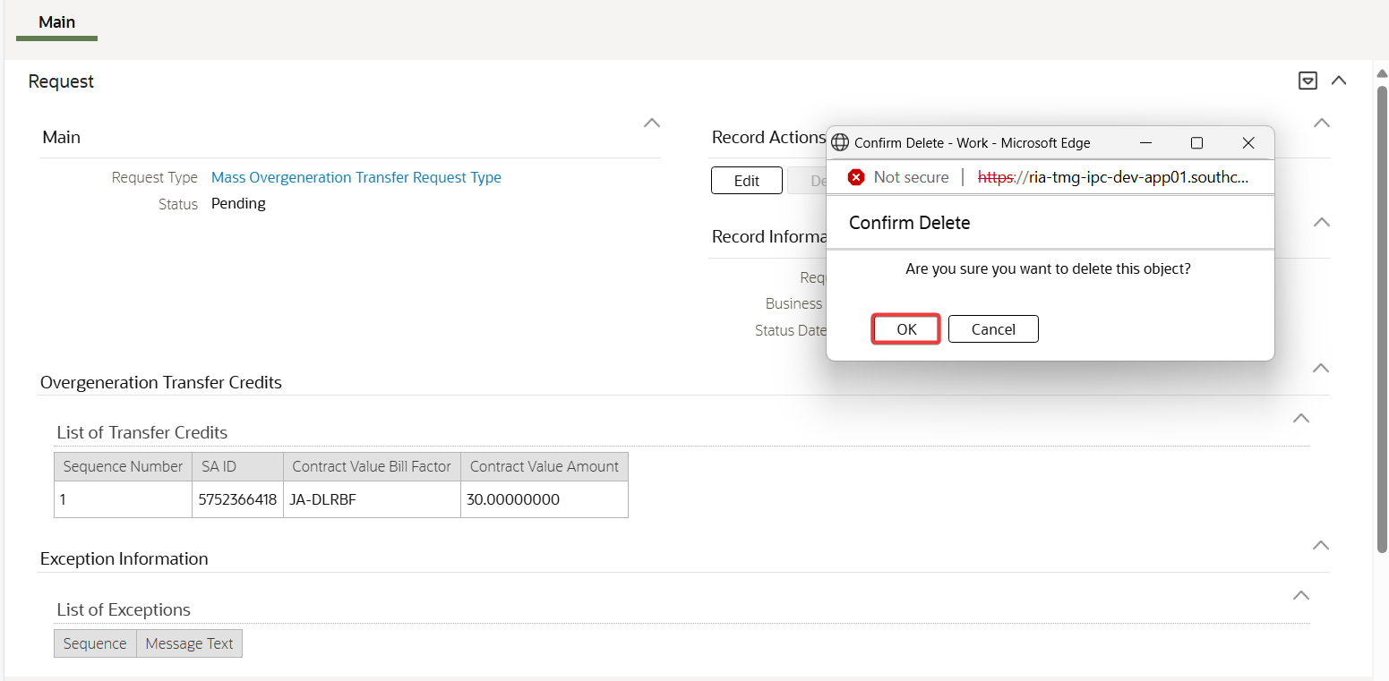

In the Confirmation Delete pop-up window, click OK button

Test Results:

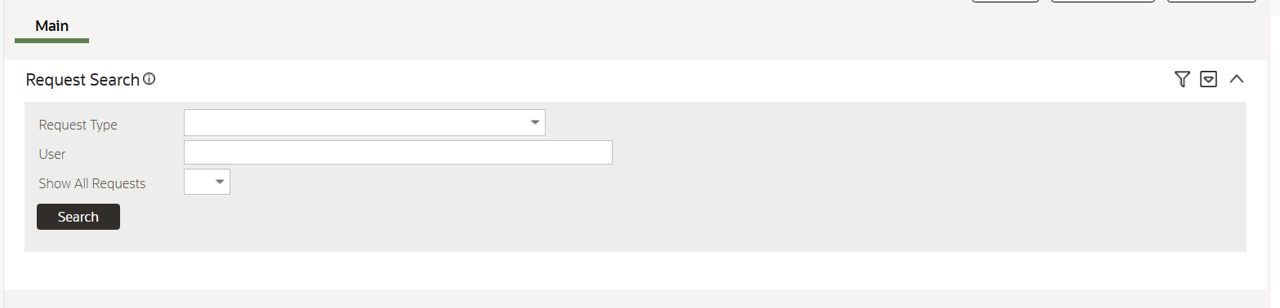

The request is deleted and navigated to the Request Query page

## In the Request page, click Process button for the pending Mass Overgeneration Transfer Request with all fields correctly populated.

Test Condition:

* In the Request page, click Process button for the pending Mass Overgeneration Transfer Request with all fields correctly populated.

Expected Results:

* Request processed successfully and transitioned to Completed status.
* Overgeneration SA has the credits successfully transferred to the specified SAs. Contract values reflect the system date as date of transfer and transfer amount accurately.

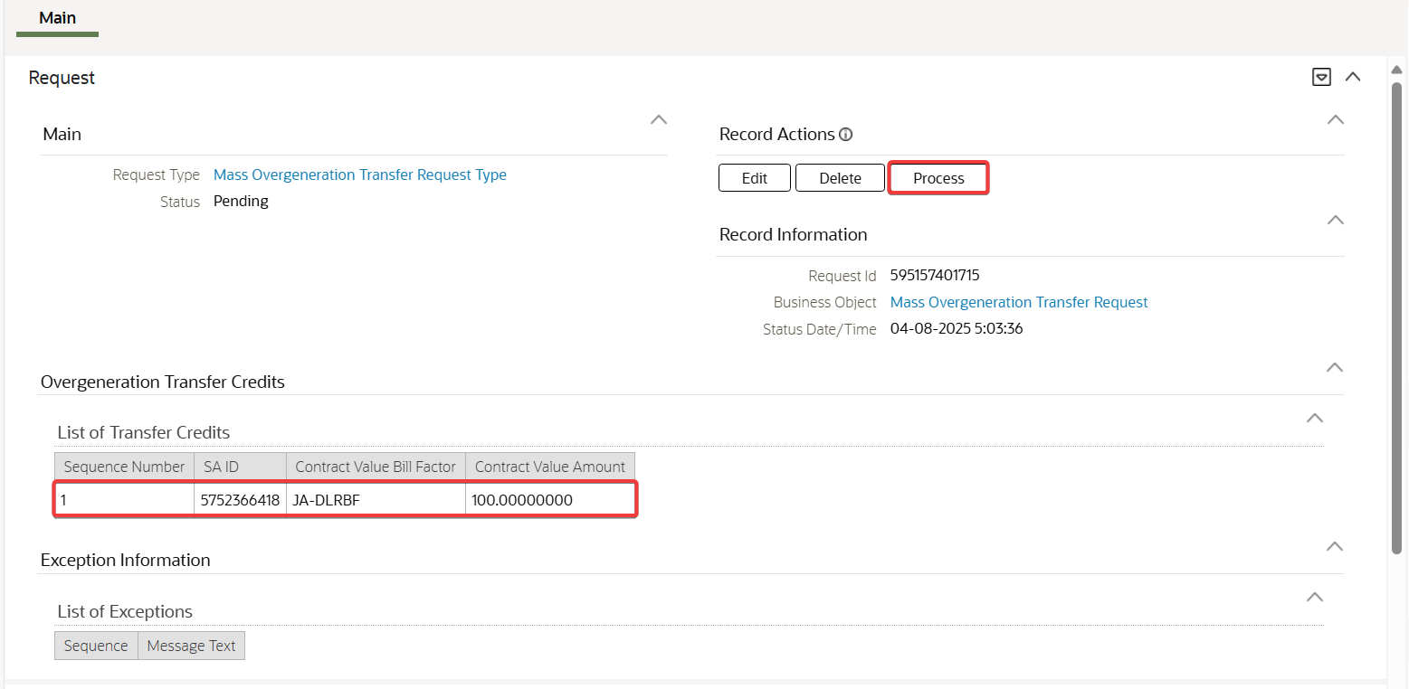

In the Request page, click Process button for the pending Mass Overgeneration Transfer Request with all fields correctly populated.

Test Results:

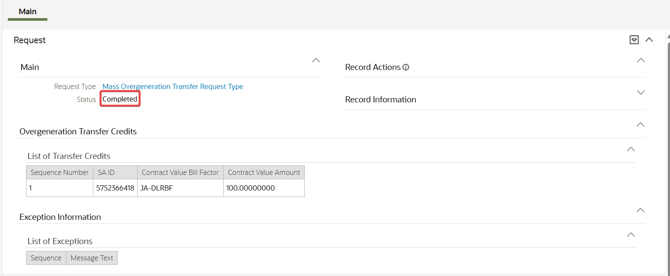

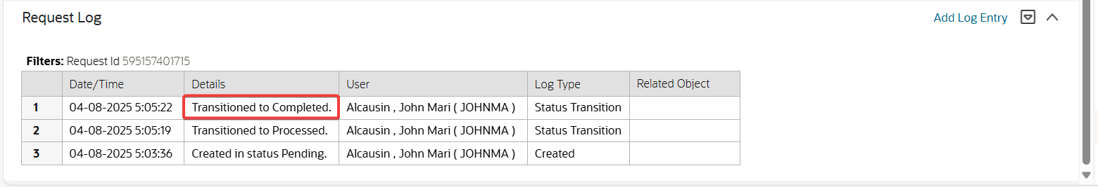

Request processed successfully and transitioned to Completed status.

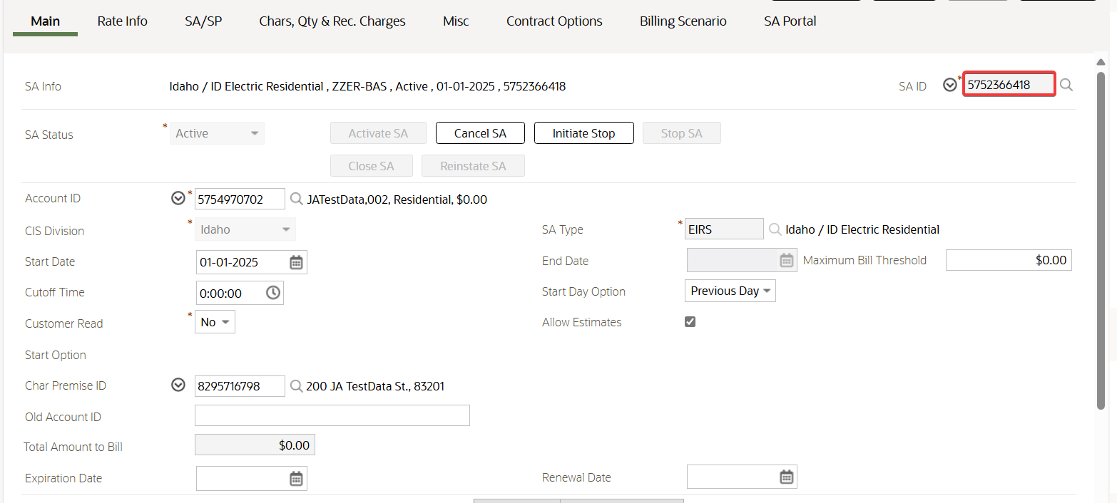

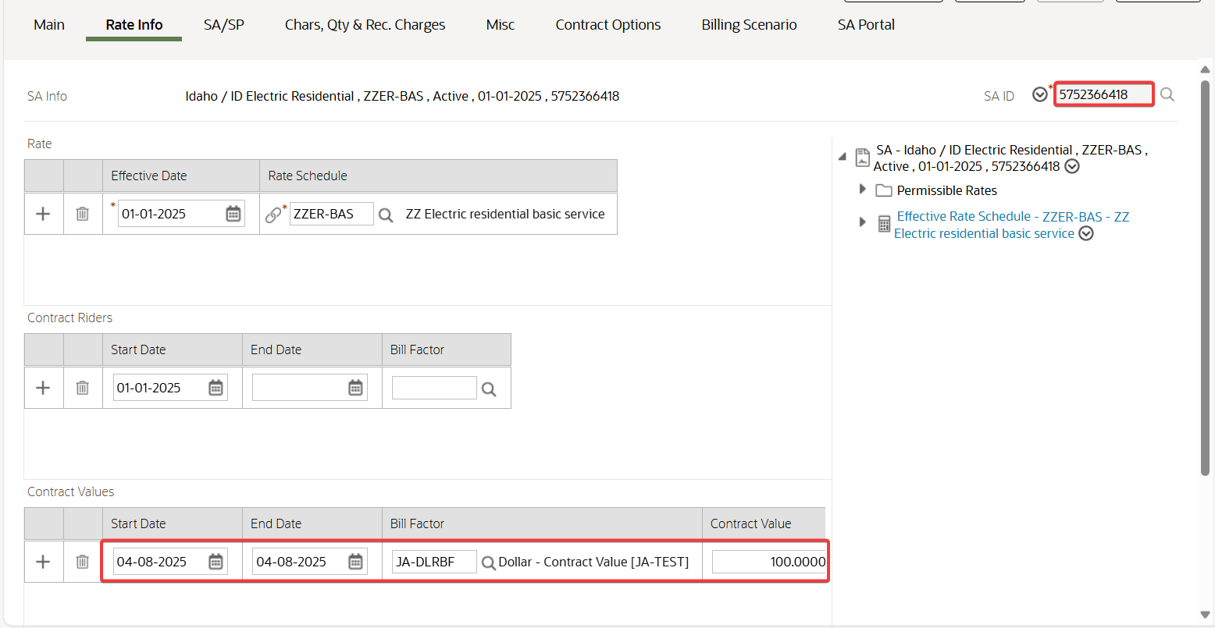

Overgeneration SA has the credits successfully transferred to the specified SAs. Contract values reflect the system date as date of transfer and transfer amount accurately.

## In the Request page, click Process button for the pending Mass Overgeneration Transfer Request with missing SA ID

Test Condition:

* In the Request page, click Process button for the pending Mass Overgeneration Transfer Request with missing SA ID

Expected Results:

* Request processed successfully but with error message indicating SA ID is missing under Exception Information section
* Request is in Completed status.

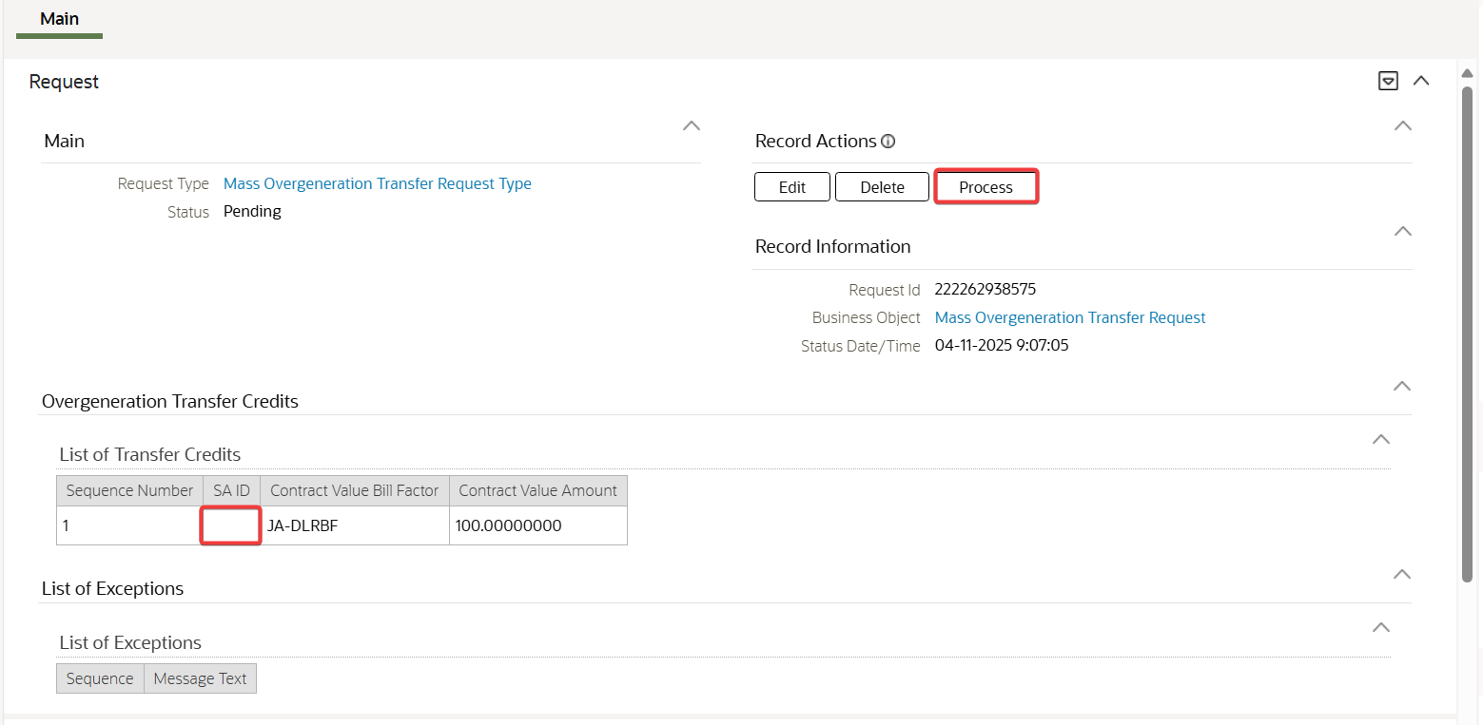

In the Request page, click Process button for the pending Mass Overgeneration Transfer Request with missing SA ID

Test Results:

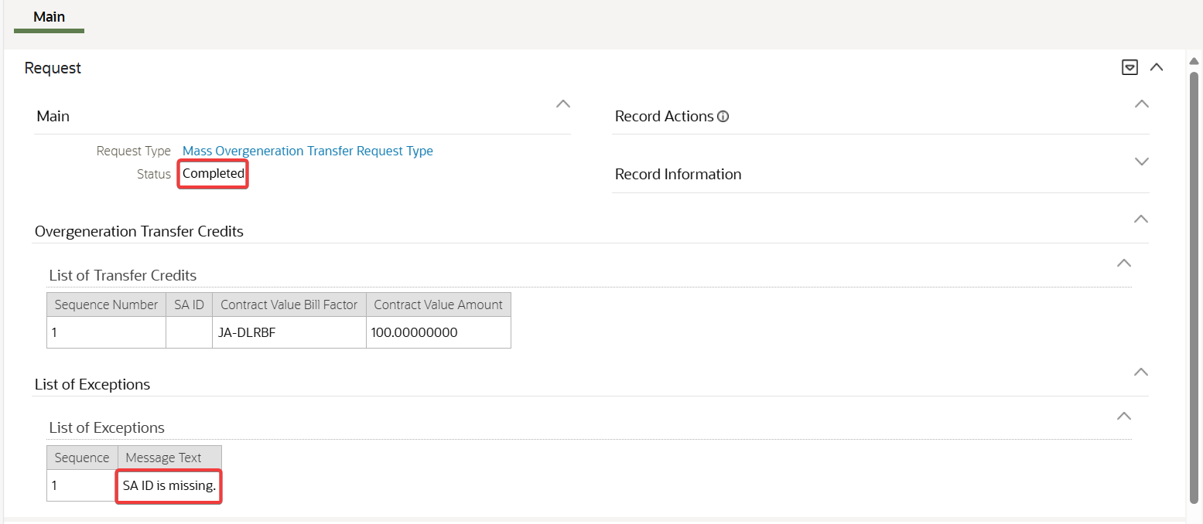

Request processed successfully but with error message indicating SA ID is missing under Exception Information section. Request is in Completed status

## In the Request page, click Process button for the pending Mass Overgeneration Transfer Request with missing Contract Value Bill Factor

Test Condition:

* In the Request page, click Process button for the pending Mass Overgeneration Transfer Request with missing Contract Value Bill Factor

Expected Results:

* Request processed successfully but with error message indicating Contract Value Bill Factor is missing under Exception Information section.
* Request is in Completed status.

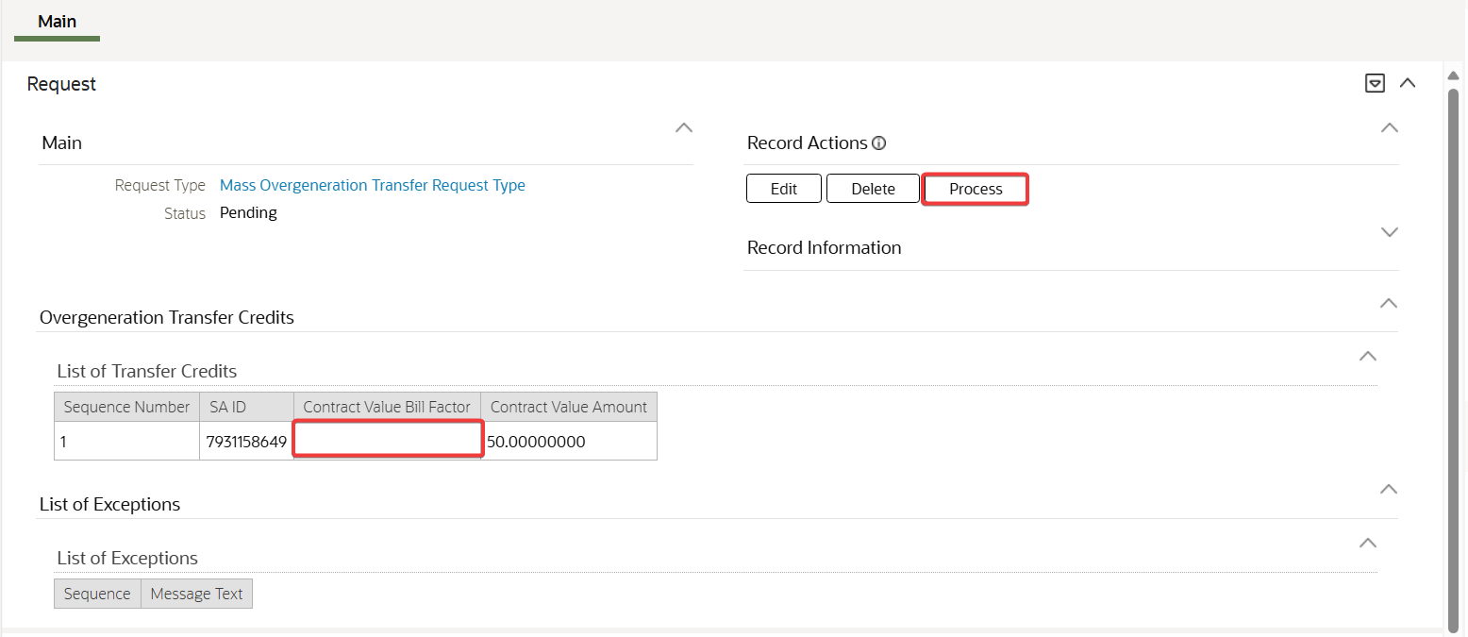

In the Request page, click Process button for the pending Mass Overgeneration Transfer Request with missing Contract Value Bill Factor

Test Results:

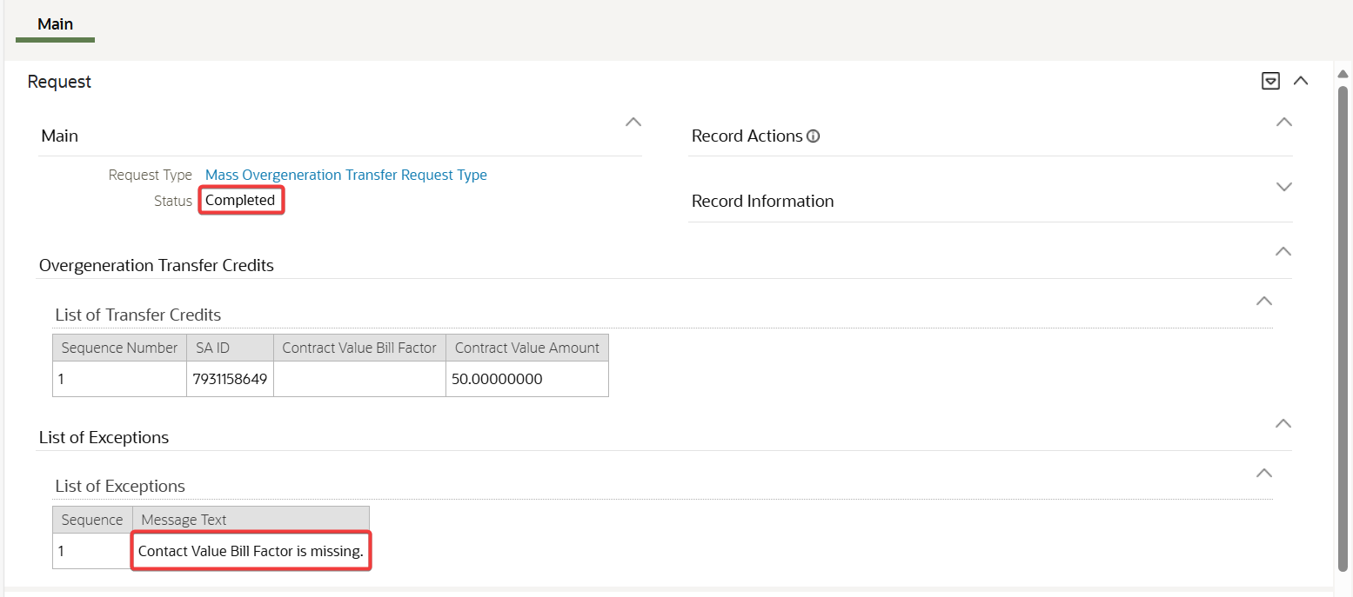

Request processed successfully but with error message indicating Contract Value Bill Factor is missing under Exception Information section. Request is in Completed status.

## In the Request page, click Process button for the pending Mass Overgeneration Transfer Request with missing Contract Value Amount

Test Condition:

* In the Request page, click Process button for the pending Mass Overgeneration Transfer Request with missing Contract Value Amount

Expected Results:

* Request processed successfully but with error message indicating Contract Value Amount is missing under Exception Information section.
* Request is in Completed status

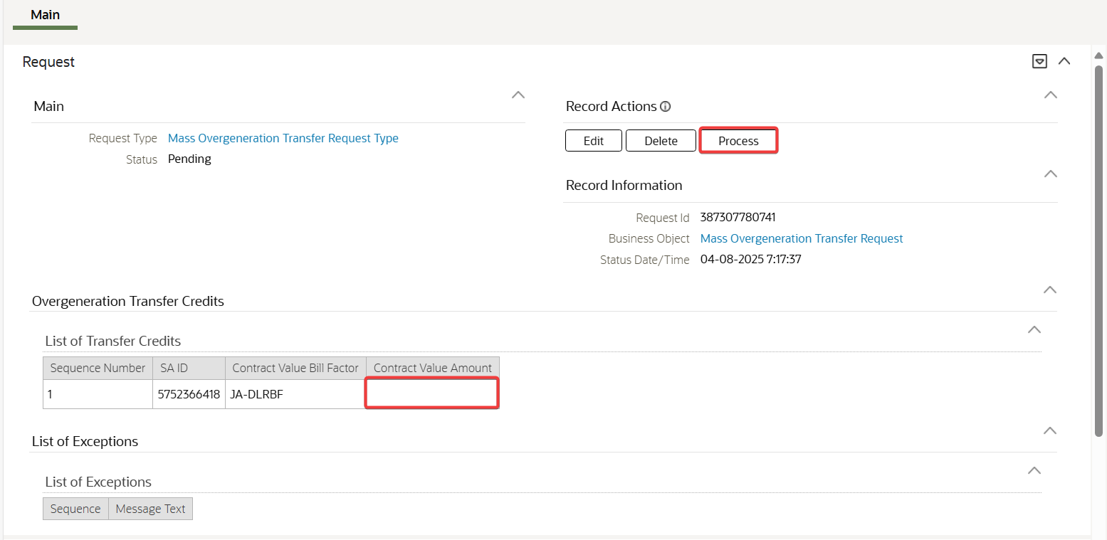

In the Request page, click Process button for the pending Mass Overgeneration Transfer Request with missing Contract Value Amount

Test Results:

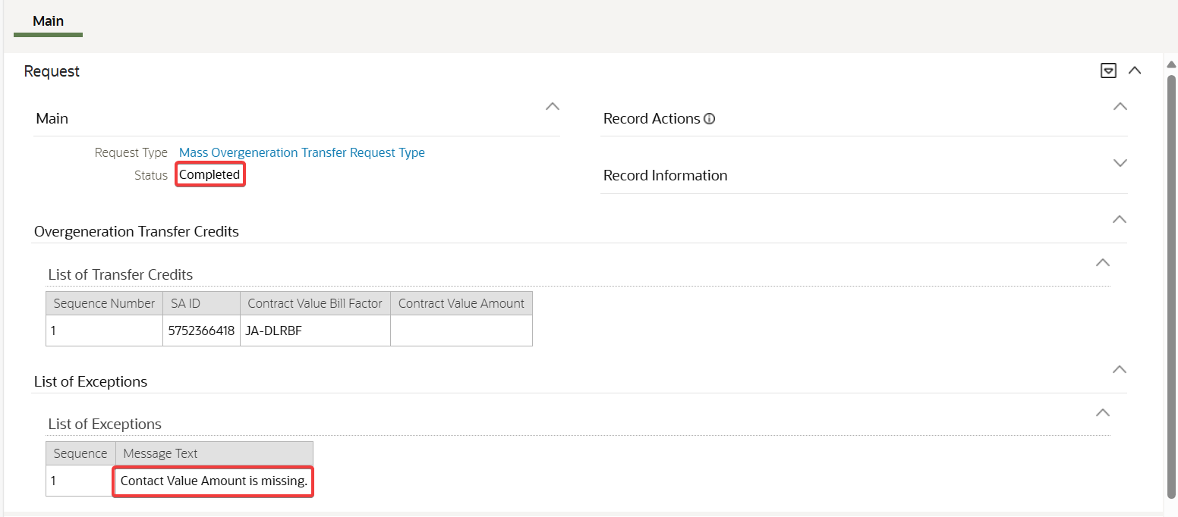

Request processed successfully but with error message indicating Contract Value Amount is missing under Exception Information section. Request is in Completed status.

## In the Request page, click Process button for the pending Mass Overgeneration Transfer Request with invalid SA ID

Test Condition:

* In the Request page, click Process button for the pending Mass Overgeneration Transfer Request with invalid SA ID

Expected Results:

* Request processed successfully but with error message indicating SA ID is invalid under Exception Information section.
* Request is in Completed status

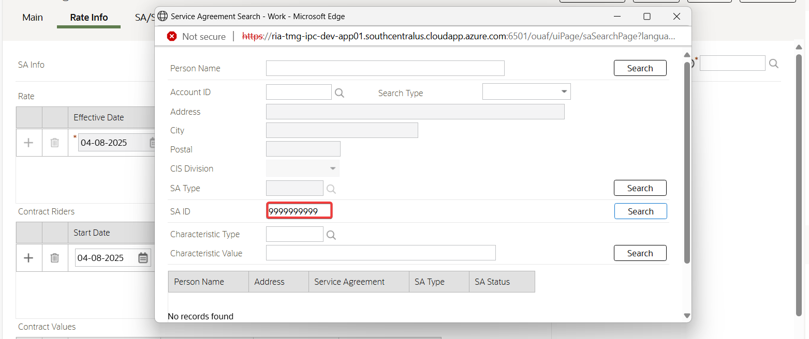

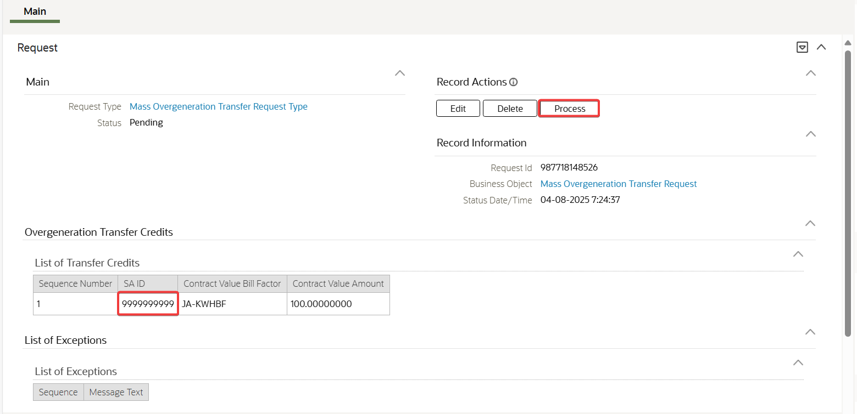

In the Request page, click Process button for the pending Mass Overgeneration Transfer Request with invalid SA ID

Test Results:

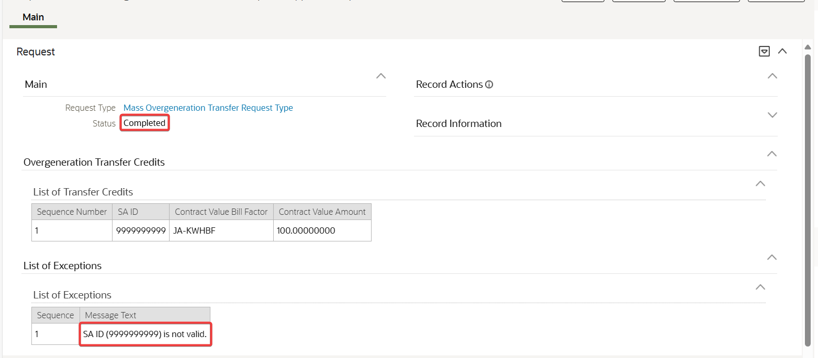

Request processed successfully but with error message indicating SA ID is invalid under Exception Information section. Request is in Completed status

## In the Request page, click Process button for the pending Mass Overgeneration Transfer Request with invalid Contract Value Bill Factor

Test Condition:

* In the Request page, click Process button for the pending Mass Overgeneration Transfer Request with invalid Contract Value Bill Factor

Expected Results:

* Request processed successfully but with error message indicating Contract Value Bill Factor is not valid under Exception Information section.
* Request is in Completed status.

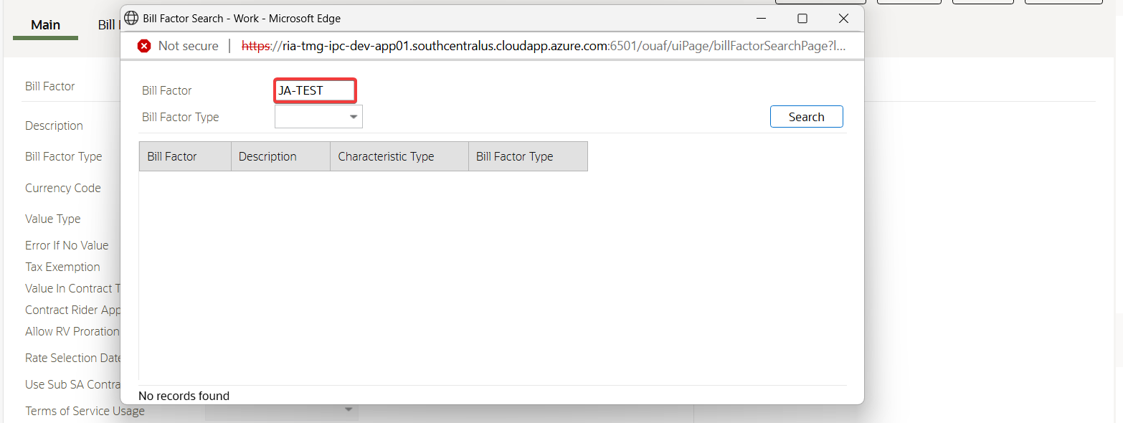

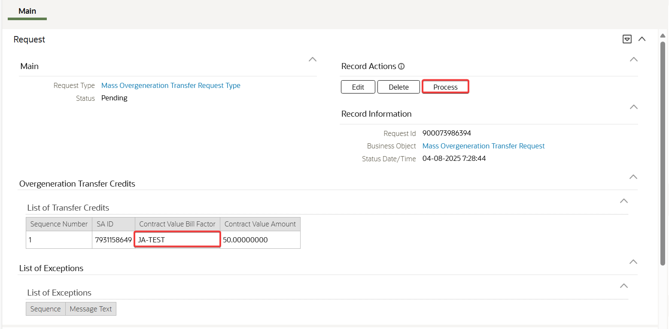

In the Request page, click Process button for the pending Mass Overgeneration Transfer Request with invalid Contract Value Bill Factor

Test Results:

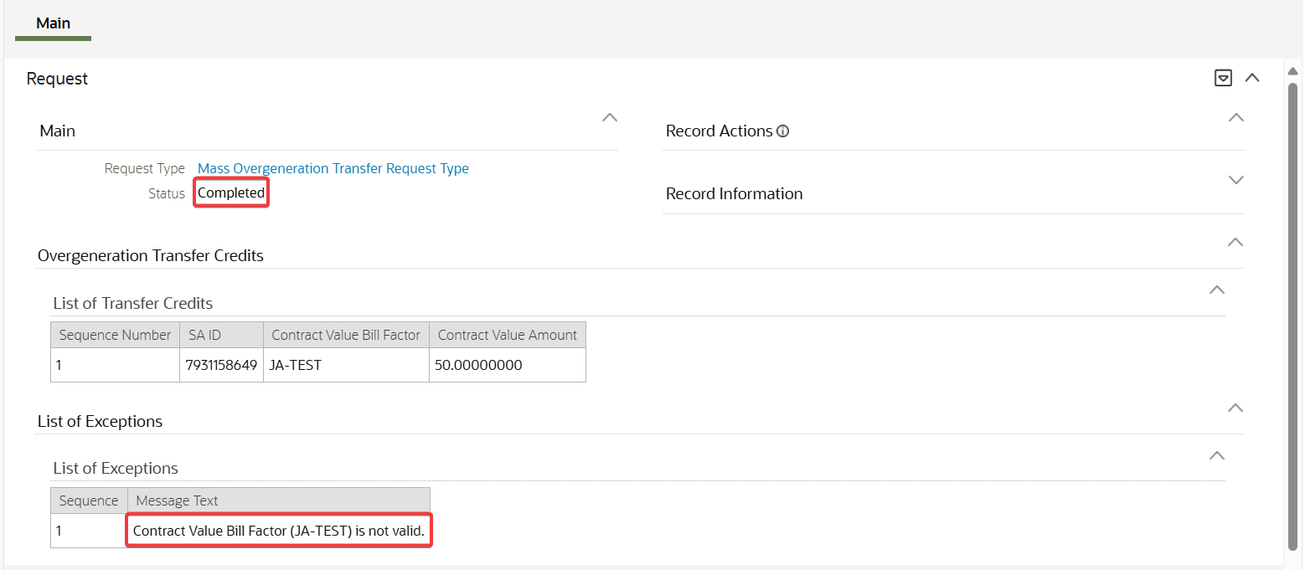

Request processed successfully but with error message indicating Contract Value Bill Factor is not valid under Exception Information section. Request is in Completed status.

## In the Request page, click Process button for the pending Mass Overgeneration Transfer Request with invalid Contract Value Amount

Test Condition:

* In the Request page, click Process button for the pending Mass Overgeneration Transfer Request with invalid Contract Value Amount

Expected Results:

* Request processed successfully but with error message indicating Contract Value Amount is invalid number under Exception Information section.
* Request is in Completed status.

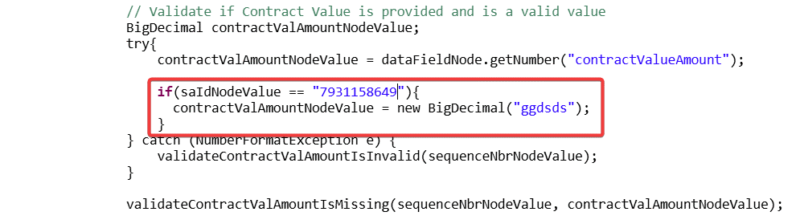

**Technical Note:** The Code was updated to force the error in validating the Contract Value Amount.

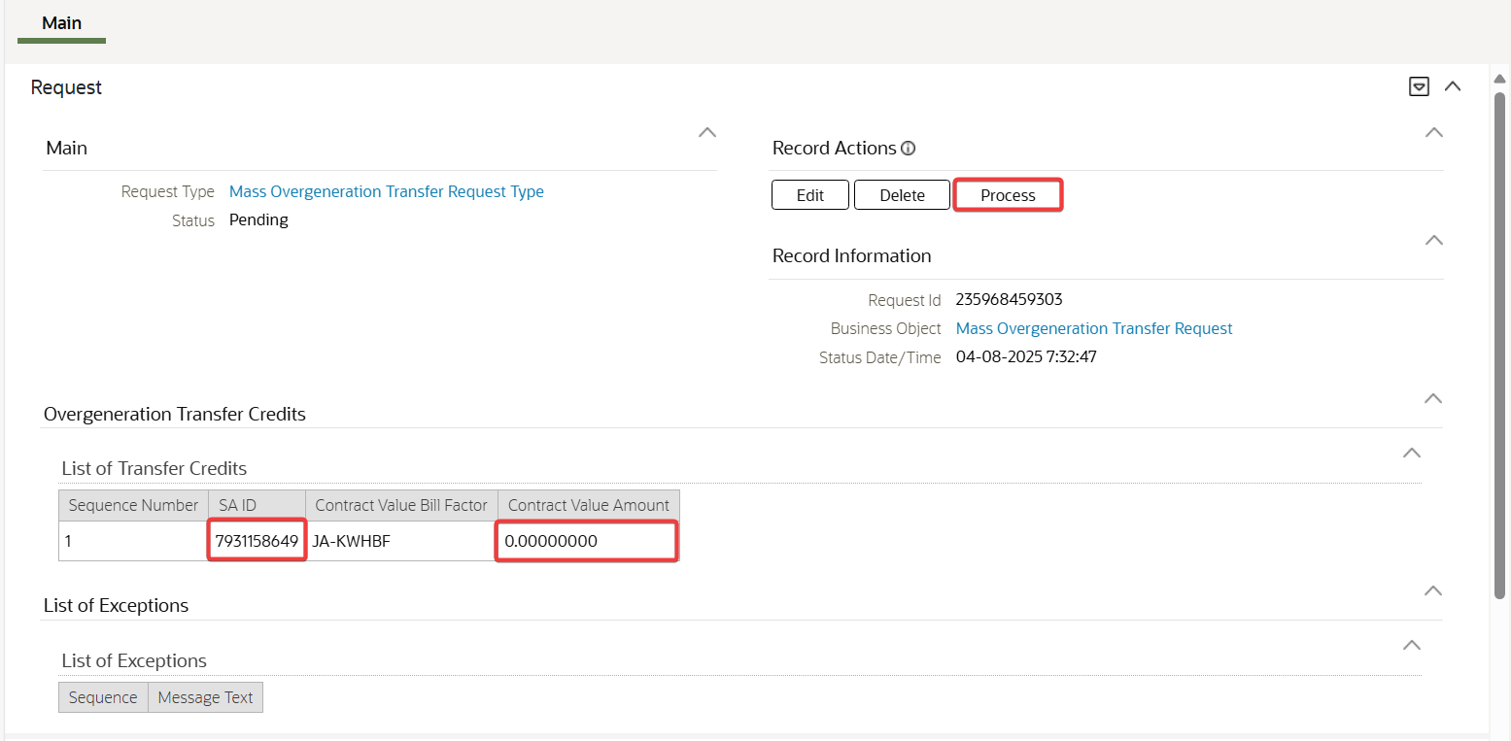

In the Request page, click Process button for the pending Mass Overgeneration Transfer Request with invalid Contract Value Amount

Test Results:

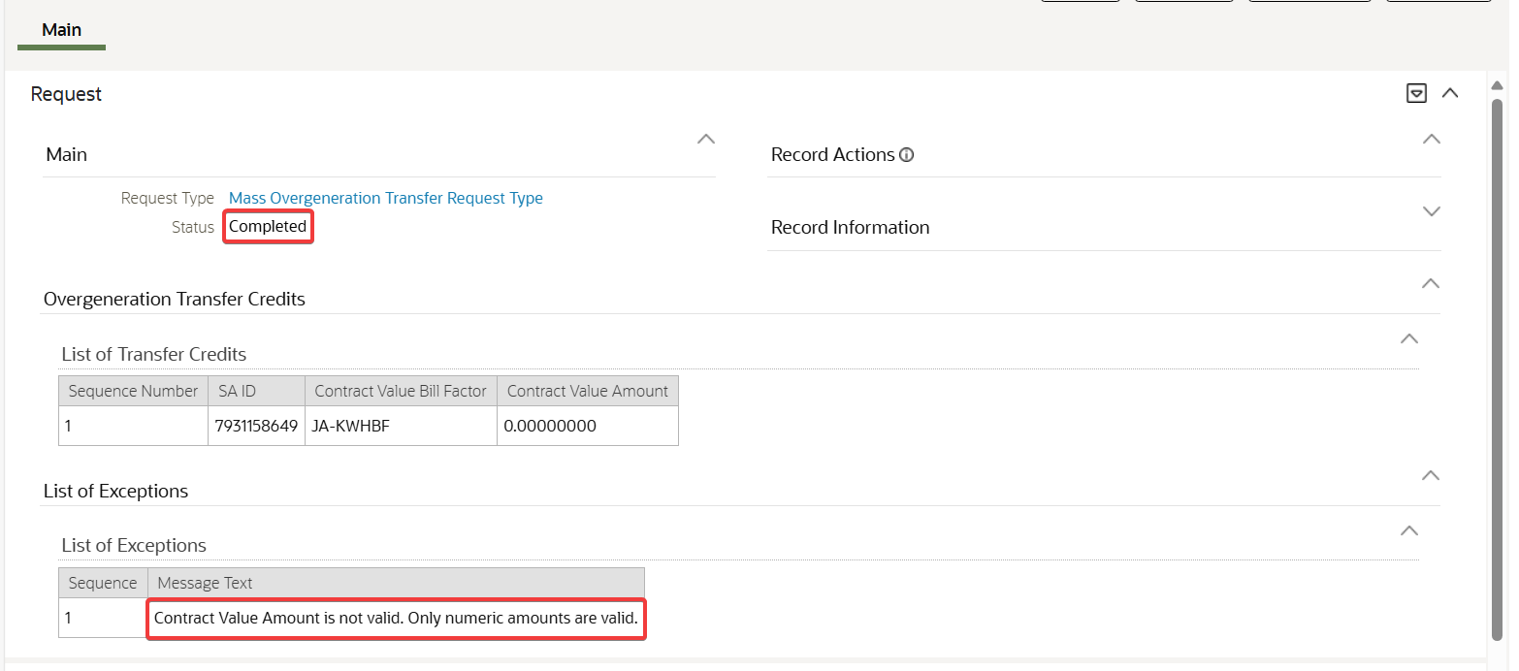

Request processed successfully but with error message indicating Contract Value Amount is invalid number under Exception Information section. Request is in Completed status.

## In the Request page, click Process button for the pending Mass Overgeneration Transfer Request with SA that has existing Contract Value with the same Bill Factor and Start Date.

Test Condition:

* In the Request page, click Process button for the pending Mass Overgeneration Transfer Request with SA that has existing Contract Value with the same Bill Factor and Start Date.

Expected Results:

* Request processed successfully but with error message indicating duplicate Contract Value under Exception Information section.
* Request is in Completed status.





In the Request page, click Process button for the pending Mass Overgeneration Transfer Request with SA that has existing Contract Value with the same Bill Factor and Start Date.

Test Results:



Request processed successfully but with error message indicating duplicate Contract Value under Exception Information section. Request is in Completed status.

## In the Request page, click Process button for the pending Mass Overgeneration Transfer Request with SA that has existing Contract Value with the same Bill Factor, Start Date and End Date.

Test Condition:

* In the Request page, click Process button for the pending Mass Overgeneration Transfer Request with SA that has existing Contract Value with the same Bill Factor, Start Date and End Date.

Expected Results:

* Request processed successfully but with error message indicating duplicate Contract Value under Exception Information section.
* Request is in Completed status.





In the Request page, click Process button for the pending Mass Overgeneration Transfer Request with SA that has existing Contract Value with the same Bill Factor, Start Date and End Date.

Test Results:



Request processed successfully but with error message indicating duplicate Contract Value under Exception Information section. Request is in Completed status.

## In the Mass Overgeneration Request BO – Processed status, update the Transitory State to No and clear the Transition Condition. In the Request page, click Process button for the pending Mass Overgeneration Transfer Request.

**Technical Note:** To verify Test Condition #41, temporarily set the Transitory State to No and clear the Transition Condition for the Mass Overgeneration Transfer Request BO – Processed status, as it is configured to auto-transition from Processed to Completed status. Ensure to revert these changes after completing the verification

Test Condition:

* In the Mass Overgeneration Request BO – Processed status, update the Transitory State to No and clear the Transition Condition.
* In the Request page, click Process button for the pending Mass Overgeneration Transfer Request.

Expected Results:

* Request processed successfully and transitioned to Processed status.
* In the Record Actions section, only the Complete button is available.

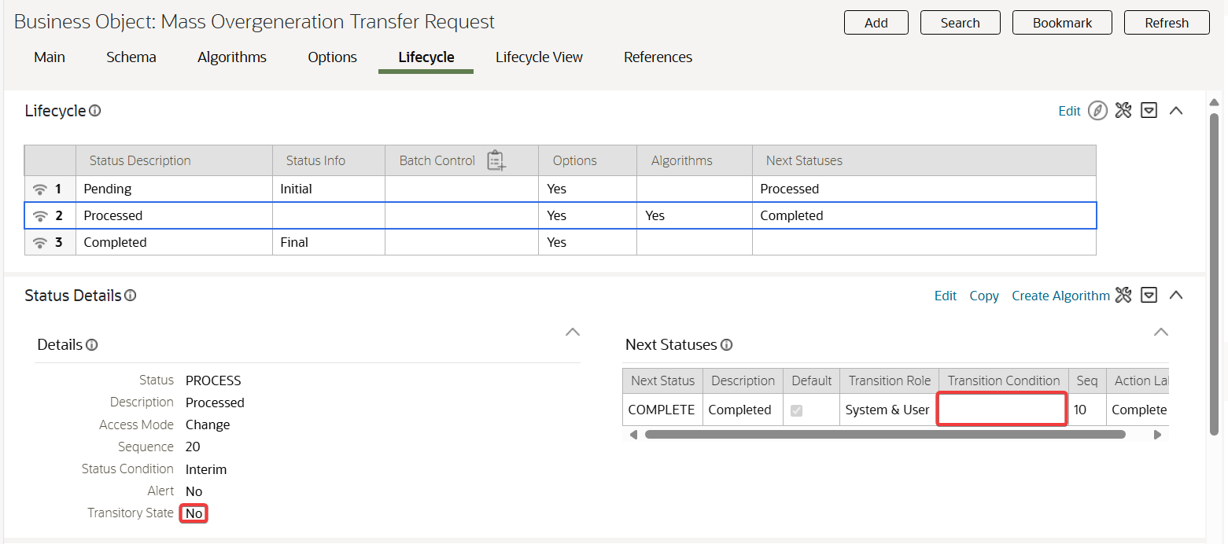

In the Mass Overgeneration Request BO – Processed status, update the Transitory State to No and clear the Transition Condition.

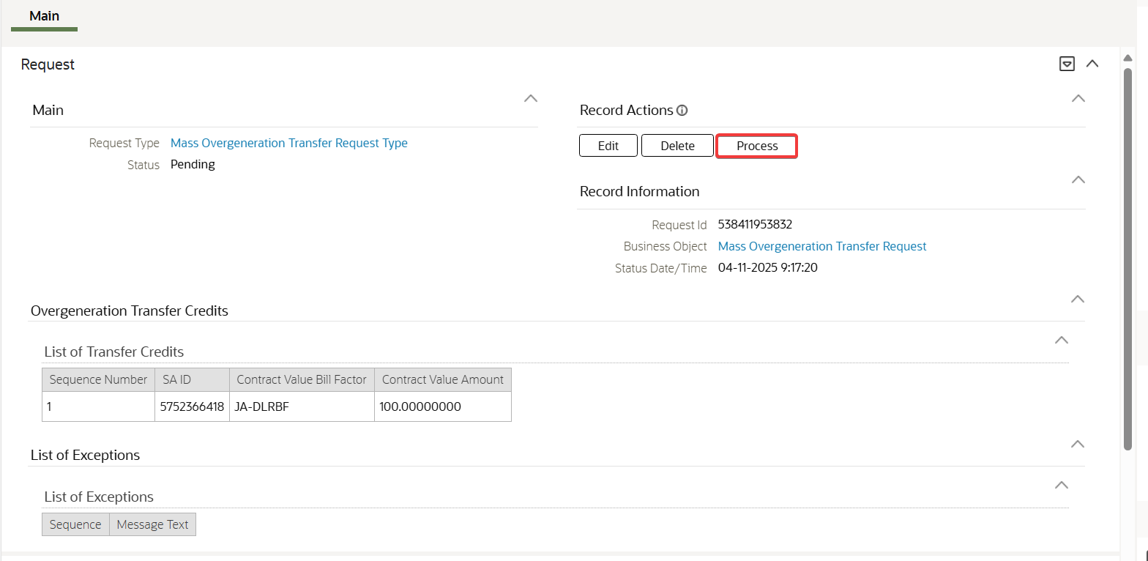

In the Request page, click Process button for the pending Mass Overgeneration Transfer Request.

Test Results:

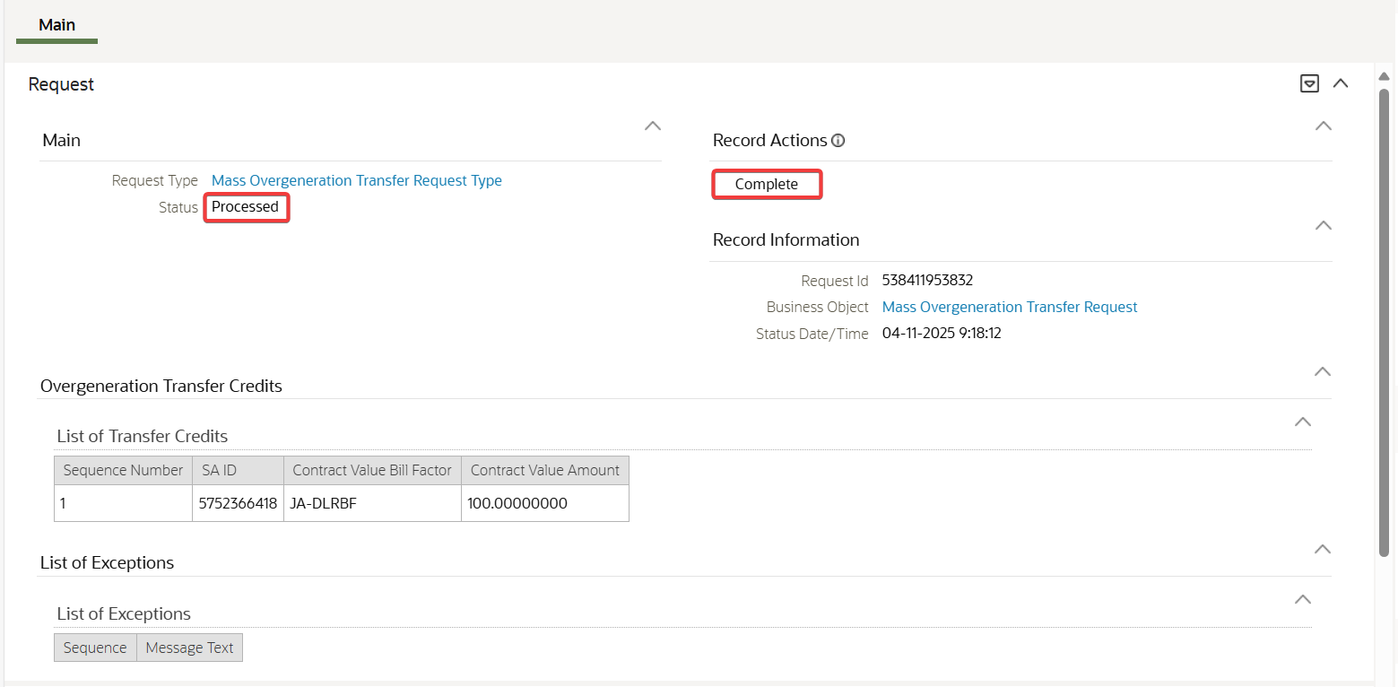

Request processed successfully and transitioned to Processed status. In the Record Actions section, only the Complete button is available.